## Special Methods

A class may define or inherit special methods, often referred to as “dunder” methods because, as described earlier, their names have leading and trailing double underscores. Each special method relates to a specific operation. Python implicitly calls a special method whenever you perform the related operation on an instance object. In most cases, the method’s return value is the operation’s result, and attempting an operation when its related method is not present raises an exception. Throughout this section, we point out the cases in which these general rules do not apply. In the following discussion, x is the instance of class C on which you perform the operation, and y is the other operand, if any. The parameter self of each method also refers to the instance object x. Whenever we mention calls to x.__whatever__(...), keep in mind that the exact call happening is rather, pedantically speaking, x.__class__.__whatever__(x, ...).

General-Purpose Special Methods

Some dunder methods relate to general-purpose operations. A class that defines or inherits these methods allows its instances to control such operations. These operations can be divided into categories:

**Initialization and finalization**

A class can control its instances’ initialization (a very common requirement) via special methods __new__ and __init__, and/or their finalization (a rare requirement) via __del__.

**String representation**

A class can control how Python renders its instances as strings via special methods __repr__, __str__, __format__, and __bytes__.

**Comparison, hashing, and use in a Boolean context**

A class can control how its instances compare with other objects (via special methods __lt__, __le__, __gt__, __ge__, __eq__, and __ne__), how dictionaries use them as keys and sets use them as members (via __hash__), and whether they evaluate as truthy or falsy in Boolean contexts ( via __bool__).

**Attribute reference, binding, and unbinding**

A class can control access to its instances’ attributes (reference, binding, unbinding) via special methods __getattribute__, __getattr__, __setattr__, and __delattr__.

**Callable instances**

A class can make its instances callable, just like function objects, via special method __call__.

Table 4-1 documents the general-purpose special methods.

Table 4-1. General-purpose special methods

__bool__ __bool__(self)

When evaluating x as true or false (see “Boolean Values” on page 51)— for example, on a call to bool(x)—Python calls x.__bool__(), which should return True or False. When __bool__ is not present, Python calls __len__, and takes x as falsy when x.__len__() returns 0 (to check that a container is nonempty, avoid coding if len(container)>0:; use if container: instead). When neither __bool__ nor __len__ is present, Python considers x truthy.

__bytes__ __bytes__(self)

Calling bytes(x) calls x.__bytes__(), if present. If a class supplies both special methods __bytes__ and __str__, they should return “equivalent” strings, respectively, of bytes and str type.

__call__ __call__(self[, args...])

When you call x([args...]), Python translates the operation into a call to x.__call__([args...]). The arguments for the call operation correspond to the parameters for the __call__ method, minus the first one. The first parameter, conventionally called self, refers to x: Python supplies it implicitly, just as in any other call to a bound method.

__del__ __del__(self)

Just before x disappears via garbage collection, Python calls x.__del__() to let x finalize itself. If __del__ is absent, Python does no special finalization on garbage-collecting x (this is the most common case: very few classes need to define __del__). Python ignores the return value of __del__ and doesn’t implicitly call __del__ methods of class C’s superclasses. C.__del__ must explicitly perform any needed finalization, including, if need be, by delegation. When class C has base classes to finalize, C.__del__ must call super().__del__(). The __del__ method has no specific connection with the del statement,

covered in “del Statements” on page 56. __del__ is generally not the best approach when you need timely and guaranteed finalization. For such needs, use the try/finally statement

covered in “try/finally” on page 198 (or, even better, the with statement, covered in “The with Statement” on page 93). Instances of classes defining __del__ don’t participate in cyclic garbage collection, covered in “Garbage Collection” on page 435. Be careful to avoid reference loops involving such instances: define __del__ only when there is no feasible alternative.

__delattr__ __delattr__(self, name)

At every request to unbind attribute x.y (typically, del x.y), Python calls x.__delattr__('y'). All the considerations discussed later for __setattr__ also apply to __delattr__. Python ignores the return value of __delattr__. Absent __delattr__, Python turns del x.y into del x.__dict__['y'].

__dir__ __dir__(self)

When you call dir(x), Python translates the operation into a call to x.__dir__(), which must return a sorted list of x’s attributes. When x’s class has no __dir__, dir(x) performs introspection to return a sorted list of x’s attributes, striving to produce relevant, rather than complete, information.

__eq__, __ge__,

__gt__, __le__,

__lt__, __ne__

__eq__(self, other), __ge__(self, other),

__gt__(self, other), __le__(self, other),

__lt__(self, other), __ne__(self, other)

The comparisons x == y, x >= y, x > y, x <= y, x < y, and x != y, respectively, call the special methods listed here, which should return False or True. Each method may return NotImplemented to tell Python to handle the comparison in alternative ways (e.g., Python may then try y > x in lieu of x < y).

Best practice is to define only one inequality comparison method (normally __lt__) plus __eq__, and decorate the class with func tools.total_ordering (covered in Table 8-7), to avoid boilerplate and any risk of logical contradictions in your comparisons.

__format__

__format__(self, format_string='') Calling format(x) calls x.__format__(''), and calling format(x, format_string) calls x.__format__(format_string). The class is responsible for interpreting the format string (each class may define its own small “language” of format specifications, inspired by those implemented by built-in types, as covered in “String Formatting” on page 287). When __format__ is inherited from object, it delegates to __str__ and does not accept a nonempty format string.

__getattr__

__getattr__(self, name) When x.y can’t be found by the usual steps (i.e., when an AttributeError would usually be raised), Python calls x.__getattr__('y'). Python does not call __getattr__ for attributes found by normal means (as keys

in x.__dict__, or via x.__class__). If you want Python to call __getattr__ for every attribute, keep the attributes elsewhere (e.g., in another dict referenced by an attribute with a private name), or override __getattribute__ instead. __getattr__ should raise AttributeError if it can’t find y.

__getattribute__

__getattribute_(self, name) At every request to access attribute x.y, Python calls x.__getattribute__('y'), which must get and return the attribute value or else raise AttributeError. The usual semantics of attribute access (x.__dict__, C.__slots__, C’s class attributes, x.__getattr__) are all due to object.__getattribute__. When class C overrides __getattribute__, it must implement all of the attribute semantics it wants to offer. The typical way to implement attribute access is by delegating (e.g., call object.__getattribute__(self, ...) as part of the operation of your override of __getattribute__).

Overriding __getattribute__ Slows Attribute Access When a class overrides __getattribute__, all attribute accesses on instances of the class become slow, as the overriding code executes on every attribute access.

__hash__

__hash__(self) Calling hash(x) calls x.__hash__() (and so do other contexts that need to know x’s hash value, namely using x as a dictionary key, such as D[x] where D is a dictionary, or using x as a set member). __hash__ must return an int such that x==y implies hash(x)==hash(y), and must always return the same value for a given object. When __hash__ is absent, calling hash(x) calls id(x) instead, as long as __eq__ is also absent. Other contexts that need to know x’s hash value behave the same way. Any x such that hash(x) returns a result, rather than raising an exception, is known as a hashable object. When __hash__ is absent, but __eq__ is present, calling hash(x) raises an exception (and so do other contexts that need to know x’s hash value). In this case, x is not hashable and therefore cannot be a dictionary key or set member. You normally define __hash__ only for immutable objects that also define __eq__. Note that if there exists any y such that x==y, even if y is of a different type, and both x and y are hashable, you must ensure that hash(x)==hash(y). (There are few cases, among Python built-ins, where x==y can hold between objects of different types. The most important ones are equality between different number types: an int can equal a bool, a float, a fractions.Fraction instance, or a decimal.Decimal instance.)

__init__ __init__(self[, args...])

When a call C([args...]) creates instance x of class C, Python calls x.__init__([args...]) to let x initialize itself. If __init__ is absent

(i.e., it’s inherited from object), you must call C without arguments, C(), and x has no instance-specific attributes on creation.

Python performs no implicit call to __init__ methods of class C’s superclasses. C.__init__ must explicitly perform any initialization, including, if need be, by delegation. For example, when class C has a base class B to initialize without arguments, the code in C.__init__ must explicitly call super().__init__(). __init__’s inheritance works just like for any other method or attribute: if C itself does not override __init__, it inherits it from the first superclass in its __mro__ to override __init__, like every other attribute. __init__ must return None; otherwise, calling the class raises TypeError.

__new__ __new__(cls[, args...])

When you call C([args...]), Python gets the new instance x that you are creating by invoking C.__new__(C[, args...]). Every class has the class method __new__ (usually, it just inherits it from object), which can return any value x. In other words, __new__ need not return a new instance of C, although it’s expected to do so. If the value x that __new__ returns is an instance of C or of any subclass of C (whether a new or a previously existing one), Python then calls __init__ on x (with the same [args...] originally passed to __new__).

**Initialize Immutables in __new__, All Others in __init__**

You can perform most kinds of initialization of new instances in either __init__ or __new__, so you may wonder where it’s best to place them. Best practice is to put the initialization in __init__ only, unless you have a specific reason to put it in __new__. (When a type is immutable, __init__ cannot change its instances: in this case, __new__ has to perform all initialization.)

__repr__ __repr__(self)

Calling repr(x) (which happens implicitly in the interactive interpreter when x is the result of an expression statement) calls x.__repr__() to get and return a complete string representation of x. If __repr__ is absent, Python uses a default string representation. __repr__ should return a string with unambiguous information on x. When feasible, try to make eval(repr(x))==x (but, don’t go crazy to achieve this goal!).

__setattr__

__setattr__(self, name, value) At any request to bind attribute x.y (usually, an assignment statement x.y=value, but also, e.g., setattr(x, 'y', value)), Python calls x.__setattr__('y', value). Python always calls __setattr__ for any attribute binding on x—a major difference from __getattr__ (in this respect, __setattr__ is closer to __getattribute__). To avoid recursion, when x.__setattr__ binds x’s attributes, it must modify x.__dict__ directly (e.g., via x.__dict__[name]=value); or better, __setattr__ can delegate to the superclass (call super().__setattr__('y', value)). Python ignores the return value of __setattr__. If __setattr__ is absent (i.e., inherited from object), and C.y is not an overriding descriptor, Python usually translates x.y=z into x.__dict__['y']=z (however, __setattr__ also works fine with __slots__).

__str__

__str__(self) Like print(x), str(x) calls x.__str__() to get an informal, concise string representation of x. If __str__ is absent, Python calls x.__repr__. __str__ should return a convenient human-readable string, even when that entails some approximation.

Special Methods for Containers

An instance can be a container (a sequence, mapping, or set—mutually exclusive concepts9). For maximum usefulness, containers should provide special methods __getitem__, __contains__, and __iter__ (and, if mutable, also __setitem__ and __delitem__), plus nonspecial methods discussed in the following sections. In many cases, you can obtain suitable implementations of the nonspecial methods by extending the appropriate abstract base class from the collections.abc module, such as Sequence, MutableSequence, and so on, as covered in “Abstract Base Classes” on page 150.

Sequences

In each item-access special method, a sequence that has L items should accept any integer key such that -L<=key<L.10 For compatibility with built-in sequences, a negative index key, 0>key>=-L, should be equivalent to key+L. When key has an invalid type, indexing should raise a TypeError exception. When key is a value of a valid type but out of range, indexing should raise an IndexError exception. For sequence classes that do not define __iter__, the for statement relies on these requirements, as do built-in functions that take iterable arguments. Every item-access special method of a sequence should also, if at all practical, accept as its

index argument an instance of the built-in type slice whose start, step, and stop attributes are ints or None; the slicing syntax relies on this requirement, as covered in “Container slicing” on page 149. A sequence should also allow concatenation (with another sequence of the same type) by +, and repetition by * (multiplication by an integer). A sequence should therefore have special methods __add__, __mul__, __radd__, and __rmul__, covered in “Special Methods for Numeric Objects” on page 155; in addition, mutable sequences should have equivalent in-place methods __iadd__ and __imul__. A sequence should be meaningfully comparable to another sequence of the same type, implementing lexicographic comparison, like lists and tuples do. (Inheriting from the Sequence or MutableSequence abstract base class does not suffice to fulfill all of these requirements; inheriting from MutableSequence, at most, only supplies __iadd__.)

Every sequence should have the nonspecial methods covered in “List methods” on page 67: count and index in any case, and, if mutable, then also append, insert, extend, pop, remove, reverse, and sort, with the same signatures and semantics as the corresponding methods of lists. (Inheriting from the Sequence or MutableSe quence abstract base class does suffice to fulfill these requirements, except for sort.) An immutable sequence should be hashable if, and only if, all of its items are. A sequence type may constrain its items in some ways (for example, accepting only string items), but that is not mandatory.

Mappings

A mapping’s item-access special methods should raise a KeyError exception, rather than IndexError, when they receive an invalid key argument value of a valid type. Any mapping should define the nonspecial methods covered in “Dictionary Methods” on page 71: copy, get, items, keys, and values. A mutable mapping should also define the methods clear, pop, popitem, setdefault, and update. (Inheriting from the Mapping or MutableMapping abstract base class fulfills these requirements, except for copy.)

An immutable mapping should be hashable if all of its items are. A mapping type may constrain its keys in some ways—for example, accepting only hashable keys, or (even more specifically) accepting, say, only string keys—but that is not mandatory. Any mapping should be meaningfully comparable to another mapping of the same type (at least for equality and inequality, although not necessarily for ordering comparisons).

Sets

Sets are a peculiar kind of container: they are neither sequences nor mappings and cannot be indexed, but they do have a length (number of elements) and are iterable. Sets also support many operators (&, |, ^, and -, as well as membership tests

and comparisons) and equivalent nonspecial methods (intersection, union, and so on). If you implement a set-like container, it should be polymorphic to Python built-in sets, covered in “Sets” on page 48. (Inheriting from the Set or MutableSet abstract base class fulfills these requirements.)

An immutable set-like type should be hashable if all of its elements are. A set-like type may constrain its elements in some ways—for example, accepting only hashable elements, or (more specifically) accepting, say, only integer elements—but that is not mandatory.

Container slicing

When you reference, bind, or unbind a slicing such as x[i:j] or x[i:j:k] on a container x (in practice, this is only used with sequences), Python calls x’s applicable item-access special method, passing as key an object of a built-in type called a slice object. A slice object has the attributes start, stop, and step. Each attribute is None if you omit the corresponding value in the slice syntax. For example, del x[:3] calls x.__delitem__(y), where y is a slice object such that y.stop is 3, y.start is None, and y.step is None. It is up to container object x to appropriately interpret slice object arguments passed to x’s special methods. The method indices of slice objects can help: call it with your container’s length as its only argument, and it returns a tuple of three nonnegative indices suitable as start, stop, and step for a loop indexing each item in the slice. For example, a common idiom in a sequence class’s __getitem__ special method to fully support slicing is:

def __getitem__(self, index):

# Recursively special-case slicing

if isinstance(index, slice):

return self.__class__(self[x]

for x in range(*index.indices(len(self))))

# Check index, and deal with a negative and/or out-of-bounds index

index = operator.index(index)

if index < 0:

index += len(self)

if not (0 <= index < len(self)):

raise IndexError

# Index is now a correct int, within range(len(self))

# ...rest of __getitem__, dealing with single-item access...

This idiom uses generator expression (genexp) syntax and assumes that your class’s __init__ method can be called with an iterable argument to create a suitable new instance of the class.

Container methods

The special methods __getitem__, __setitem__, __delitem__, __iter__, __len__, and __contains__ expose container functionality (see Table 4-2).

Container methods

**__contains__ __contains__(self, item)**

The Boolean test y in x calls x.__contains__(y). When x is a sequence, or set-like, __contains__ should return True when y equals the value of an item in x. When x is a mapping, __contains__ should return True when y equals the value of a key in x. Otherwise, __contains__ should return False. When __contains__ is absent and x is iterable, Python performs y in x as follows, taking time proportional to len(x):

for z in x:

if y==z:

return True

return False

__delitem__ __delitem__(self, key)

For a request to unbind an item or slice of x (typically del x[key]), Python calls x.__delitem__(key). A container x should have __delitem__ if x is mutable and items (and possibly slices) can be removed.

**__getitem__ __getitem__(self, key)**

When you access x[key] (i.e., when you index or slice container x), Python calls x.__getitem__(key). All (non-set-like) containers should have __getitem__.

**__iter__ __iter__(self)**

For a request to loop on all items of x (typically for item in x), Python calls x.__iter__() to get an iterator on x. The built-in function iter(x) also calls x.__iter__(). When __iter__ is absent, iter(x) synthesizes and returns an iterator object that wraps x and yields x[0], x[1], and so on, until one of these indexings raises an IndexError exception to indicate the end of the container. However, it is best to ensure that all of the container classes you code have __iter__.

**__len__ __len__(self)**

Calling len(x) calls x.__len__() (and so do other built-in functions that need to know how many items are in container x). __len__ should return an int, the number of items in x. Python also calls x._len__() to evaluate x in a Boolean context, when __bool__ is absent; in this case, a container is falsy if and only if the container is empty (i.e., the container’s length is 0). All containers should have __len__, unless it’s just too expensive for the container to determine how many items it contains.

**__setitem__ __setitem__(self, key, value)**

For a request to bind an item or slice of x (typically an assignment x[key]=value), Python calls x.__setitem__(key, value). A container x should have __seti tem__ if x is mutable, so items, and maybe slices, can be added or rebound.

### Examples of Usage

**Special Methods / Dunder / Magic Methods**

> A class may define or inherit **special methods**, often referred to as **"dunder” methods"**, called so as their names have **leading and trailing double underscores**

> Python **implicitly calls a special method whenever you perform the related operation** on an **instance object**

> Whenever we mention calls to x.__whatever__(...), keep in mind that the exact call happening is rather, pedantically speaking, x.__class__.__whatever__(x, ...).

**Initialization and finalization**

A class can control its instance's initialization (a very common requirement) via special methods __new__ and __init__, and/or their finalization (a rare requirement) via __del__.

**What happens if __new__ does not return an instance?**

class A:

def __new__(cls):

print("Creating instance")

def __init__(self):

print("Initializing instance")

print(A())

# Output:

Creating instance

None

**Returning a different type from** __new__

class A:

def __new__(cls):

print("Creating instance")

return "Hello, World!"

print(A())

**Returning an instances of another class**

class GeeksforGeeks:

def __str__(self):

return "GeeksforGeeks Instance"

class Geek:

def __new__(cls):

return GeeksforGeeks()

def __init__(self):

print("Inside init")

print(Geek())

# Output: GeeksforGeeks Instance

**String representation**

A class can control how Python renders its instances as strings via special methods __repr__, __str__, __format__, and __bytes__**.

__repr__ magic method is used to represent the instance of a class in string. When we try to print the object of a class the __repr__ method is implicitly invoked that returns a string

```

__str__(self): Defines behavior for when str() is called on an instance of your class.

__repr__(self): To get called by built-in repr() method to return a machine readable representation of a type.

# Python program to demonstrate writing of __repr__ and __str__ for user defined classes

# A user defined class to represent Complex numbers

class Complex:

# Constructor

def __init__(self, real, imag):

self.real = real

self.imag = imag

# For call to repr(). Prints object's information

def __repr__(self):

return 'Rational(%s, %s)' % (self.real, self.imag)

# For call to str(). Prints readable form

def __str__(self):

return '%s + i%s' % (self.real, self.imag)

# Driver program to test above

t = Complex(10, 20)

# Same as "print t"

print (str(t))

print (repr(t))

__hash__(self): It has to return an integer, and its result is used for quick key comparison in dictionaries.

class Emp:

def __init__(self, emp_name, id):

self.emp_name = emp_name

self.id = id

def __eq__(self, other):

# Equality Comparison between two objects

return self.emp_name == other.emp_name and self.id == other.id

def __hash__(self):

# hash(custom_object)

return hash((self.emp_name, self.id))

emp = Emp('Ragav', 12)

print("The hash is: %d" % hash(emp))

# We'll check if two objects with the same attribute values have the same hash

emp_copy = Emp('Ragav', 12)

print("The hash is: %d" % hash(emp_copy))

__format__(self, formatstr): return a new style of string.

__nonzero__(self): Defines behavior for when bool() is called on an instance of your class.

__dir__(self): This method to return a list of attributes of a class.

__sizeof__(self): It return the size of the object.

__unicode__(self): This method to return an unicode string of a type.

**Comparison, hashing, and use in a Boolean context**

A class can control how its instances compare with other objects (via special methods **__lt__, __le__, __gt__, __ge__, __eq__, and __ne__**), how dictionaries use them as keys and sets use them as members (via **__hash__**), and whether they evaluate as truthy or falsy in Boolean contexts ( via **__bool__**).

class Comparison:

def __init__(self, a):

self.a = a

def __lt__(self, object2):

return self.a < object2.a

def __gt__(self, object2):

return self.a > object2.a

def __le__(self, object2):

return self.a <= object2.a

def __ge__(self, object2):

return self.a >= object2.a

def __eq__(self, object2):

return self.a == object2.a

def __ne__(self, object2):

return self.a != object2.a

a = Comparison(1)

b = Comparison(2)

print(

a < b,

a > b,

a <= b,

a >= b,

a == b,

a != b

)

**Attribute reference, binding, and unbinding**

A class can control access to its instances’ attributes (reference, binding, unbinding) via special methods __getattribute__, __getattr__, __setattr__, and __delattr__.

**Callable instances**

A class can make its instances callable, just like function objects, via special method __call__.

```

class CallExample:

def __init__(self, val):

self.val = val

def __call__(self, b):

return self.val * b

call_example = CallExample(5)

print(call_example(6))

# Output: 30

__getitem__ and __setitem__ **magic method**

__getitem__ method is used to get an item from the invoked instances’ attribute. __getitem__ is commonly used with containers like list, tuple, etc.

class A:

def __init__(self, item):

self.item = item

def __getitem__(self, index):

return self.item[index]

a = A([1, 2, 3])

print(f"First item: {a[0]}")

print(f"Second item: {a[1]}")

print(f"Third item: {a[2]}")

# Output:

# First item: 1

# Second item: 2

# Third item: 3

__setitem__ method is used to set the item into a specific index of the invoked instances’ attribute. Similar to __getitem__, __setitem__ is also used with containers.

class SetItemExample:

def __init__(self, item):

self.item = item

def __setitem__(self, index, item1):

self.item[index] = item1

setitem_instance = SetItemExample([1, 2, 3])

print(f"Items before setting: {setitem_instance.item}")

setitem_instance[1] = 5

print(f"Items after setting: {setitem_instance.item}")

# Output

# Items before setting: [1, 2, 3]

# Items after setting: [1, 5, 3]

**__len__ magic method**

__len__ magic method is used to find the length of the instance attributes. When we use len(instance), it returns the length of the instance attribute which is usually containers.

When we invoke the len() method the length of the list named item is returned that is defined inside the __len__ method.

class LenExample:

def __init__(self, item):

self.item = item

def __len__(self):

return len(self.item)

len_instance = LenExample([1, 2, 3])

print( len( len_instance ) )

# Output: 3

**__contains__ method**

__contains__ method is invoked when using the membership operator ‘in’. When we want to check whether an element is present in the object’s attributes that are usually container (lists, tuple) we can use the __contains__ method.

class ContainsExample:

def __init__(self, items):

self.items = items

def __contains__(self, item):

return item in self.items

contains_instance = ContainsExample([1, 2, 3, 4, 5])

print(4 in contains_instance)

**__enter__ and __exit__ magic methods**

__enter__ and __exit__ methods are used along with the ‘with’ block in python. The ‘with’ block in python is used to open and close the file object or any other objects that have a close method.

class WriteFile:

def __init__(self, file_name):

self.file_name = file_name

self.file = None

def log(self, text):

self.file.write(text+'n')

def __enter__(self):

self.file = open(self.file_name, "a+")

return self

def __exit__(self, exc_type, exc_val, exc_tb):

self.file.close()

with WriteFile(r"filename.txt") as log_file:

log_file.log("Log Test 1")

log_file.log("Log Test 2")

**__iter__ magic method**

__iter__ method is used to provide a generator object for the provided instance. We can make use of iter() and next() method to leverage __iter__ method.

class Squares:

def __init__(self, start, stop):

self.start = start

self.stop = stop

def __iter__(self):

for value in range(self.start, self.stop + 1):

yield value ** 2

i = iter(Squares(1, 3))

print(next(i))

print(next(i))

print(next(i))

# Output: 1 4 9

In the code above we are going to find the squares of the values between the provided range (start and stop). When we invoke the method iter(Squares(1, 3)) the __iter__ method is invoked which is a method that yields squares of the values between the provided range. In our example, we use the range from 1 to 3 so the output would be 1, 4, and 9 if we invoke the next() method.

<https://www.analyticsvidhya.com/blog/2021/08/explore-the-magic-methods-in-python/#h-getitem-and-setitem-magic-method>

### Abstract Base Classes

Abstract base classes (ABCs) are an important pattern in object-oriented design: they’re classes that cannot be directly instantiated, but exist to be extended by concrete classes (the more usual kind of classes, ones that can be instantiated).

One recommended approach to OO design (attributed to Arthur J. Riel) is to never extend a concrete class.11 If two concrete classes have enough in common to tempt you to have one of them inherit from the other, proceed instead by making an abstract base class that subsumes all they have in common, and have each concrete class extend that ABC. This approach avoids many of the subtle traps and pitfalls of inheritance. Python offers rich support for ABCs—enough to make them a first-class part of Python’s object model.12

The abc module

The standard library module abc supplies metaclass ABCMeta and class ABC (subclassing abc.ABC makes abc.ABCMeta the metaclass, and has no other effect). When you use abc.ABCMeta as the metaclass for any class C, this makes C an ABC and supplies the class method C.register, callable with a single argument: that single argument can be any existing class (or built-in type) X. Calling C.register(X) makes X a virtual subclass of C, meaning that issub class(X, C) returns True, but C does not appear in X.__mro__, nor does X inherit any of C’s methods or other attributes.

Of course, it’s also possible to have a new class Y inherit from C in the normal way, in which case C does appear in Y.__mro__, and Y inherits all of C’s methods, as usual in subclassing.

An ABC C can also optionally override class method __subclasshook__, which issubclass(X, C) calls with the single argument X (X being any class or type).

When C.__subclasshook__(X) returns True, then so does issubclass(X, C);

when C.__subclasshook__(X) returns False, then so does issubclass(X, C).

When C.__subclasshook__(X) returns NotImplemented, then issubclass(X, C)

proceeds in the usual way.

The abc module also supplies the decorator abstractmethod to designate methods that must be implemented in inheriting classes. You can define a property as abstract by using both the property and abstractmethod decorators, in that order.13 Abstract methods and properties can have implementations (available to subclasses via the super built-in), but the point of making methods and properties abstract is that you can instantiate a nonvirtual suclass X of an ABC C only if X overrides every abstract property and method of C.

ABCs in the collections module

collections supplies many ABCs, in collections.abc.14 Some of these ABCs accept as a virtual subclass any class defining or inheriting a specific abstract method, as listed in Table 4-3.

Table 4-3. Single-method ABCs

ABC Abstract methods

Callable __call__

Container __contains__

Hashable __hash__

Iterable __iter__

Sized __len__

The other ABCs in collections.abc extend one or more of these, adding more abstract methods and/or mixin methods implemented in terms of the abstract methods. (When you extend any ABC in a concrete class, you must override the

abstract methods; you can also override some or all of the mixin methods, when that helps improve performance, but you don’t have to—you can just inherit them, when this results in performance that’s sufficient for your purposes.)

Table 4-4 details the ABCs in collections.abc that directly extend the preceding ones.

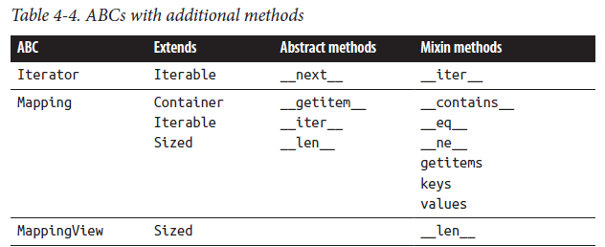

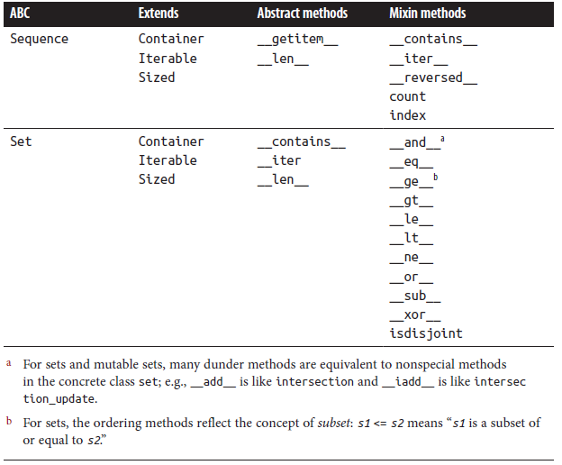

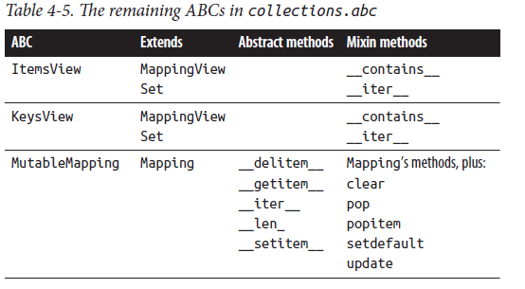

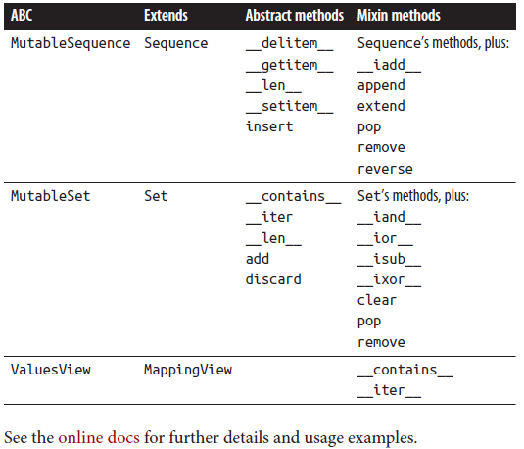

See the online docs for further details and usage examples.

ABCs in the numbers module

numbers supplies a hierarchy (also known as a tower) of ABCs representing various kinds of numbers. Table 4-6 lists the ABCs in the numbers module.

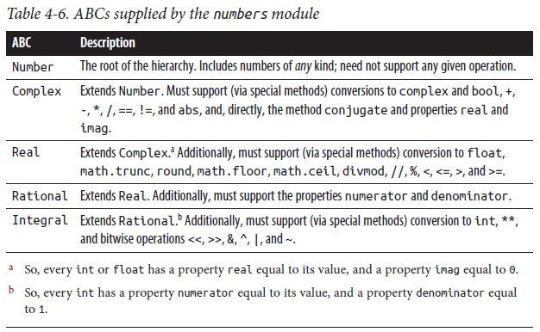

Special Methods for Numeric Objects

An instance may support numeric operations by means of many special methods. Some classes that are not numbers also support some of the special methods in Table 4-7 in order to overload operators such as + and *. In particular, sequences

should have special methods __add__, __mul__, __radd__, and __rmul__, as mentioned in “Sequences” on page 43. When one of the binary methods (such as __add__, __sub__, etc.) is called with an operand of an unsupported type for that method, the method should return the built-in singleton NotImplemented.

Table 4-7. Special methods for numeric objects

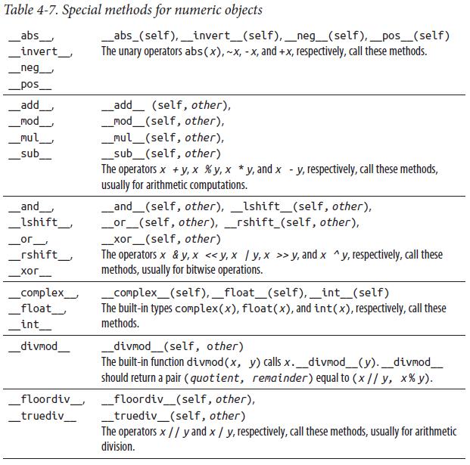

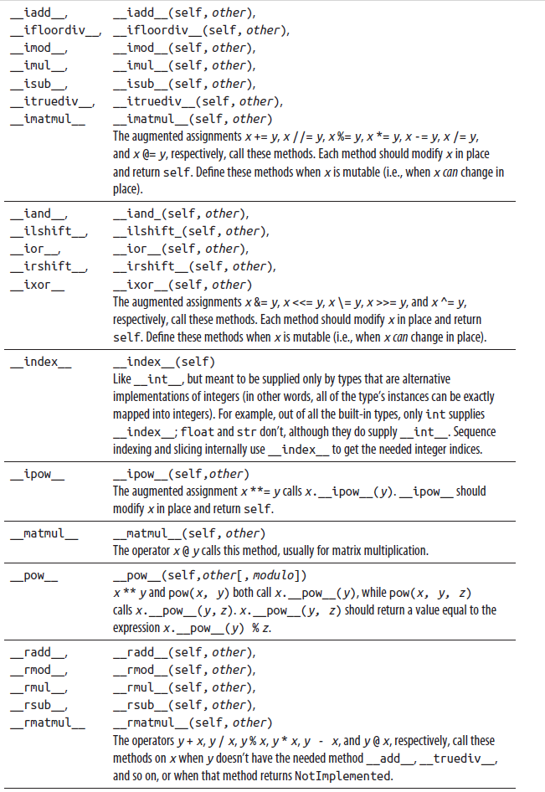

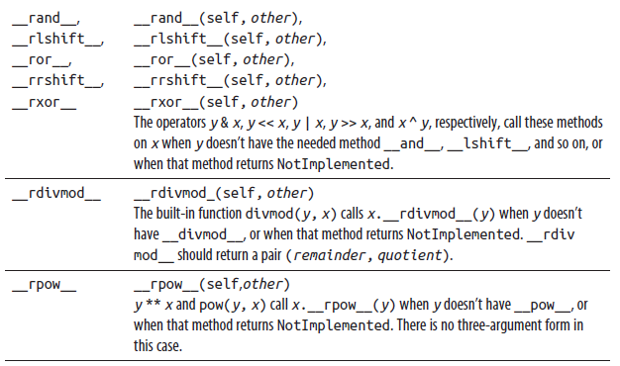

### Decorators

In Python, you often use higher-order functions: callables that accept a function as an argument and return a function as their result. For example, descriptor types such as staticmethod and classmethod, covered in “Class-Level Methods” on page

135, can be used, within class bodies, as follows:

def f(cls, ...):

# ...definition of f snipped...

f = classmethod(f)

However, having the call to classmethod textually after the def statement hurts code readability: while reading f’s definition, the reader of the code is not yet aware that f is going to become a class method rather than an instance method. The code is more readable if the mention of classmethod comes before the def. For this purpose, use the syntax form known as decoration:

@classmethod

def f(cls, ...):

# ...definition of f snipped...

The decorator, here @classmethod, must be immediately followed by a def statement and means that f = classmethod(f) executes right after the def statement (for whatever name f the def defines). More generally, @expression evaluates the expression (which must be a name, possibly qualified, or a call) and binds the result to an internal temporary name (say, __aux); any decorator must be immediately followed by a def (or class) statement, and means that f = __aux(f) executes right after the def or class statement (for whatever name f the def or class defines). The object bound to __aux is known as a decorator, and it’s said to decorate function or class f.

Decorators are a handy shorthand for some higher-order functions. You can apply decorators to any def or class statement, not just in class bodies. You may code custom decorators, which are just higher-order functions accepting a function or class object as an argument and returning a function or class object as the result. For example, here is a simple example decorator that does not modify the function it decorates, but rather prints the function’s docstring to standard output at function definition time:

def showdoc(f):

if f.__doc__:

print(f'{f.__name__}: {f.__doc__}')

else:

print(f'{f.__name__}: No docstring!')

return f

@showdoc

def f1():

"""a docstring""" # prints: f1: a docstring

@showdoc

def f2():

pass # prints: f2: No docstring!

The standard library module functools offers a handy decorator, wraps, to enhance decorators built by the common “wrapping” idiom:

import functools

def announce(f):

@functools.wraps(f)

def wrap(*a, **k):

print(f'Calling {f.__name__}')

return f(*a, **k)

return wrap

Decorating a function f with @announce causes a line announcing the call to be printed before each call to f. Thanks to the functools.wraps(f) decorator, the wrapper adopts the name and docstring of the wrappee: this is useful, for example, when calling the built-in help on such a decorated function.

## Metaclasses

Any object, even a class object, has a type. In Python, types and classes are also firstclass objects. The type of a class object is also known as the class’s metaclass.15 An object’s behavior is mostly determined by the type of the object. This also holds for

classes: a class’s behavior is mostly determined by the class’s metaclass. Metaclasses are an advanced subject, and you may want to skip the rest of this section. However, fully grasping metaclasses can lead you to a deeper understanding of Python; very occasionally, it can be useful to define your own custom metaclasses.

Alternatives to Custom Metaclasses for Simple Class Customization While a custom metaclass lets you tweak classes’ behaviors in pretty much any way you want, it’s often possible to achieve some customizations more simply than by

coding a custom metaclass.

When a class C has or inherits a class method __init_subclass__, Python calls that method whenever you subclass C, passing the newly built subclass as the only positional argument. __init_subclass__ can also have named parameters, in which case Python passes corresponding named arguments found in the class statement that performs the subclassing. As a purely illustrative example:

>>> class C:

... def __init_subclass__(cls, foo=None, **kw):

... print(cls, kw)

... cls.say_foo = staticmethod(lambda: f'*{foo}*')

... super().__init_subclass__(**kw)

...

>>> class D(C, foo='bar'):

... pass

...

<class '__main__.D'> {}

>>> D.say_foo()

'*bar*'

The code in __init_subclass__ can alter cls in any applicable, post-class-creation way; essentially, it works like a class decorator that Python automatically applies to any subclass of C.

Another special method used for customization is __set_name__, which lets you ensure that instances of descriptors added as class attributes know what class you’re adding them to, and under which names. At the end of the class statement that

adds ca to class C with name n, when the type of ca has the method __set_name__, Python calls ca.__set_name__(C, n). For example:

>>> class Attrib:

... def __set_name__(self, cls, name):

... print(f'Attribute {name!r} added to {cls}')

...

>>> class AClass:

... some_name = Attrib()

...

Attribute 'some_name' added to <class '__main__.AClass'>

>>>

How Python Determines a Class’s Metaclass

The class statement accepts optional named arguments (after the bases, if any). The most important named argument is metaclass, which, if present, identifies the new class’s metaclass. Other named arguments are allowed only if a non-type metaclass is present, in which case they are passed on to the optional __prepare__ method of the metaclass (it’s entirely up to the __prepare__ method to make use of such named arguments). ( Or when a base class has __init_subclass__, in which case the named arguments are passed to that method, as covered in “Alternatives to Custom Metaclasses for Simple Class Customization” on page 159. ) When the named argument metaclass is absent, Python determines the metaclass by inheritance; for classes with no explicitly specified bases, the metaclass defaults to type.

Python calls the __prepare__ method, if present, as soon as it determines the metaclass, as follows:

class M:

def __prepare__(classname, *classbases, **kwargs):

return {}

# ...rest of M snipped...

class X(onebase, another, metaclass=M, foo='bar'):

# ...body of X snipped...

Here, the call is equivalent to M.__prepare__('X', onebase, another, foo='bar'). __prepare__, if present, must return a mapping (usually just a dictionary), which Python uses as the d mapping in which it executes the class body. If __prepare__ is

absent, Python uses a new, initially empty dict as d.

How a Metaclass Creates a Class

Having determined the metaclass M, Python calls M with three arguments: the class name (a str), the tuple of base classes t, and the dictionary (or other mapping resulting from __prepare__) d in which the class body just finished executing. ( This is similar to calling type with three arguments, as described in “Dynamic class definition using the type built-in function” on page 133.) The call returns the class object C, which Python then binds to the class name, completing the execution of the class statement. Note that this is in fact an instantiation of type M, so the call to M executes M.__init__(C, namestring, t, d), where C is the return value of M.__new__(M, namestring, t, d), just as in any other instantiation.

After Python creates the class object C, the relationship between class C and its type (type(C), normally M) is the same as that between any object and its type. For example, when you call the class object C (to create an instance of C), M.__call__ executes, with class object C as the first argument.

Note the benefit, in this context, of the approach described in “Per Instance Methods” on page 140, whereby special methods are looked up only on the class, not on the instance. Calling C to instantiate it must execute the metaclass’s M.__call__, hether or not C has a per instance attribute (method) __call__ (i.e., independently of whether instances of C are or aren’t callable). This way, the Python object model avoids having to make the relationship between a class and its metaclass an ad hoc special case. Avoiding ad hoc special cases is a key to Python’s power: Python has few, simple, general rules, and applies them consistently. Defining and using your own metaclasses It’s easy to define custom metaclasses: inherit from type and override some of its methods. You can also perform most of the tasks for which you might consider creating a metaclass with __new__, __init__, __getattribute__, and so on, without involving metaclasses. However, a custom metaclass can be faster, since special

processing is done only at class creation time, which is a rare operation. A custom metaclass lets you define a whole category of classes in a framework that magically acquire whatever interesting behavior you’ve coded, quite independently of what special methods the classes themselves may choose to define.

To alter a specific class in an explicit way, a good alternative is often to use a class decorator, as mentioned in “Decorators” on page 157. However, decorators are not inherited, so the decorator must be explicitly applied to each class of interest. ( __init_subclass__, covered in “Alternatives to Custom Metaclasses for Simple Class Customization” on page 159, works much like an “inherited decorator,” so it’s often an alternative to a custom metaclass ) Metaclasses, on the other hand, are inherited; in fact, when you define a custom metaclass M, it’s usual to also define an otherwise empty class C with metaclass M, so that other classes requiring M can just inherit from C.

Some behavior of class objects can be customized only in metaclasses. The following example shows how to use a metaclass to change the string format of class objects:

class MyMeta(type):

def __str__(cls):

return f'Beautiful class {cls.__name__!r}'

class MyClass(metaclass=MyMeta):

pass

x = MyClass()

print(type(x)) # prints: Beautiful class 'MyClass'

A substantial custom metaclass example

Suppose that, programming in Python, we miss C’s struct type: an object that is just a bunch of data attributes, in order, with fixed names (data classes, covered in the following section, fully address this requirement, which makes this example a purely illustrative one). Python lets us easily define a generic Bunch class that is similar, apart from the fixed order and names:

class Bunch:

def __init__(self, **fields):

self.__dict__ = fields

p = Bunch(x=2.3, y=4.5)

print(p) # prints: <_main__.Bunch object at 0x00AE8B10>

A custom metaclass can exploit the fact that attribute names are fixed at class creation time. The code shown in Example 4-1 defines a metaclass, MetaBunch, and a class, Bunch, to let us write code like:

class Point(Bunch):

"""A Point has x and y coordinates, defaulting to 0.0,

and a color, defaulting to 'gray'-and nothing more,

except what Python and the metaclass conspire to add,

such as __init__ and __repr__.

"""

x = 0.0

y = 0.0

color = 'gray'

# example uses of class Point

q = Point()

print(q) # prints: Point()

p = Point(x=1.2, y=3.4)

print(p) # prints: Point(x=1.2, y=3.4)

In this code, the print calls emit readable string representations of our Point instances. Point instances are quite memory lean, and their performance is basically the same as for instances of the simple class Bunch in the previous example (there is no extra overhead due to implicit calls to special methods). Example 4-1 is quite substantial, and following all its details requires a grasp of aspects of Python discussed later in this book, such as strings (covered in Chapter 9) and module warnings (covered in “The warnings Module” on page 538). The identifier mcl used in Example 4-1 stands for “metaclass,” clearer in this special advanced case than the habitual case of cls standing for “class.”

Example 4-1. The MetaBunch metaclass

import warnings

class MetaBunch(type):

"""

Metaclass for new and improved "Bunch": implicitly defines

__slots__, __init__, and __repr__ from variables bound in

class scope.

A class statement for an instance of MetaBunch (i.e., for a class whose metaclass is MetaBunch) must define only class-scope data attributes (and possibly special methods, but NOT __init__ and __repr__). MetaBunch removes the data attributes from class scope, snuggles them instead as items in

a class-scope dict named __dflts__, and puts in the class a

__slots__ with those attributes' names, an __init__ that takes

as optional named arguments each of them (using the values in

__dflts__ as defaults for missing ones), and a __repr__ that

shows the repr of each attribute that differs from its default

value (the output of __repr__ can be passed to __eval__ to make

an equal instance, as per usual convention in the matter, if

each non-default-valued attribute respects that convention too).

The order of data attributes remains the same as in the class body.

"""

def __new__(mcl, classname, bases, classdict):

"""Everything needs to be done in __new__, since

type.__new__ is where __slots__ are taken into account.

"""

# Define as local functions the __init__ and __repr__ that

# we'll use in the new class

def __init__(self, **kw):

"""__init__ is simple: first, set attributes without

explicit values to their defaults; then, set those

explicitly passed in kw.

"""

for k in self.__dflts__:

if not k in kw:

setattr(self, k, self.__dflts__[k])

for k in kw:

setattr(self, k, kw[k])

def __repr__(self):

"""__repr__ is minimal: shows only attributes that

differ from default values, for compactness.

"""

rep = [f'{k}={getattr(self, k)!r}'

for k in self.__dflts__

if getattr(self, k) != self.__dflts__[k]

]

return f'{classname}({', '.join(rep)})'

# Build the newdict that we'll use as class dict for the

# new class

newdict = {'__slots__': [], '__dflts__': {},

'__init__': __init__, '__repr__' :__repr__,}

for k in classdict:

if k.startswith('__') and k.endswith('__'):

# Dunder methods: copy to newdict, or warn

# about conflicts

if k in newdict:

warnings.warn(f'Cannot set attr {k!r}'

f' in bunch-class {classname!r}')

else:

newdict[k] = classdict[k]

else:

# Class variables: store name in __slots__, and

# name and value as an item in __dflts__

newdict['__slots__'].append(k)

newdict['__dflts__'][k] = classdict[k]

# Finally, delegate the rest of the work to type.__new__

return super().__new__(mcl, classname, bases, newdict)

class Bunch(metaclass=MetaBunch):

"""For convenience: inheriting from Bunch can be used to get

the new metaclass (same as defining metaclass= yourself).

"""

Pass

Data Classes

As the previous Bunch class exemplified, a class whose instances are just a bunch of named data items is a great convenience. Python’s standard library covers that with the dataclasses module.

The main feature of the dataclasses module you’ll be using is the dataclass function: a decorator you apply to any class whose instances you want to be just such a bunch of named data items. As a typical example, consider the following code:

import dataclasses

@dataclasses.dataclass

class Point:

x: float

y: float

Now you can call, say, pt = Point(0.5, 0.5) and get a variable with attributes pt.x and pt.y, each equal to 0.5. By default, the dataclass decorator has imbued the class Point with an __init__ method accepting initial floating-point values for attributes x and y, and a __repr__ method ready to appropriately display any instance of the class:

>>> pt

Point(x=0.5, y=0.5)

The dataclass function takes many optional named parameters to let you tweak details of the class it decorates. The parameters you may be explicitly using most often are listed in Table 4-8.

Table 4-8. Commonly used dataclass function parameters

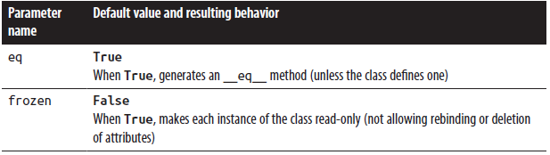

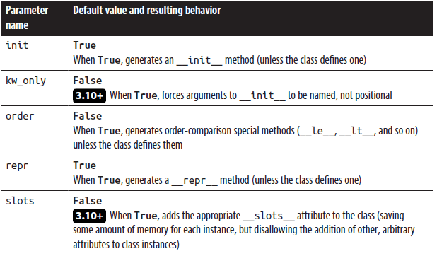

The decorator also adds to the class a __hash__ method (allowing instances to be keys in a dictionary and members of a set) when that is safe (typically, when you set frozen to True). You may force the addition of __hash__ even when that’s not necessarily safe, but we earnestly recommend that you don’t; if you insist, check the online docs for details on how to do so.

If you need to tweak each instance of a dataclass after the automatically generated __init__ method has done the core work of assigning each instance attribute, define a method called __post_init__, and the decorator will ensure it is called right after __init__ is done.

Say you wish to add an attribute to Point to capture the time when the point was created. This could be added as an attribute assigned in __post_init__. Add the attribute create_time to the members defined for Point, as type float with a default value of 0, and then add an implementation for __post_init__:

def __post_init__(self):

self.create_time = time.time()

Now if you create the variable pt = Point(0.5, 0.5), printing it out will display the creation timestamp, similar to the following:

>>> pt

Point(x=0.5, y=0.5, create_time=1645122864.3553088)

Like regular classes, dataclasses can also support additional methods and properties, such as this method that computes the distance between two Points and this property that returns the distance from a Point at the origin:

def distance_from(self, other):

dx, dy = self.x - other.x, self.y - other.y

return math.hypot(dx, dy)

@property

def distance_from_origin(self):

return self.distance_from(Point(0, 0))

For example:

>>> pt.distance_from(Point(-1, -1))

2.1213203435596424

>>> pt.distance_from_origin

0.7071067811865476

The dataclasses module also supplies asdict and astuple functions, each taking a dataclass instance as the first argument and returning, respectively, a dict and a tuple with the class’s fields. Furthermore, the module supplies a field function that you may use to customize the treatment of some of a dataclass’s fields (i.e., instance attributes), and several other specialized functions and classes needed only for very advanced, esoteric purposes; to learn all about them, check out the online docs.

Enumerated Types (Enums)

When programming, you’ll often want to create a set of related values that catalog or enumerate the possible values for a particular property or program setting, ( Don’t confuse this concept with the unrelated enumerate built-in function, covered in Chapter 8, which generates (number, item) pairs from an iterable ) whatever they might be: terminal colors, logging levels, process states, playing card suits, clothing sizes, or just about anything else you can think of. An enumerated type (enum) is a type that defines a group of such values, with symbolic names that you can use as typed global constants. Python provides the Enum class and related subclasses in the enum module for defining enums.

Defining an enum gives your code a set of symbolic constants that represent the values in the enumeration. In the absence of enums, constants might be defined as ints, as in this code:

# colors

RED = 1

GREEN = 2

BLUE = 3

# sizes

XS = 1

S = 2

M = 3

L = 4

XL = 5

However, in this design, there is no mechanism to warn against nonsense expressions like RED > XL or L * BLUE, since they are all just ints. There is also no logical grouping of the colors or sizes.

Instead, you can use an Enum subclass to define these values:

from enum import Enum, auto

class Color(Enum):

RED = 1

GREEN = 2

BLUE = 3

class Size(Enum):

XS = auto()

S = auto()

M = auto()

L = auto()

XL = auto()

Now, code like Color.RED > Size.S stands out visually as incorrect, and at runtime raises a Python TypeError. Using auto() automatically assigns incrementing int values beginning with 1 (in most cases, the actual values assigned to enum members

are not meaningful).

Calling Enum Creates a Class, Not an Instance

Surprisingly, when you call enum.Enum(), it doesn’t return a newly built instance, but rather a newly built subclass. So, the

preceding snippet is equivalent to: from enum import Enum

Color = Enum('Color', ('RED', 'GREEN', 'BLUE'))

Size = Enum('Size', 'XS S M L XL')

When you call Enum (rather than explicitly subclassing it in a class statement), the first argument is the name of the subclass

you’re building; the second argument gives all the names of that subclass’s members, either as a sequence of strings or as a

single whitespace-separated (or comma-separated) string.

We recommend that you define Enum subclasses using class inheritance syntax, instead of this abbreviated form. The class form is more visually explicit, so it is easier to see if a member is missing, misspelled, or added later.

The values within an enum are called its members. It is conventional to use all uppercase characters to name enum members, treating them much as though they were manifest constants. Typical uses of the members of an enum are assignment and identity checking:

while process_state is ProcessState.RUNNING:

# running process code goes here

if processing_completed():

process_state = ProcessState.IDLE

You can obtain all members of an Enum by iterating over the Enum class itself, or from the class’s __members__ attribute. Enum members are all global singletons, so comparison with is and is not is preferred over == or !=. The enum module contains several classes ( enum’s specialized metaclass behaves so differently from the usual type metaclass that it’s worth pointing out all the differences between enum.Enum and ordinary classes. You can read about this in the “How are Enums different?” section of Python’s online documentation ) to support different forms of enums, listed in Table 4-9.

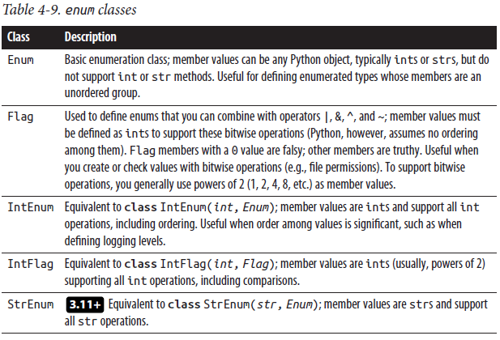

The enum module also defines some support functions, listed in Table 4-10.

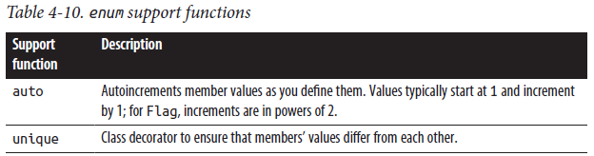

The following example shows how to define a Flag subclass to work with the file permissions in the st_mode attribute returned from calling os.stat or Path.stat (for a description of the stat functions, see Chapter 11):

import enum

import stat

class Permission(enum.Flag):

EXEC_OTH = stat.S_IXOTH

WRITE_OTH = stat.S_IWOTH

READ_OTH = stat.S_IROTH

EXEC_GRP = stat.S_IXGRP

WRITE_GRP = stat.S_IWGRP

READ_GRP = stat.S_IRGRP

EXEC_USR = stat.S_IXUSR

WRITE_USR = stat.S_IWUSR

READ_USR = stat.S_IRUSR

@classmethod

def from_stat(cls, stat_result):

return cls(stat_result.st_mode & 0o777)

from pathlib import Path

cur_dir = Path.cwd()

dir_perm = Permission.from_stat(cur_dir.stat())

if dir_perm & Permission.READ_OTH:

print(f'{cur_dir} is readable by users outside the owner group')

# the following raises TypeError: Flag enums do not support order

# comparisons

print(Permission.READ_USR > Permission.READ_OTH)

Using enums in place of arbitrary ints or strs can add readability and type integrity to your code. You can find more details on the classes and methods of the enum module in the Python docs.

## Type Annotations

Annotating your Python code with type information is an optional step which can be very helpful during development and maintenance of a large project or a library. Static type checkers and lint tools help identify and locate data type mismatches in function arguments and return values. IDEs can use these type annotations (also called type hints) to improve autocompletion and to provide pop-up documentation. Third-party packages and frameworks can use type annotations to tailor runtime behavior, or to autogenerate code based on type annotations for methods and variables.

Type annotations and checking in Python continue to evolve, and touch on many complicated issues. This chapter covers some of the most common use cases for type annotations; you can find more comprehensive material in the resources listed at the end of the chapter.

Type Annotation Support Varies by Python Version Python’s features supporting type annotations have evolved from version to version, with some significant additions and deletions. The rest of this chapter will describe the type annotation support in the most recent versions of Python (3.10 and later), with notes to indicate features that might be present or absent in other versions.

History

Python is, fundamentally, a dynamically typed language. This lets you rapidly develop code by naming and using variables without having to declare them. Dynamic typing allows for flexible coding idioms, generic containers, and polymorphic data handling without requiring explicit definition of interface types or class hierarchies. The downside is that the language offers no help during development in flagging variables of incompatible types being passed to or returned from functions. In place of the development-time compile step that some languages utilize to detect and report data type issues, Python relies on developers to maintain comprehensive unit tests, especially (though far from exclusively! ( Strong, extensive unit tests will also guard against many business logic problems that no amount of type checking would ever catch for you—so, type hints are not to be used instead of unit tests, but in addition to them )) to uncover data type errors by re-creating the runtime environment in a series of test cases.

**Type Annotations Are Not Enforced**

Type annotations are not enforced at runtime. Python does not perform any type validation or data conversion based on them; the executable Python code is still responsible for using variables and function arguments properly. However, type annotations must be syntactically correct. A late-imported or dynamically imported module containing an invalid type annotation raises a SyntaxError exception in your running Python program, just like any invalid Python statement.

Historically, the absence of any kind of type checking was often seen as a shortcoming of Python, with some programmers citing this as a reason for choosing other programming languages. However, the community wanted Python to maintain its runtime type freedom, so the logical approach was to add support for static type checks performed at development time by lint-like tools (described further in the following section) and IDEs. Some attempts were made at type checking based on parsing function signatures or docstrings. Guido van Rossum cited several cases on the Python Developers mailing list showing that type annotations could be helpful; for example, when maintaining large legacy codebases. With an annotation syntax, development tools could perform static type checks to highlight variable and function usages that conflict with the intended types.

The first official version of type annotations used specially formatted comments to indicate variable types and return codes, as defined in PEP 484, a provisional PEP for Python 3.5. ( The syntax for type annotation was introduced in Python 3.0, but only later were its semantics specified. ) Using comments allowed for rapid implementation of, and experimentation with, the new typing syntax, without having to modify the Python compiler itself. ( This approach was also compatible with Python 2.7 code, still in widespread use at the time. ) The third-party package mypy gained broad acceptance performing static type checking using these comments. With the adoption of PEP 526 in Python 3.6, type annotations were fully incorporated into the Python language itself, with a supporting typing module added to the standard library.

Type-Checking Utilities

As type annotations have become an established part of Python, type-checking utilities and IDE plug-ins have also become part of the Python ecosystem.

mypy

The standalone mypy utility continues to be a mainstay for static type checking, always up-to-date (give or take a Python version!) with evolving Python type annotation forms. mypy is also available as a plug-in for editors including Vim, Emacs, and SublimeText, and for the Atom, PyCharm, and VS Code IDEs. (PyCharm, VS Code, and Wing IDE also incorporate their own type-checking features separate from mypy.) The most common command for running mypy is simply mypy my_python_script.py.

You can find more detailed usage examples and command-line options in the mypy online documentation, as well as a cheat sheet that serves as a handy reference. Code examples later in this section will include example mypy error messages to illustrate the kinds of Python errors that can be caught using type checking.

Other Type Checkers

Other type checkers to consider using include:

MonkeyType

Instagram’s MonkeyType uses the sys.setprofile hook to detect types dynamically at runtime; like pytype (see below), it can also generate a .pyi (stub) file instead of, or in addition to, inserting type annotations in the Python code file itself.

pydantic

pydantic also works at runtime, but it does not generate stubs or insert type annotations; rather, its primary goal is to parse inputs and ensure that Python code receives clean data. As described in the online docs, it also allows you to extend its validation features for your own environment. See “FastAPI” on page 605 for a simple example.

Pylance

Pylance is a type checking module primarily meant to embed Pyright (see below) into VS Code.

Pyre

Facebook’s Pyre can also generate .pyi files. It currently does not run on Windows, unless you have the Windows Subsystem for Linux (WSL) installed.

Pyright

Pyright is Microsoft’s static type checking tool, available as a command-line utility and a VS Code extension.

pytype

pytype from Google is a static type checker that focuses on type inferencing (and offers advice even in the absence of type hints) in addition to type annotations. Type inferencing offers a powerful capability for detecting type errors even in code without annotations. pytype can also generate .pyi files and merge stub files back into .py sources (the most recent versions of mypy are following suit on this). Currently, pytype does not run on Windows unless you first install WSL.

The emergence of type-checking applications from multiple major software organizations is a testimonial to the widespread interest in the Python developer community in using type annotations.

### Type Annotation Syntax

A type annotation is specified in Python using the form:

identifier: type_specification

type_specification can be any Python expression, but usually involves one or more built-in types (for example, just mentioning a Python type is a perfectly valid expression) and/or attributes imported from the typing module (discussed in the following section). The typical form is:

type_specifier[type_parameter, ...]

Here are some examples of type expressions used as type annotations for a variable:

import typing

# an int

count: int

# a list of ints, with a default value

counts: list[int] = []

# a dict with str keys, values are tuples containing 2 ints and a str

employee_data: dict[str, tuple[int, int, str]]

# a callable taking a single str or bytes argument and returning a bool

str_predicate_function: typing.Callable[[str | bytes], bool]

# a dict with str keys, whose values are functions that take and return

# an int

str_function_map: dict[str, typing.Callable[[int], int]] = {

'square': lambda x: x * x,

'cube': lambda x: x * x * x,

}

Note that lambdas do not accept type annotations.

Typing Syntax Changes in Python 3.9 and 3.10

One of the most significant changes in type annotations during the span of Python versions covered in this book was the support added in Python 3.9 for using built-in Python types, as shown in these examples.

-3.9 Prior to Python 3.9, these annotations required the use of type names imported from the typing module, such as Dict, List, Tuple, etc.

3.10+ Python 3.10 added support for using | to indicate alternative types, as a more readable, concise alternative to the Union[atype, btype, ...] notation. The | operator can also be used to replace Optional[atype] with atype | None. For instance, the previous str_predicate_function definition would take one of the following forms, depending on your version of Python:

# prior to 3.10, specifying alternative types

# requires use of the Union type

from typing import Callable, Union

str_predicate_function: Callable[Union[str, bytes], bool]

# prior to 3.9, built-ins such as list, tuple, dict,

# set, etc. required types imported from the typing

# module

from typing import Dict, Tuple, Callable, Union

employee_data: Dict[str, Tuple[int, int, str]]

str_predicate_function: Callable[Union[str, bytes], bool]

To annotate a function with a return type, use the form:

def identifier(argument, ...) -> type_specification :

where each argument takes the form:

identifier[: type_specification[ = default_value]]

Here’s an example of an annotated function:

def pad(a: list[str], min_len: int = 1, padstr: str = ' ') -> list[str]:

"""Given a list of strings and a minimum length, return a copy of

the list extended with "padding" strings to be at least the

minimum length.

"""

return a + ([padstr] * (min_len - len(a)))

Note that when an annotated parameter has a default value, PEP 8 recommends using spaces around the equals sign.

**Forward-Referencing Types That Are Not Yet Fully Defined**

At times, a function or variable definition needs to reference a type that has not yet been defined. This is quite common in class methods, or methods that must define arguments or return values of the type of the current class. Those function signatures are parsed at compile time, and at that point the type is not yet defined. For example, this classmethod fails to compile:

class A:

@classmethod

def factory_method(cls) -> A:

# ... method body goes here ...

Since class A has not yet been defined when Python compiles factory_method, the code raises NameError.

The problem can be resolved by enclosing the return type A in quotes:

class A:

@classmethod

def factory_method(cls) -> 'A':

# ... method body goes here ...

A future version of Python may defer the evaluation of type annotations until runtime, making the enclosing quotes unnecessary (Python’s Steering Committee is evaluating various possibilities). You can preview this behavior using from __future__ import annotations.

### The typing Module

The typing module supports type hints. It contains definitions that are useful when creating type annotations, including:

• Classes and functions for defining types

• Classes and functions for modifying type expressions

• Abstract base classes (ABCs)

• Protocols

• Utilities and decorators

• Classes for defining custom types

#### Types

The initial implementations of the typing module included definitions of types corresponding to Python built-in containers and other types, as well as types from standard library modules. Many of these types have since been deprecated (see below), but some are still useful, since they do not correspond directly to any Python built-in type. Table 5-1 lists the typing types still useful in Python 3.9 and later.

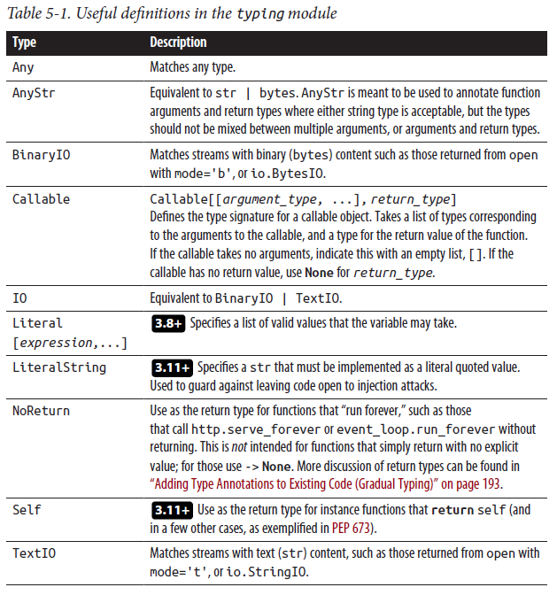

-3.9 Prior to 3.9, the definitions in the typing module were used to create types representing built-in types, such as List[int] for a list of ints. From 3.9 onward, these names are deprecated, as their corresponding built-in or standard library types now support the [] syntax: a list of ints is now simply typed using list[int]. Table 5-2 lists the definitions from the typing module that were necessary prior to Python 3.9 for type annotations using built-in types.

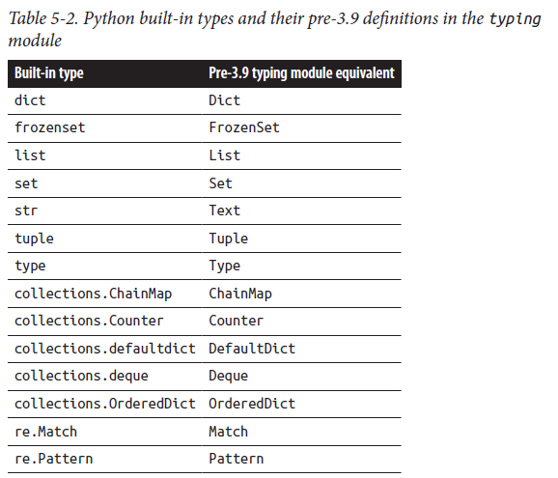

#### Type Expression Parameters

Some types defined in the typing module modify other type expressions. The types listed in Table 5-3 provide additional typing information or constraints for the modified types in type_expression.

**Table 5-3. Type expression parameters**

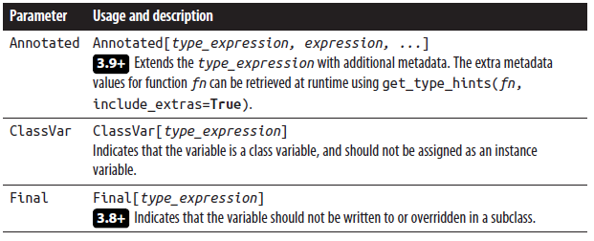

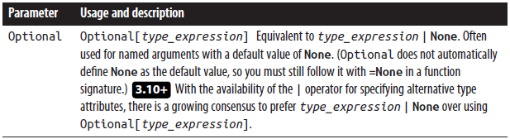

#### Abstract Base Classes

Just as for built-in types, the initial implementations of the typing module included definitions of types corresponding to abstract base classes in the collections.abc module. Many of these types have since been deprecated (see below), but two definitions have been retained as aliases to ABCs in collections.abc (see Table 5-4).

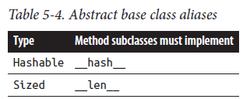

-3.9 Prior to Python 3.9, the following definitions in the typing module represented abstract base classes defined in the collections.abc module, such as Sequence[int] for a sequence of ints. From 3.9 onward, these names in the typing module are deprecated, as their corresponding types in collections.abc now support the [] syntax:

AbstractSet Container Mapping

AsyncContextManager ContextManager MappingView

AsyncGenerator Coroutine MutableMapping

AsyncIterable Generator MutableSequence

AsyncIterator ItemsView MutableSet

Awaitable Iterable Reversible

ByteString Iterator Sequence

Collection KeysView ValuesView

#### Protocols

The typing module defines several protocols, which are similar to what some other languages call “interfaces.” Protocols are abstract base classes intended to concisely express constraints on a type, ensuring it contains certain methods. Each protocol

currently defined in the typing module relates to a single special method, and its name starts with Supports followed by the name of the method (however, other libraries, such as those defined in typeshed, need not follow the same constraints). Protocols can be used as minimal abstract classes to determine a class’s support for that protocol’s capabilities: all that a class needs to do to comply with a protocol is to implement the protocol’s special method(s).

Table 5-5 lists the protocols defined in the typing module.

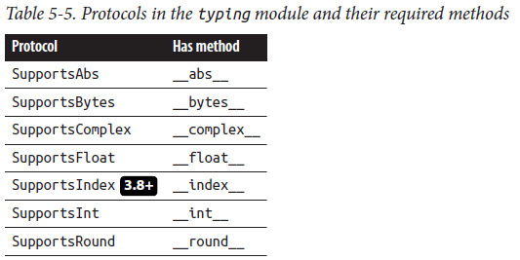

A class does not have to explicitly inherit from a protocol in order to satisfy issubclass(cls, protocol_type), or for its instances to satisfy isinstance(obj, protocol_type). The class simply has to implement the method(s) defined in the protocol. Imagine, for example, a class implementing Roman numerals:

class RomanNumeral:

"""Class representing some Roman numerals and their int

values.

"""

int_values = {'I': 1, 'II': 2, 'III': 3, 'IV': 4, 'V': 5}

def __init__(self, label: str):

self.label = label

def __int__(self) -> int:

return RomanNumeral.int_values[self.label]

To create an instance of this class (to, say, represent a sequel in a movie title) and get its value, you could use the following code:

>>> movie_sequel = RomanNumeral('II')

>>> print(int(movie_sequel))

RomanNumeral satisfies issubclass, and isinstance checks with SupportsInt because it implements __int__, even though it does not inherit explicitly from the protocol class SupportsInt: ( And SupportsInt uses the runtime_checkable decorator )

>>> issubclass(RomanNumeral, typing.SupportsInt)

True

>>> isinstance(movie_sequel, typing.SupportsInt)

True

#### Utilities and Decorators

Table 5-6 lists commonly used functions and decorators defined in the typing module; it’s followed by a few examples.

Table 5-6. Commonly used functions and decorators defined in the typing module

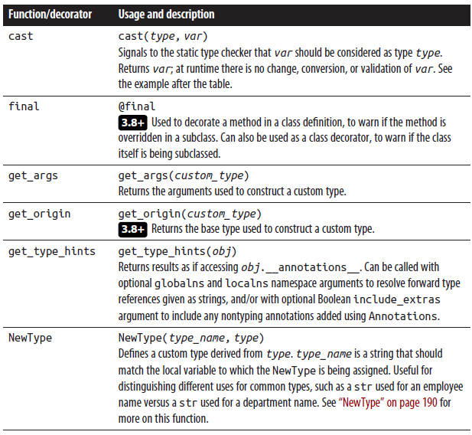

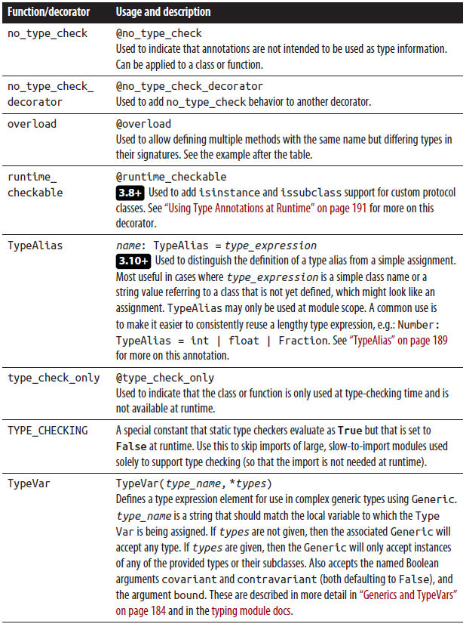

Use overload at type-checking time to flag named arguments that must be used in particular combinations. In this case, fn must be called with either a str key and int value pair, or with a single bool value:

@typing.overload

def fn(*, key: str, value: int):

...

@typing.overload

def fn(*, strict: bool):

...

def fn(**kwargs):

# implementation goes here, including handling of differing

# named arguments

pass

# valid calls

fn(key='abc', value=100)

fn(strict=True)

# invalid calls

fn(1)

fn('abc')

fn('abc', 100)

fn(key='abc')

fn(True)

fn(strict=True, value=100)

Note that the overload decorator is used purely for static type checking. To actually dispatch to different methods based on a parameter type at runtime, use functools.singledispatch.

Use the cast function to force a type checker to treat a variable as being of a particular type, within the scope of the cast:

def func(x: list[int] | list[str]):

try:

return sum(x)

except TypeError:

x = cast(list[str], x)

return ','.join(x)

**Use cast with Caution**

cast is a way of overriding any inferences or prior annotations that may be present at a particular place in your code. It may hide actual type errors in your code, rendering the type-checking pass incomplete or inaccurate. The func in the preceding example raises no mypy warnings itself, but fails at runtime if passed a list of mixed ints and strs.

#### Defining Custom Types

Just as Python’s class syntax permits the creation of new runtime types and behavior, the typing module constructs discussed in this section enable the creation of specialized type expressions for advanced type checking. The typing module includes three classes from which your classes can inherit to get type definitions and other default features, listed in Table 5-7.

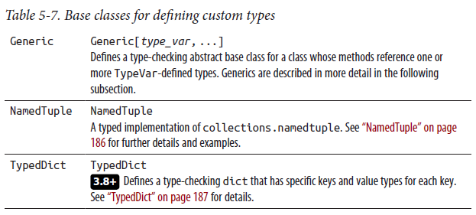

Generics and TypeVars

Generics are types that define a template for classes that can adapt the type annotations of their method signatures based on one or more type parameters. For instance, dict is a generic that takes two type parameters: the type for the dictionary keys and the type for the dictionary values. Here is how dict might be used to define a dictionary that maps color names to RGB triples:

color_lookup: dict[str, tuple[int, int, int]] = {}

The variable color_lookup will support statements like:

color_lookup['red'] = (255, 0, 0)

color_lookup['red'][2]

However, the following statements generate mypy errors, due to a mismatched key or value type:

color_lookup[0]

error: Invalid index type "int" for "dict[str, tuple[int, int, int]]";

expected type "str"

color_lookup['red'] = (255, 0, 0, 0)

error: Incompatible types in assignment (expression has type

"tuple[int, int, int, int]", target has type "tuple[int, int, int]")

Generic typing permits the definition of behavior in a class that is independent of the specific types of the objects that class works with. Generics are often used for defining container types, such as dict, list, set, etc. By defining a generic type, we avoid the necessity of exhaustively defining types for DictOfStrInt, DictO fIntEmployee, and so on. Instead, a generic dict is defined as dict[KT, VT], where KT and VT are placeholders for the dict’s key type and value type, and the specific types for any particular dict can be defined when the dict is instantiated. As an example, let’s define a hypothetical generic class: an accumulator that can be updated with values, but which also supports an undo method. Since the accumulator is a generic container, we declare a TypeVar to represent the type of the contained objects:

import typing

T = typing.TypeVar('T')

The Accumulator class is defined as a subclass of Generic, with T as a type parameter. Here is the class declaration and its __init__ method, which creates a contained list, initially empty, of objects of type T:

class Accumulator(typing.Generic[T]):

def __init__(self):

self._contents: list[T] = []

To add the update and undo methods, we define arguments that reference the contained objects as being of type T:

def update(self, *args: T) -> None:

self._contents.extend(args)

def undo(self) -> None:

# remove last value added

if self._contents:

self._contents.pop()

Lastly, we add __len__ and __iter__ methods so that Accumulator instances can be iterated over:

def __len__(self) -> int:

return len(self._contents)

def __iter__(self) -> typing.Iterator[T]:

return iter(self._contents)

Now this class can be used to write code using Accumulator[int] to collect a number of int values:

acc: Accumulator[int] = Accumulator()

acc.update(1, 2, 3)

print(sum(acc)) # prints 6

acc.undo()

print(sum(acc)) # prints 3

Because acc is an Accumulator containing ints, the following statements generate mypy error messages:

acc.update('A')

error: Argument 1 to "update" of "Accumulator" has incompatible type

"str"; expected "int"

print(''.join(acc))

error: Argument 1 to "join" of "str" has incompatible type

"Accumulator[int]"; expected "Iterable[str]"

Restricting TypeVar to specific types

Nowhere in our Accumulator class do we ever invoke methods directly on the contained T objects themselves. For this example, the T TypeVar is purely untyped, so type checkers like mypy cannot infer the presence of any attributes or methods of the T objects. If the generic needs to access attributes of the T objects it contains, then T should be defined using a modified form of TypeVar.

Here are some examples of TypeVar definitions:

# T must be one of the types listed (int, float, complex, or str)

T = typing.TypeVar('T', int, float, complex, str)

# T must be the class MyClass or a subclass of the class MyClass

T = typing.TypeVar('T', bound=MyClass)

# T must implement __len__ to be a valid subclass of the Sized protocol

T = typing.TypeVar('T', bound=collections.abc.Sized)

These forms of T allow a generic defined on T to use methods from these types in T’s TypeVar definition.

NamedTuple

The collections.namedtuple function simplifies the definition of class-like tuple types that support named access to the tuple elements. NamedTuple provides a typed version of this feature, using a class with attributes-style syntax similar to dataclasses (covered in “Data Classes” on page 164). Here’s a NamedTuple with four elements, with names, types, and optional default values:

class HouseListingTuple(typing.NamedTuple):

address: str

list_price: int

square_footage: int = 0

condition: str = 'Good'

NamedTuple classes generate a default constructor, accepting positional or named arguments for each named field:

listing1 = HouseListingTuple(

address='123 Main',

list_price=100_000,

square_footage=2400,

condition='Good',

)

print(listing1.address) # prints: 123 Main

print(type(listing1)) # prints: <class 'HouseListingTuple'>

Attempting to create a tuple with too few elements raises a runtime error:

listing2 = HouseListingTuple(

'123 Main',

)

# raises a runtime error: TypeError: HouseListingTuple.__new__()

# missing 1 required positional argument: 'list_price'

TypedDict

3.8+ Python dict variables are often difficult to decipher in legacy codebases, because dicts are used in two ways: as collections of key/value pairs (such as a mapping from user ID to username), and records mapping known field names to values. It is usually easy to see that a function argument is to be passed as a dict, but the actual keys and value types are dependent on the code that may call that function. Beyond simply defining that a dict may be a mapping of str values to int values, as in dict[str, int], a TypedDict defines the expected keys and the types of each corresponding value. The following example defines a TypedDict version of the previous house listing type (note that TypedDict definitions do not accept default value definitions):

class HouseListingDict(typing.TypedDict):

address: str

list_price: int

square_footage: int

condition: str

TypedDict classes generate a default constructor, accepting named arguments for each defined key:

listing1 = HouseListingDict(

address='123 Main',

list_price=100_000,

square_footage=2400,

condition='Good',

)

print(listing1['address']) # prints 123 Main

print(type(listing1)) # prints <class 'dict'>

listing2 = HouseListingDict(

address='124 Main',

list_price=110_000,

)

Unlike the NamedTuple example, listing2 will not raise a runtime error, simply creating a dict with just the given keys. However, mypy will flag listing2 as a type error with the message:

error: Missing keys ("square_footage", "condition") for TypedDict

"HouseListing"

To indicate to the type checker that some keys may be omitted (but to still validate those that are given), add total=False to the class declaration:

class HouseListing(typing.TypedDict, total=False):

# ...

3.11+ Individual fields can also use the Required or NotRequired type annotations to explicitly mark them as required or optional:

class HouseListing(typing.TypedDict):

address: typing.Required[str]

list_price: int

square_footage: typing.NotRequired[int]

condition: str

TypedDict can be used to define a generic type, too:

T = typing.TypeVar('T')

class Node(typing.TypedDict, typing.Generic[T]):

label: T

neighbors: list[T]

n = Node(label='Acme', neighbors=['anvil', 'magnet', 'bird seed'])

**Do Not Use the Legacy TypedDict(name, **fields) Format**

To support backporting to older versions of Python, the initial release of TypedDict also let you use a syntax similar to that

for namedtuple, such as:

HouseListing = TypedDict('HouseListing', address=str, list_price=int, square_footage=int,

condition=str)

or:

HouseListing = TypedDict('HouseListing', {'address': str, 'list_price': int,

'square_footage': int, 'condition': str})

These forms are deprecated in Python 3.11, and are planned to be removed in Python 3.13.

Note that TypedDict does not actually define a new type. Classes created by inheriting from TypedDict actually serve as dict factories, such that instances created from them are dicts. Reusing the previous code snippet defining the Node class, we can see this using the type built-in function:

n = Node(label='Acme', neighbors=['anvil', 'magnet', 'bird seed'])

print(type(n)) # prints: <class 'dict'>

print(type(n) is dict) # prints: True

There is no special runtime conversion or initialization when using TypedDict; the benefits of TypedDict are those of static type checking and self documentation, which naturally accrue from using type annotations.

**Which Should You Use, NamedTuple or TypedDict?**

The two data types appear similar in terms of their supported features, but there are significant differences that should help you determine which one to use. NamedTuples are immutable, so they can be used as dictionary keys or stored in sets, and are inherently safe to share across threads. As a NamedTuple object is a tuple, you can get its property values in order simply by iterating over it. However, to get the attribute names, you need to use the special __annotations__ attribute. Since classes created with TypedDict are actually dict factories, instances created from them are dicts, with all the behavior and attributes of dicts. They are mutable, so their values can be updated without creating a new container instance, and they support all the dict methods, such as keys, values, and items. They are also easily serialized using JSON or pickle. However, being mutable, they cannot be used as keys in another dict, nor can they be stored in a set.

TypedDicts are more lenient than NamedTuples about missing keys. When a key is omitted when constructing a TypedDict, there is no error (though you will get a type-check warning from the static type checker). On the other hand, if an attribute is omitted when constructing a NamedTuple, this will raise a runtime TypeError. In short, there is no across-the-board rule for when to use a NamedTuple versus a TypedDict. Consider these alternative behaviors and how they relate to your program and its use of these data objects when deciding between a NamedTuple and a TypedDict—and don’t forget the other, often preferable, alternative of using a dataclass (covered in “Data Classes” on page 164) instead!

TypeAlias

3.10+ Defining a simple type alias can be misinterpreted as assigning a class to a variable. For instance, here we define a type for record identifiers in a database:

Identifier = int

To clarify that this statement is intended to define a custom type name for the purposes of type checking, use TypeAlias:

Identifier: TypeAlias = int

TypeAlias is also useful when defining an alias for a type that is not yet defined, and so referenced as a string value:

# Python will treat this like a standard str assignment

TBDType = 'ClassNotDefinedYet'

# indicates that this is actually a forward reference to a class

TBDType: TypeAlias = 'ClassNotDefinedYet'

TypeAlias types may only be defined at module scope. Custom types defined using TypeAlias are interchangeable with the target type. Contrast TypeAlias (which does not create a new type, just gives a new name for an existing one) with NewType,

covered in the following section, which does create a new type.

NewType

NewType allows you to define application-specific subtypes, to avoid confusion that might result from using the same type for different variables. If your program uses str values for different types of data, for example, it is easy to accidentally interchange

values. Suppose you have a program that models employees in departments. The following type declaration is not sufficiently descriptive—which is the key and which is the value?

employee_department_map: dict[str, str] = {}

Defining types for employee and department IDs makes this declaration clearer:

EmpId = typing.NewType('EmpId', str)

DeptId = typing.NewType('DeptId', str)

employee_department_map: dict[EmpId, DeptId] = {}

These type definitions will also allow type checkers to flag this incorrect usage:

def transfer_employee(empid: EmpId, to_dept: DeptId):

# update department for employee

employee_department_map[to_dept] = empid

Running mypy reports these errors for the line employee_department_map[to_dept] = empid:

error: Invalid index type "DeptId" for "Dict[EmpId, DeptId]"; expected

type "EmpId"

error: Incompatible types in assignment (expression has type "EmpId",

target has type "DeptId")

Using NewType often requires you to use typing.cast too; for example, to create an EmpId, you need to cast a str to the EmpId type.

You can also use NewType to indicate the desired implementation type for an application-specific type. For instance, the basic US postal zip code is five numeric digits. It is common to see this implemented using int, which becomes problematic with zip codes that have a leading 0. To indicate that zip codes should be implemented using str, your code can define this type-checking type:

ZipCode = typing.NewType("ZipCode", str)

Annotating variables and function arguments using ZipCode will help flag incorrect uses of int for zip code values.

#### Using Type Annotations at Runtime

Function and class variable annotations can be introspected by accessing the function or class’s __annotations__ attribute (although a better practice is to instead call inspect.get_annotations()):

>>> def f(a:list[str], b) -> int:

... pass

...

>>> f.__annotations__

{'a': list[str], 'return': <class 'int'>}

>>> class Customer:

... name: str

... reward_points: int = 0

...

>>> Customer.__annotations__

{'name': <class 'str'>, 'reward_points': <class 'int'>}

This feature is used by third-party packages such as pydantic and FastAPI to provide extra code generation and validation capabilities.

3.8+ To define your own custom protocol class that supports runtime checking with issubclass and isinstance, define that class as a subclass of typing.Proto col, with empty method definitions for the required protocol methods, and decorate the class with @runtime_checkable (covered in Table 5-6). If you don’t decorate it with @runtime_checkable, you’re still defining a Protocol that’s quite usable for static type checking, but it won’t be runtime-checkable with issubclass and is instance.

For example, we could define a protocol that indicates that a class implements the update and undo methods as follows (the Python Ellipsis, ..., is a convenient syntax for indicating an empty method definition):

T = typing.TypeVar('T')

@typing.runtime_checkable

class SupportsUpdateUndo(typing.Protocol):

def update(self, *args: T) -> None:

...

def undo(self) -> None:

...

Without making any changes to the inheritance path of Accumulator (defined in “Generics and TypeVars” on page 184), it now satisfies runtime type checks with SupportsUpdateUndo:

>>> issubclass(Accumulator, SupportsUpdateUndo)

True

>>> isinstance(acc, SupportsUpdateUndo)

True

In addition, any other class that implements update and undo methods will now qualify as a SupportsUpdateUndo “subclass.”

How to Add Type Annotations to Your Code

Having seen some of the features and capabilities provided by using type annotations, you may be wondering about the best way to get started. This section describes a few scenarios and approaches to adding type annotations.

Adding Type Annotations to New Code

When you start writing a short Python script, adding type annotations may seem like an unnecessary extra burden. As a spinoff of the Two Pizza Rule, we suggest the Two Function Rule: as soon as your script contains two functions or methods, go back and add type annotations to the method signatures, and any shared variables or types as necessary. Use TypedDict to annotate any dict structures that are used in place of classes, so that dict keys get clearly defined up front or get documented as you go; use NamedTuples (or dataclasses: some of this book’s authors strongly prefer the latter option) to define the specific attributes needed for those data “bundles.”

If you are beginning a major project with many modules and classes, then you should definitely use type annotations from the beginning. They can easily make you more productive, as they help avoid common naming and typing mistakes and ensure you get more fully supported autocompletion while working in your IDE. This is even more important on projects with multiple developers: having documented types helps tell everyone on the team the expectations for types and values to be used across the project. Capturing these types in the code itself makes them immediately accessible and visible during development, much more so than separate documentation or specifications.

If you are developing a library to be shared across projects, then you should also use type annotations from the very start, most likely paralleling the function signatures in your API design. Having type annotations in a library will make life easier for your client developers, as all modern IDEs include type annotation plug-ins to support static type checking and function autocompletion and documentation. They will also help you when writing your unit tests, since you will benefit from the same rich IDE support.

For any of these projects, add a type-checking utility to your pre-commit hooks, so that you stay ahead of any type infractions that might creep into your new codebase. This way you can fix them as they occur, instead of waiting until you do a large commit and finding that you have made some fundamental typing errors in multiple places.

Adding Type Annotations to Existing Code (Gradual Typing)

Several companies that have run projects to apply type annotations to large existing codebases recommend an incremental approach, referred to as gradual typing. With gradual typing, you can work through your codebase in a stepwise manner, adding and validating type annotations a few classes or modules at a time.

Some utilities, like mypy, will let you add type annotations function by function. mypy, by default, skips functions without typed signatures, so you can methodically go through your codebase a few functions at a time. This incremental process allows you to focus your efforts on individual parts of the code, as opposed to adding type annotations everywhere and then trying to sort out an avalanche of type-checker errors.

Some recommended approaches are:

* Identify your most heavily used modules, and begin adding types to them, a method at a time. (These could be core application class modules, or widely shared utility modules.)
* Annotate a few methods at a time, so that type-checking issues get raised and resolved gradually.
* Use pytype or pyre inference to generate initial .pyi stub files (discussed in the following section). Then, steadily migrate types from the .pyi files, either manually or using automation such as pytype’s merge_pyi utility.
* Begin using type checkers in a lenient default mode, so that most code is skipped and you can focus attention on specific files. As work progresses, shift to a stricter mode so that remaining items are made more prominent, and files that have been annotated do not regress by taking on new nonannotated code.

Using .pyi Stub Files

Sometimes you don’t have access to Python type annotations. For example, you might be using a library that does not have type annotations, or using a module whose functions are implemented in C. In these cases, you can use separate .pyi stub files containing just the related type annotations. Several of the type checkers mentioned at the beginning of this chapter can generate these stub files. You can download stub files for popular Python libraries, as well as the Python standard library itself, from the typeshed repository.

You can maintain stub files from the Python source, or, using merging utilities available in some of the type checkers, integrate them back into the original Python source.

Do Type Annotations Get in the Way of Coding?

Type annotations carry some stigma, especially for those who have worked with Python for many years and are used to taking full advantage of Python’s adaptive nature. Flexible method signatures like that of the built-in function max, which can take a single argument containing a sequence of values or multiple arguments containing the values to be maximized, have been cited as being especially challenging to type-annotate. Is this the fault of the code? Of typing? Of Python itself? Each of these explanations is possible.

In general, typing fosters a degree of formalism and discipline that can be more confining than the historical Python philosophy of “coding by and for consenting adults.” Moving forward, we may find that the flexibility of style in older Python code is not wholly conducive to long-term use, reuse, and maintenance by those who are not the original code authors. As a recent PyCon presenter suggested, “Ugly type annotations hint at ugly code.” (However, it may sometimes be the case, like for max, that it’s the typing system that’s not expressive enough.) You can take the level of typing difficulty as an indicator of your method design. If your methods require multiple Union definitions, or multiple overrides for the same method using different argument types, perhaps your design is too flexible across multiple calling styles. You may be overdoing the flexibility of your API because

Python allows it, but that might not always be a good idea in the long run. After all, as the Zen of Python says, “There should be one—and preferably only one—obvious way to do it.” Maybe that should include “only one obvious way” to call your API!

Summary

Python has steadily risen to prominence as a powerful language and programming ecosystem, supporting important enterprise applications. What was once a utility language for scripting and task automation has become a platform for significant and complex applications affecting millions of users, used in mission-critical and even extraterrestrial systems.5 Adding type annotations is a significant step in developing and maintaining these systems.

The online documentation for type annotations provides up-to-date descriptions, examples, and best practices as the syntax and practices for annotating types continue to evolve. The authors also recommend Fluent Python, 2nd edition, by Luciano Ramalho (O’Reilly), especially Chapters 8 and 15, which deal specifically with Python type annotations.

## Exceptions

[https://docs.python.org/3/tutorial/errors.html#](https://docs.python.org/3/tutorial/errors.html)

Python uses exceptions to indicate errors and anomalies. When Python detects an error, it raises an exception—that is, Python signals the occurrence of an anomalous condition by passing an exception object to the exception propagation mechanism. Your code can explicitly raise an exception by executing a raise statement. Handling an exception means catching the exception object from the propagation mechanism and taking actions as needed to deal with the anomalous situation. If a program does not handle an exception, the program terminates with an error message and traceback message. However, a program can handle exceptions and keep running, despite errors or other anomalies, by using the try statement with except clauses.

Python also uses exceptions to indicate some situations that are not errors, and not even abnormal. For example, as covered in “Iterators” on page 86, calling the next built-in function on an iterator raises StopIteration when the iterator has no more items. This is not an error; it is not even an anomaly, since most iterators run out of items eventually. The optimal strategies for checking and handling errors and other special situations in Python are therefore different from those in other languages; we cover them in “Error-Checking Strategies” on page 214.

This chapter shows how to use exceptions for errors and special situations. It also covers the logging module of the standard library, in “Logging Errors” on page 217, and the assert statement, in “The assert Statement” on page 219.

### The try Statement

The try statement is Python’s core exception handling mechanism. It’s a compound statement with three kinds of optional clauses:

1. It may have zero or more except clauses, defining how to handle particular classes of exceptions.

2. If it has except clauses, then it may also have, right afterwards, one else clause, executed only if the try suite raised no exceptions.

3. Whether or not it has except clauses, it may have a single finally clause, unconditionally executed, with the behavior covered in “try/except/finally” on page 199.

Python’s syntax requires the presence of at least one except clause or a finally clause, both of which might also be present in the same statement; else is only valid following one or more excepts.

try/except

Here’s the syntax for the try/except form of the try statement:

try:

statement(s)

except [expression [as target]]:

statement(s)

[else:

statement(s)]

[finally:

statement(s)]

This form of the try statement has one or more except clauses, as well as an optional else clause (and an optional finally clause, whose meaning does not depend on whether except and else clauses are present: we cover this in the following section).

The body of each except clause is known as an exception handler. The code executes when the expression in the except clause matches an exception object propagating from the try clause. expression is a class or tuple of classes, in parentheses, and matches any instance of one of those classes or their subclasses. The optional target is an identifier that names a variable that Python binds to the exception object just before the exception handler executes. A handler can also obtain the current exception object by calling the exc_info function ( 3.11+ or the exception function) of the module sys (covered in Table 9-3).

Here is an example of the try/except form of the try statement:

try:

1/0

print('not executed')

except ZeroDivisionError:

print('caught divide-by-0 attempt')

When an exception is raised, execution of the try suite immediately ceases. If a try statement has several except clauses, the exception propagation mechanism checks the except clauses in order; the first except clause whose expression matches the exception object executes as the handler, and the exception propagation mechanism checks no further except clauses after that.

Specific Before General

Place handlers for specific cases before handlers for more general cases: when you place a general case first, the more specific except clauses that follow never execute. The last except clause need not specify an expression. An except clause without any expression handles any exception that reaches it during propagation. Such unconditional handling is rare, but it does occur, often in “wrapper” functions that must perform some extra task before re-raising an exception (see “The raise Statement” on page 200).

Avoid a “Bare Except” That Doesn’t Re-Raise

Beware of using a “bare” except (an except clause without an expression) unless you’re re-raising the exception in it: such sloppy style can make bugs very hard to find, since the bare except is overly broad and can easily mask coding errors and other kinds of bugs by allowing execution to continue after an unanticipated exception.

New programmers who are “just trying to get things to work” may even write code like:

try:

# ...code that has a problem...

except:

pass

This is a dangerous practice, since it catches important process-exiting exceptions such as KeyboardInterrupt or Sys temExit—a loop with such an exception handler can’t be exited with Ctrl-C, and possibly not even terminated with a system kill command. At the very least, such code should use except Exception:, which is still overly broad but at least does not catch the process-exiting exceptions.

Exception propagation terminates when it finds a handler whose expression matches the exception object. When a try statement is nested (lexically in the source code, or dynamically within function calls) in the try clause of another try statement, a handler established by the inner try is reached first on propagation, so it handles the exception when it matches it. This may not be what you want. Consider this example:

try:

try:

1/0

except:

print('caught an exception')

except ZeroDivisionError:

print('caught divide-by-0 attempt')

# prints: caught an exception

In this case, it does not matter that the handler established by the clause except ZeroDivisionError: in the outer try clause is more specific than the catch-all except: in the inner try clause. The outer try does not enter into the picture: the exception doesn’t propagate out of the inner try. For more on exception propagation, see “Exception Propagation” on page 204.

The optional else clause of try/except executes only when the try clause terminates normally. In other words, the else clause does not execute when an exception propagates from the try clause, or when the try clause exits with a break, continue, or return statement. Handlers established by try/except cover only the try clause, not the else clause. The else clause is useful to avoid accidentally handling unexpected exceptions. For example:

print(repr(value), 'is ', end=' ')

try:

value + 0

except TypeError:

# not a number, maybe a string...?

try:

value + ''

except TypeError:

print('neither a number nor a string')

else:

print('some kind of string')

else:

print('some kind of number')

try/finally

Here’s the syntax for the try/finally form of the try statement:

try:

statement(s)

finally:

statement(s)

This form has one finally clause, and no else clause (unless it also has one or more except clauses, as covered in the following section).

The finally clause establishes what is known as a cleanup handler. This code always executes after the try clause terminates in any way. When an exception propagates from the try clause, the try clause terminates, the cleanup handler executes, and the exception keeps propagating. When no exception occurs, the cleanup handler executes anyway, regardless of whether the try clause reaches its end or exits by executing a break, continue, or return statement.

Cleanup handlers established with try/finally offer a robust and explicit way to specify finalization code that must always execute, no matter what, to ensure consistency of program state and/or external entities (e.g., files, databases, network connections). Such assured finalization is nowadays usually best expressed via a context manager used in a with statement (see “The with Statement and Context Managers” on page 201). Here is an example of the try/finally form of the try statement:

f = open(some_file, 'w')

try:

do_something_with_file(f)

finally:

f.close()

and here is the corresponding, more concise and readable, example of using with for exactly the same purpose:

with open(some_file, 'w') as f:

do_something_with_file(f)

Avoid break and return Statements in a finally Clause A finally clause may contain one or more of the statements continue, 3.8+ break, or return. However, such usage may make your program less clear: exception propagation stops when such a statement executes, and most programmers would not expect propagation to be stopped within a finally clause. This usage may confuse people who are reading your code, so we recommend you avoid it.

try/except/finally

A try/except/finally statement, such as:

try:

... guarded clause...

except ...expression...:

... exception handler code...

finally:

... cleanup code...

is equivalent to the nested statement:

try:

try:

... guarded clause...

except ...expression...:

... exception handler code...

finally:

... cleanup code...

A try statement can have multiple except clauses, and optionally an else clause, before a terminating finally clause. In all variations, the effect is always as just shown—that is, it’s just like nesting a try/except statement, with all the except clauses and the else clause, if any, into a containing try/finally statement.

**The raise Statement**

You can use the raise statement to raise an exception explicitly. raise is a simple statement with the following syntax:

raise [expression [from exception]]

Only an exception handler (or a function that a handler calls, directly or indirectly) can use raise without any expression. A plain raise statement re-raises the same exception object that the handler received. The handler terminates, and the exception propagation mechanism keeps going up the call stack, searching for other applicable handlers. Using raise without any expression is useful when a handler discovers that it is unable to handle an exception it receives, or can handle the exception only partially, so the exception should keep propagating to allow handlers up the call stack to perform their own handling and cleanup.

When expression is present, it must be an instance of a class inheriting from the built-in class BaseException, and Python raises that instance. When from exception is included (which can only occur in an except block that receives exception), Python raises the received expression “nested” in the newly raised exception expression. “Exceptions “wrapping” other exceptions or tracebacks” on page 209 describes this in more detail.

Here’s an example of a typical use of the raise statement:

def cross_product(seq1, seq2):

if not seq1 or not seq2:

raise ValueError('Sequence arguments must be non-empty')

return [(x1, x2) for x1 in seq1 for x2 in seq2]

Some people consider raising a standard exception here to be inappropriate, and would prefer to raise an instance of a custom exception, as covered later in this chapter; this book’s authors disagree with this opinion. This cross_product example function returns a list of all pairs with one item from each of its sequence arguments, but first, it tests both arguments. If either argument

is empty, the function raises ValueError rather than just returning an empty list as the list comprehension would normally do.

Check Only What You Need To

There is no need for cross_product to check whether seq1 and seq2 are iterable: if either isn’t, the list comprehension

itself raises the appropriate exception, presumably a TypeError.

Once an exception is raised, by Python itself or with an explicit raise statement in your code, it is up to the caller to either handle it (with a suitable try/except statement) or let it propagate further up the call stack. Don’t Use raise for Redundant Error Checks Use the raise statement only to raise additional exceptions for cases that would normally be OK but that your specification defines to be errors. Do not use raise to duplicate the same error checking that Python already (implicitly) does on your behalf.

**The with Statement and Context Managers**

The with statement is a compound statement with the following syntax:

with expression [as varname] [, ...]:

statement(s)

# 3.10+ multiple context managers for a with statement

# can be enclosed in parentheses

with (expression [as varname], ...):

statement(s)

The semantics of with are equivalent to:

_normal_exit = True

_manager = expression

varname = _manager.__enter__()

try:

statement(s)

except:

_normal_exit = False

if not _manager.__exit_(*sys.exc_info()):

raise

# note that exception does not propagate if __exit__ returns

# a true value

finally:

if _normal_exit:

_manager.__exit__(None, None, None)

where _manager and _normal_exit are arbitrary internal names that are not used elsewhere in the current scope. If you omit the optional as varname part of the with clause, Python still calls _manager.__enter__, but doesn’t bind the result to any name, and still calls _manager.__exit__ at block termination. The object returned by the expression, with methods __enter__ and __exit__, is known as a context manager.

The with statement is the Python embodiment of the well-known C++ idiom “resource acquisition is initialization” (RAII): you need only write context manager classes—that is, classes with two special methods, __enter__ and __exit__.

__enter__ must be callable without arguments. __exit__ must be callable with three arguments: all None when the body completes without propagating exceptions, and otherwise, the type, value, and traceback of the exception. This provides the

same guaranteed finalization behavior as typical ctor/dtor pairs have for auto variables in C++ and try/finally statements have in Python or Java. In addition, they can finalize differently depending on what exception, if any, propagates, and optionally block a propagating exception by returning a true value from __exit__. For example, here is a simple, purely illustrative way to ensure <name> and </name> tags are printed around some other output (note that context manager classes often have lowercase names, rather than following the normal title case convention for class names):

class enclosing_tag:

def __init__(self, tagname):

self.tagname = tagname

def __enter__(self):

print(f'<{self.tagname}>', end='')

def __exit__(self, etyp, einst, etb):

print(f'</{self.tagname}>')

# to be used as:

with enclosing_tag('sometag'):

# ...statements printing output to be enclosed in

# a matched open/close `sometag` pair...

A simpler way to build context managers is to use the contextmanager decorator in the contextlib module of the Python standard library. This decorator turns a generator function into a factory of context manager objects. The contextlib way to implement the enclosing_tag context manager, having imported contextlib earlier, is:

@contextlib.contextmanager

def enclosing_tag(tagname):

print(f'<{tagname}>', end='')

try:

yield

finally:

print(f'</{tagname}>')

# to be used the same way as before

contextlib supplies, among others, the class and functions listed in Table 6-1.

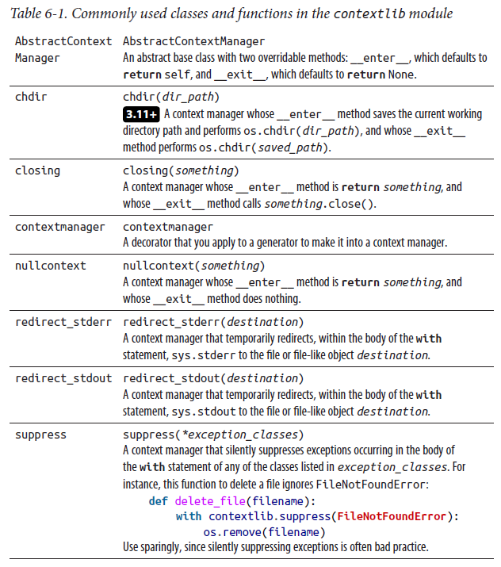

### Generators and Exceptions

To help generators cooperate with exceptions, yield statements are allowed inside try/finally statements. Moreover, generator objects have two other relevant methods, throw and close. Given a generator object g built by calling a generator function, the throw method’s signature is:

g.throw(exc_value)

When the generator’s caller calls g.throw, the effect is just as if a raise statement with the same argument executed at the spot of the yield at which generator g is suspended.

The generator method close has no arguments; when the generator’s caller calls g.close(), the effect is like calling g.throw(GeneratorExit()).1 GeneratorExit is a built-in exception class that inherits directly from BaseException. Generators also

have a finalizer (the special method __del__) that implicitly calls close when the generator object is garbage-collected.

If a generator raises or propagates a StopIteration exception, Python turns the exception’s type into RuntimeError.

### Exception Propagation

When an exception is raised, the exception propagation mechanism takes control. The normal control flow of the program stops, and Python looks for a suitable exception handler. Python’s try statement establishes exception handlers via its except clauses. The handlers deal with exceptions raised in the body of the try clause, as well as exceptions propagating from functions called by that code, directly or indirectly. If an exception is raised within a try clause that has an applicable except handler, the try clause terminates and the handler executes. When the handler finishes, execution continues with the statement after the try statement (in the absence of any explicit change to the flow of control, such as a raise or return statement).

If the statement raising the exception is not within a try clause that has an applicable handler, the function containing the statement terminates, and the exception propagates “upward” along the stack of function calls to the statement that called the function. If the call to the terminated function is within a try clause that has an applicable handler, that try clause terminates, and the handler executes. Otherwise, the function containing the call terminates, and the propagation process repeats, unwinding the stack of function calls until an applicable handler is found.

If Python cannot find any applicable handler, by default the program prints an error message to the standard error stream (sys.stderr). The error message includes a traceback that gives details about functions terminated during propagation. You can change Python’s default error-reporting behavior by setting sys.excepthook (covered in Table 8-3). After error reporting, Python goes back to the interactive session, if any, or terminates if execution was not interactive. When the exception type is SystemExit, termination is silent and ends the interactive session, if any.

Here are some functions to show exception propagation at work:

def f():

print('in f, before 1/0')

1/0 # raises a ZeroDivisionError exception

print('in f, after 1/0')

def g():

print('in g, before f()')

f()

print('in g, after f()')

def h():

print('in h, before g()')

try:

g()

print('in h, after g()')

except ZeroDivisionError:

print('ZD exception caught')

print('function h ends')

Calling the h function prints the following:

in h, before g()

in g, before f()

in f, before 1/0

ZD exception caught

function h ends

That is, none of the “after” print statements execute, since the flow of exception propagation cuts them off.

The function h establishes a try statement and calls the function g within the try clause. g, in turn, calls f, which performs a division by 0, raising an exception of type ZeroDivisionError. The exception propagates all the way back to the except clause in h. The functions f and g terminate during the exception propagation phase, which is why neither of their “after” messages is printed. The execution of h’s try clause also terminates during the exception propagation phase, so its “after” message isn’t printed either. Execution continues after the handler, at the end of h’s try/except block.

### Exception Objects

Exceptions are instances of BaseException (more specifically, instances of one of its subclasses). Table 6-2 lists the attributes and methods of BaseException. Table 6-2. Attributes and methods of the BaseException class

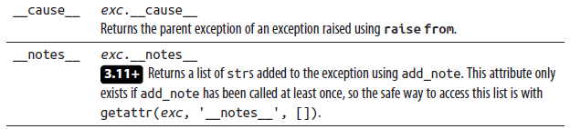

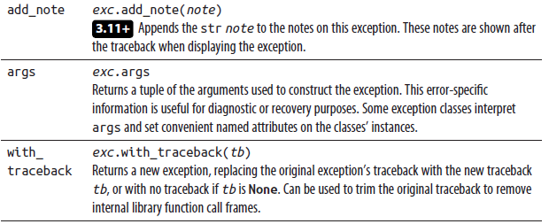

#### The Hierarchy of Standard Exceptions

As mentioned previously, exceptions are instances of subclasses of BaseException. The inheritance structure of exception classes is important, as it determines which except clauses handle which exceptions. Most exception classes extend the class Exception; however, the classes KeyboardInterrupt, GeneratorExit, and System Exit inherit directly from BaseException and are not subclasses of Exception. Thus, a handler clause except Exception as e does not catch KeyboardInterrupt, GeneratorExit, or SystemExit (we covered exception handlers in “try/except” on page 196 and GeneratorExit in “Generators and Exceptions” on page 203). Instances of SystemExit are normally raised via the exit function in the sys module (covered in Table 8-3). When the user hits Ctrl-C, Ctrl-Break, or other interrupting keys on their keyboard, that raises KeyboardInterrupt.

The hierarchy of built-in exception classes is, roughly:

BaseException

Exception

AssertionError, AttributeError, BufferError, EOFError, MemoryError, ReferenceError,

OsError, StopAsyncIteration, StopIteration, SystemError, TypeError

ArithmeticError (abstract)

OverflowError, ZeroDivisionError

ImportError

ModuleNotFoundError, ZipImportError

LookupError (abstract)

IndexError, КеуЕггог

NameError

UnboundLocalError

OSError

. . .

RuntimeError

RecursionError

NotImplementedError

SyntaxError

IndentationError

TabError

ValueError

UnsupportedOperation

UnicodeError

UnicodeDecodeError, UnicodeEncodeError,

UnicodeTranslateError

Warning

. . .

GeneratorExit

KeyboardInterrupt

SystemExit

There are other exception subclasses (in particular, Warning and OSError have many, whose omission is indicated here with ellipses), but this is the gist. A complete list is available in Python’s online docs.

The classes marked “(abstract)” are never instantiated directly; their purpose is to make it easier for you to specify except clauses that handle a range of related errors.

#### Standard Exception Classes

Table 6-3 lists exception classes raised by common runtime errors.

Table 6-3. Standard exception classes

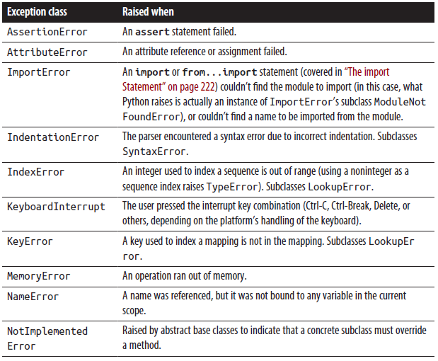

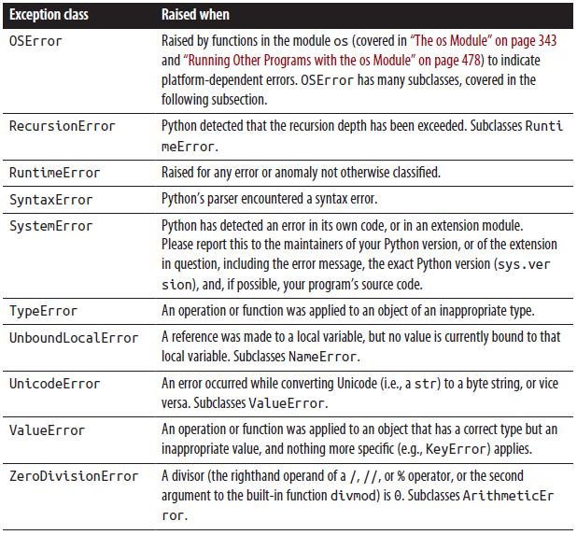

OSError subclasses

OSError represents errors detected by the operating system. To handle such errors more elegantly, OSError has many subclasses, whose instances are what actually get raised; for a complete list, see Python’s online docs.

For example, consider this task: try to read and return the contents of a certain file, return a default string if the file does not exist, and propagate any other exception that makes the file unreadable (except for the file not existing). Using an existing OSError subclass, you can accomplish the task quite simply:

def read_or_default(filepath, default):

try:

with open(filepath) as f:

return f.read()

except FileNotFoundError:

return default

The FileNotFoundError subclass of OSError makes this kind of common task simple and direct to express in code.

Exceptions “wrapping” other exceptions or tracebacks Sometimes, you cause an exception while trying to handle another. To let you clearly diagnose this issue, each exception instance holds its own traceback object; you can make another exception instance with a different traceback with the with_traceback method.

Moreover, Python automatically stores which exception it’s handling as the __con text__ attribute of any further exception raised during the handling (unless you set the exception’s __suppress_context__ attribute to True with the raise...from statement, which we cover shortly). If the new exception propagates, Python’s error message uses that exception’s __context__ attribute to show details of the problem. For example, take the (deliberately!) broken code:

try:

1/0

except ZeroDivisionError:

1+'x'

The error displayed is:

Traceback (most recent call last):

File "<stdin>", line 1, in <module>

ZeroDivisionError: division by zero

During handling of the above exception, another exception occurred:

Traceback (most recent call last):

File "<stdin>", line 3, in <module>

TypeError: unsupported operand type(s) for +: 'int' and 'str'

Thus, Python clearly displays both exceptions, the original and the intervening one. To get more control over the error display, you can, if you wish, use the raise...from statement. When you execute raise e from ex, both e and ex are exception objects: e is the one that propagates, and ex is its “cause.” Python records ex as the value of e.__cause__, and sets e.__suppress_context__ to true. (Alternatively, ex can be None: then, Python sets e.__cause__ to None, but still sets e.__suppress_context__ to true, and thus leaves e.__context__ alone).

As another example, here’s a class implementing a mock filesystem directory using a Python dict, with the filenames as the keys and the file contents as the values:

class FileSystemDirectory:

def __init__(self):

self._files = {}

def write_file(self, filename, contents):

self._files[filename] = contents

def read_file(self, filename):

try:

return self._files[filename]

except KeyError:

raise FileNotFoundError(filename)

When read_file is called with a nonexistent filename, the access to the self._files dict raises KeyError. Since this code is intended to emulate a filesystem directory, read_file catches the KeyError and raises FileNotFoundError instead.

As is, accessing a nonexistent file named 'data.txt' will output an exception message similar to:

Traceback (most recent call last):

File "C:\dev\python\faux_fs.py", line 11, in read_file

return self._files[filename]

KeyError: 'data.txt'

During handling of the above exception, another exception occurred:

Traceback (most recent call last):

File "C:\dev\python\faux_fs.py", line 20, in <module>

print(fs.read_file("data.txt"))

File "C:\dev\python\faux_fs.py", line 13, in read_file

raise FileNotFoundError(filename)

FileNotFoundError: data.txt

This exception report shows both the KeyError and the FileNotFoundError. To suppress the internal KeyError exception (to hide implementation details of File SystemDirectory), we change the raise statement in read_file to:

raise FileNotFoundError(filename) from None

Now the exception only shows the FileNotFoundError information:

Traceback (most recent call last):

File "C:\dev\python\faux_fs.py", line 20, in <module>

print(fs.read_file("data.txt"))

File "C:\dev\python\faux_fs.py", line 13, in read_file

raise FileNotFoundError(filename) from None

FileNotFoundError: data.txt

For details and motivations regarding exception chaining and embedding, see PEP 3134.

### Custom Exception Classes

You can extend any of the standard exception classes in order to define your own exception class. Often, such a subclass adds nothing more than a docstring:

class InvalidAttributeError(AttributeError):

"""Used to indicate attributes that could never be valid."""

An Empty Class or Function Should Have a Docstring As covered in “The pass Statement” on page 92, you don’t need a pass statement to make up the body of a class. The docstring (which you should always write, to document the class’s purpose if nothing else!) is enough to keep Python happy. Best practice for all “empty” classes (regardless of whether they are exception classes), just like for all “empty” functions, is usually to have a docstring and no pass statement.

Given the semantics of try/except, raising an instance of a custom exception class such as InvalidAttributeError is almost the same as raising an instance of its standard exception superclass, AttributeError, but with some advantages. Any except clause that can handle AttributeError can handle InvalidAttributeError just as well. In addition, client code that knows about your InvalidAttributeError custom exception class can handle it specifically, without having to handle all other cases of AttributeError when it is not prepared for those. For example, suppose you write code like the following:

class SomeFunkyClass:

"""much hypothetical functionality snipped"""

def __getattr__(self, name):

"""only clarifies the kind of attribute error"""

if name.startswith('_'):

raise InvalidAttributeError(

f'Unknown private attribute {name!r}'

)

else:

raise AttributeError(f'Unknown attribute {name!r}')

Now, client code can, if it so chooses, be more selective in its handlers. For example:

s = SomeFunkyClass()

try:

value = getattr(s, thename)

except InvalidAttributeError as err:

warnings.warn(str(err), stacklevel=2)

value = None

# other cases of AttributeError just propagate, as they're unexpected

Use Custom Exception Classes

It’s an excellent idea to define, and raise, instances of custom exception classes in your modules, rather than plain standard exceptions. By using custom exception classes that extend standard ones, you make it easier for callers of your module’s code to handle exceptions that come from your module separately from others, if they choose to.

Custom Exceptions and Multiple Inheritance

An effective approach to the use of custom exceptions is to multiply inherit exception classes from your module’s special custom exception class and a standard exception class, as in the following snippet:

class CustomAttributeError(CustomException, AttributeError):

"""An AttributeError which is ALSO a CustomException."""

Now, an instance of CustomAttributeError can only be raised explicitly and deliberately, showing an error related specifically to your code that also happens to be an AttributeError. When your code raises an instance of CustomAttributeError, that exception can be caught by calling code that’s designed to catch all cases of AttributeError as well as by code that’s designed to catch all exceptions raised only, specifically, by your module.

Use Multiple Inheritance for Custom Exceptions

Whenever you must decide whether to raise an instance of a specific standard exception, such as AttributeError, or of a custom exception class you define in your module, consider this multiple inheritance approach, which, in this book’s authors’ opinion,2 gives you the best of both worlds in such cases. Make sure you clearly document this aspect of your module, because the technique, although handy, is not widely used. Users of your module may not expect it unless you clearly and explicitly document what you are doing.

Other Exceptions Used in the Standard Library

Many modules in Python’s standard library define their own exception classes, which are equivalent to the custom exception classes that your own modules can define. Typically, all functions in such standard library modules may raise exceptions of such classes, in addition to exceptions in the standard hierarchy covered in “Standard Exception Classes” on page 207. We cover the main cases of such exception classes throughout the rest of this book, in chapters covering the standard library modules that supply and may raise them.

ExceptionGroup and except*

3.11+ In some circumstances, such as when performing validation of some input data against multiple criteria, it is useful to be able to raise more than a single exception at once. Python 3.11 introduced a mechanism to raise multiple exceptions at once using an ExceptionGroup instance and to process more than one exception using an except* form in place of except.

To raise ExceptionGroup, the validating code captures multiple Exceptions into a list and then raises an ExceptionGroup that is constructed using that list. Here is some code that searches for misspelled and invalid words, and raises an ExceptionGroup containing all of the found errors:

class GrammarError(Exception):

"""Base exception for grammar checking"""

def __init__(self, found, suggestion):

self.found = found

self.suggestion = suggestion

class InvalidWordError(GrammarError):

"""Misused or nonexistent word"""

class MisspelledWordError(GrammarError):

"""Spelling error"""

invalid_words = {

'irregardless': 'regardless',

"ain't": "isn't",

}

misspelled_words = {

'tacco': 'taco',

}

def check_grammar(s):

exceptions = []

for word in s.lower().split():

if (suggestion := invalid_words.get(word)) is not None:

exceptions.append(InvalidWordError(word, suggestion))

elif (suggestion := misspelled_words.get(word)) is not None:

exceptions.append(MisspelledWordError(word, suggestion))

if exceptions:

raise ExceptionGroup('Found grammar errors', exceptions)

The following code validates a sample text string and lists out all the found errors:

text = "Irregardless a hot dog ain't a tacco"

try:

check_grammar(text)

except* InvalidWordError as iwe:

print('\n'.join(f'{e.found!r} is not a word, use {e.suggestion!r}'

for e in iwe.exceptions))

except* MisspelledWordError as mwe:

print('\n'.join(f'Found {e.found!r}, perhaps you meant'

f' {e.suggestion!r}?'

for e in mwe.exceptions))

else:

print('No errors!')

giving this output:

'irregardless' is not a word, use 'regardless'

"ain't" is not a word, use "isn't"

Found 'tacco', perhaps you meant 'taco'?

Unlike except, after it finds an initial match, except* continues to look for additional exception handlers matching exception types in the raised ExceptionGroup.

Error-Checking Strategies

Most programming languages that support exceptions raise exceptions only in rare cases. Python’s emphasis is different. Python deems exceptions appropriate whenever they make a program simpler and more robust, even if that makes exceptions

rather frequent.

LBYL Versus EAFP

A common idiom in other languages, sometimes known as “look before you leap” (LBYL), is to check in advance, before attempting an operation, for anything that might make the operation invalid. This approach is not ideal, for several reasons:

* The checks may diminish the readability and clarity of the common, mainstream cases where everything is OK.
* The work needed for checking purposes may duplicate a substantial part of the work done in the operation itself.
* The programmer might easily err by omitting a needed check.
* The situation might change between the moment when you perform the checks and the moment when, later (even by a tiny fraction of a second!), you attempt the operation.

The preferred idiom in Python is to attempt the operation in a try clause and handle the exceptions that may result in one or more except clauses. This idiom is known as “It’s easier to ask forgiveness than permission” (EAFP), a frequently quoted motto widely credited to Rear Admiral Grace Murray Hopper, co-inventor of COBOL. EAFP shares none of the defects of LBYL. Here is a function using the LBYL idiom:

def safe_divide_1(x, y):

if y==0:

print('Divide-by-0 attempt detected')

return None

else:

return x/y

With LBYL, the checks come first, and the mainstream case is somewhat hidden at the end of the function.

Here is the equivalent function using the EAFP idiom:

def safe_divide_2(x, y):

try:

return x/y

except ZeroDivisionError:

print('Divide-by-0 attempt detected')

return None

With EAFP, the mainstream case is up front in a try clause, and the anomalies are handled in the following except clause, making the whole function easier to read and understand.

EAFP is a good error-handling strategy, but it is not a panacea. In particular, you must take care not to cast too wide a net, catching errors that you did not expect and therefore did not mean to catch. The following is a typical case of such a risk (we cover built-in function getattr in Table 8-2):

def trycalling(obj, attrib, default, *args, **kwds):

try:

return getattr(obj, attrib)(*args, **kwds)

except AttributeError:

return default

The intention of the trycalling function is to try calling a method named attrib on the object obj, but to return default if obj has no method thus named. However, the function as coded does not do just that: it also accidentally hides any error case where an AttributeError is raised inside the sought-after method, silently returning default in those cases. This could easily hide bugs in other code. To do exactly what’s intended, the function must take a little bit more care:

def trycalling(obj, attrib, default, *args, **kwds):

try:

method = getattr(obj, attrib)

except AttributeError:

return default

else:

return method(*args, **kwds)

This implementation of trycalling separates the getattr call, placed in the try clause and therefore guarded by the handler in the except clause, from the call of the method, placed in the else clause and therefore free to propagate any exception. The proper approach to EAFP involves frequent use of the else clause in try/except statements (which is more explicit, and thus better Python style, than just placing the nonguarded code after the whole try/except statement).

### Handling Errors in Large Programs

In large programs, it is especially easy to err by making your try/except statements too broad, particularly once you have convinced yourself of the power of EAFP as a general error-checking strategy. A try/except combination is too broad when it catches too many different errors, or an error that can occur in too many different places. The latter is a problem when you need to distinguish exactly what went wrong and where, and the information in the traceback is not sufficient to pinpoint such details (or you discard some or all of the information in the traceback). For effective error handling, you have to keep a clear distinction between errors and anomalies that you expect (and thus know how to handle) and unexpected errors and anomalies that may indicate a bug in your program.

Some errors and anomalies are not really erroneous, and perhaps not even all that anomalous: they are just special “edge” cases, perhaps somewhat rare but nevertheless quite expected, which you choose to handle via EAFP rather than via LBYL to avoid LBYL’s many intrinsic defects. In such cases, you should just handle the anomaly, often without even logging or reporting it.

**Keep Your try/except Constructs Narrow**

Be very careful to keep try/except constructs as narrow as feasible. Use a small try clause that contains a small amount of code that doesn’t call too many other functions, and use very specific exception class tuples in the except clauses. If need be, further analyze the details of the exception in your handler code, and raise again as soon as you know it’s not a case this handler can deal with.

Errors and anomalies that depend on user input or other external conditions not under your control are always expected, precisely because you have no control over their underlying causes. In such cases, you should concentrate your effort on handling the anomaly gracefully, reporting and logging its exact nature and details, and keeping your program running with undamaged internal and persistent state. Your try/except clauses should still be reasonably narrow, although this is not quite as crucial as when you use EAFP to structure your handling of not-really-erroneous special/edge cases.

Lastly, entirely unexpected errors and anomalies indicate bugs in your program’s design or coding. In most cases, the best strategy regarding such errors is to avoid try/except and just let the program terminate with error and traceback messages. (You might want to log such information and/or display it more suitably with an application-specific hook in sys.excepthook, as we’ll discuss shortly.) In the unlikely case that your program must keep running at all costs, even under dire circumstances, try/except statements that are quite wide may be appropriate, with the try clause guarding function calls that exercise vast swaths of program functionality, and broad except clauses.

In the case of a long-running program, make sure to log all details of the anomaly or error to some persistent place for later study (and also report to yourself some indication of the problem, so that you know such later study is necessary). The key is making sure that you can revert the program’s persistent state to some undamaged, internally consistent point. The techniques that enable long-running programs to survive some of their own bugs, as well as environmental adversities, are known as checkpointing (basically, periodically saving program state, and writing the program so it can reload the saved state and continue from there) and transaction processing; we do not cover them further in this book.

### Logging Errors

When Python propagates an exception all the way to the top of the stack without finding an applicable handler, the interpreter normally prints an error traceback to the standard error stream of the process (sys.stderr) before terminating the program. You can rebind sys.stderr to any file-like object usable for output in order to divert this information to a destination more suitable for your purposes. When you want to change the amount and kind of information output on such occasions, rebinding sys.stderr is not sufficient. In such cases, you can assign your own function to sys.excepthook: Python calls it when terminating the program due to an unhandled exception. In your exception-reporting function, output whatever information will help you diagnose and debug the problem and direct that information to whatever destinations you please. For example, you might use the traceback module (covered in “The traceback Module” on page 533) to format stack traces. When your exception-reporting function terminates, so does your program.

The logging module

The Python standard library offers the rich and powerful logging module to let you organize the logging of messages from your applications in systematic, flexible ways. Pushing things to the limit, you might write a whole hierarchy of Logger classes and subclasses; you could couple the loggers with instances of Handler (and subclasses thereof), or insert instances of the class Filter to fine-tune criteria determining what messages get logged in which ways.

Messages are formatted by instances of the Formatter class—the messages themselves are instances of the LogRecord class. The logging module even includes a dynamic configuration facility, whereby you may dynamically set logging configuration files by reading them from disk files, or even by receiving them on a dedicated socket in a specialized thread.

While the logging module sports a frighteningly complex and powerful architecture, suitable for implementing highly sophisticated logging strategies and policies that may be needed in vast and complicated software systems, in most applications you might get away with using a tiny subset of the package. First, import logging. Then, emit your message by passing it as a string to any of the module’s functions debug, info, warning, error, or critical, in increasing order of severity. If the string you pass contains format specifiers such as %s (as covered in “Legacy String Formatting with %” on page 297), then, after the string, pass as further arguments all the values to be formatted in that string. For example, don’t call:

logging.debug('foo is %r' % foo)

which performs the formatting operation whether it’s needed or not; rather, call:

logging.debug('foo is %r', foo)

which performs formatting if and only if needed (i.e., if and only if calling debug is going to result in logging output, depending on the current threshold logging level). If foo is used only for logging and is especially compute- or I/O-intensive to create, you can use isEnabledFor to conditionalize the expensive code that creates foo:

if logging.getLogger().isEnabledFor(logging.DEBUG):

foo = cpu_intensive_function()

logging.debug('foo is %r', foo)

Configuring logging

Unfortunately, the logging module does not support the more readable formatting approaches covered in “String Formatting” on page 287, but only the legacy one mentioned in the previous subsection. Fortunately, it’s very rare to need any formatting specifiers beyond %s (which calls __str__) and %r (which calls __repr__).

By default, the threshold level is WARNING: any of the functions warning, error, or critical results in logging output, but the functions debug and info do not. To change the threshold level at any time, call logging.getLogger().setLevel, passing as the only argument one of the corresponding constants supplied by the logging module: DEBUG, INFO, WARNING, ERROR, or CRITICAL. For example, once you call:

logging.getLogger().setLevel(logging.DEBUG)

all of the logging functions from debug to critical result in logging output until you change the level again. If later you call:

logging.getLogger().setLevel(logging.ERROR) then only the functions error and critical result in logging output (debug, info,

and warning won’t result in logging output); this condition, too, persists until you change the level again, and so forth.

By default, logging output goes to your process’s standard error stream (sys.stderr, as covered in Table 8-3) and uses a rather simplistic format (for example, it does not include a timestamp on each line it outputs). You can control these settings by instantiating an appropriate handler instance, with a suitable formatter instance, and creating and setting a new logger instance to hold it. In the simple, common case in which you just want to set these logging parameters once and for all, after which they persist throughout the run of your program, the simplest approach is to call the logging.basicConfig function, which lets you set things up quite simply via named parameters. Only the very first call to logging.basicConfig has any effect, and only if you call it before any of the logging functions (debug, info, and so on). Therefore, the most common use is to call logging.basicConfig at the very start of your program. For example, a common idiom at the start of aprogram is something like:

import logging

logging.basicConfig(

format='%(asctime)s %(levelname)8s %(message)s',

filename='/tmp/logfile.txt', filemode='w')

This setting writes logging messages to a file, nicely formatted with a precise human-readable timestamp, followed by the severity level right-aligned in an eightcharacter field, followed by the message proper.

For much, much more detailed information on the logging module and all the wonders you can perform with it, be sure to consult Python’s rich online documentation.

The assert Statement

The assert statement allows you to introduce “sanity checks” into a program. assert is a simple statement with the following syntax:

assert condition[, expression]

When you run Python with the optimize flag (-O, as covered in “Command-Line Syntax and Options” on page 22), assert is a null operation: the compiler generates no code for it. Otherwise, assert evaluates condition. When condition is satisfied, assert does nothing. When condition is not satisfied, assert instantiates AssertionError with expression as the argument (or without arguments, if there is no expression) and raises the resulting instance.3 assert statements can be an effective way to document your program. When you want to state that a significant, nonobvious condition C is known to hold at a certain point in a program’s execution (known as an invariant of your program), assert C is often better than a comment that just states that C holds.

Don’t Overuse assert

Never use assert for other purposes besides sanity-checking program invariants. A serious but very common mistake is to use assert about the values of inputs or arguments. Checking for erroneous arguments or inputs is best done more explicitly, and in particular must not be done using assert, since it can be turned into a null operation by a Python commandline flag.

The advantage of assert is that, when C does not in fact hold, assert immediately alerts you to the problem by raising AssertionError, if the program is running without the -O flag. Once the code is thoroughly debugged, run it with -O, turning assert into a null operation and incurring no overhead (the assert remains in your source code to document the invariant).

The __debug__ Built-in Variable When you run Python without the option -O, the __debug__ built-in variable is True. When you run Python with the option -O, __debug__ is False. Also, in the latter case the compiler generates no code for any if statement whose sole guard condition is __debug__.

To exploit this optimization, surround the definitions of functions that you call only in assert statements with if __debug__:. This technique makes compiled code smaller and faster when Python is run with -O, and enhances program clarity by showing that those functions exist only to perform sanity checks.

## Modules and Packages

A typical Python program is made up of several source files. Each source file is a module, grouping code and data for reuse. Modules are normally independent of each other, so that other programs can reuse the specific modules they need. Sometimes, to manage complexity, developers group together related modules into a package—a hierarchical, tree-like structure of related modules and subpackages. A module explicitly establishes dependencies upon other modules by using import or from statements. In some programming languages, global variables provide a hidden conduit for coupling between modules. In Python, global variables are not global to all modules, but rather are attributes of a single module object. Thus, Python modules always communicate in explicit and maintainable ways, clarifying

the couplings between them by making them explicit.

Python also supports extension modules—modules coded in other languages such as C, C++, Java, C#, or Rust. For the Python code importing a module, it does not matter whether the module is pure Python or an extension. You can always start by coding a module in Python. Should you need more speed later, you can refactor and recode some parts of your module in lower-level languages, without changing the client code that uses the module. Chapter 25 (available online) shows how to write extensions in C and Cython.

This chapter discusses module creation and loading. It also covers grouping modules into packages, using setuptools to install packages, and how to prepare packages for distribution; this latter subject is more thoroughly covered in Chapter 24 (also available online). We close this chapter with a discussion of how best to manage your Python environment(s) .

### Module Objects

In Python, a module is an object with arbitrarily named attributes that you can bind and reference. Modules in Python are handled like other objects. Thus, you can pass a module as an argument in a call to a function. Similarly, a function can return a module as the result of a call. A module, just like any other object, can be bound to a variable, an item in a container, or an attribute of an object. Modules can be keys or values in a dictionary, and can be members of a set. For example, the sys.modules dictionary, discussed in “Module Loading” on page 227, holds module objects as its values. The fact that modules can be treated like other values in Python is often expressed by saying that modules are first-class objects.

#### The import Statement

The Python code for a module named aname usually lives in a file named aname.py, as covered in “Searching the Filesystem for a Module” on page 228. You can use any Python source file1 as a module by executing an import statement in another Python source file. import has the following syntax:

import modname [as varname][,...]

After the import keyword come one or more module specifiers separated by commas. In the simplest, most common case, a module specifier is just modname, an identifier—a variable that Python binds to the module object when the import statement finishes. In this case, Python looks for the module of the same name to satisfy the import request. For example, this statement:

import mymodule looks for the module named mymodule and binds the variable named mymodule in the current scope to the module object. modname can also be a sequence of identifiers separated by dots (.) to name a module contained in a package, as covered in “Packages” on page 233.

When as varname is part of a module specifier, Python looks for a module named modname and binds the module object to the variable varname. For example, this: import mymodule as alias looks for the module named mymodule and binds the module object to the variable alias in the current scope. varname must always be a simple identifier.

The module body

The body of a module is the sequence of statements in the module’s source file. There is no special syntax required to indicate that a source file is a module; as mentioned previously, you can use any valid Python source file as a module. A module’s body executes immediately the first time a given run of a program imports it. When the body starts executing, the module object has already been created, with an entry in sys.modules already bound to the module object. The module’s (global) namespace is gradually populated as the module’s body executes.

Attributes of module objects

An import statement creates a new namespace containing all the attributes of the module. To access an attribute in this namespace, use the name or alias of the module as a prefix:

import mymodule

a = mymodule.f()

or:

import mymodule as alias

a = alias.f()

This reduces the time it takes to import the module and ensures that only those applications that use that module incur the overhead of creating it. Normally, it is the statements in the module body that bind the attributes of a module object. When a statement in the module body binds a (global) variable, what gets bound is an attribute of the module object.

**A Module Body Exists to Bind the Module’s Attributes**

The normal purpose of a module body is to create the module’s attributes: def statements create and bind functions, class statements create and bind classes, and assignment statements can bind attributes of any type. For clarity and cleanliness in your code, be wary about doing anything else in the top logical level of the module’s body except binding the module’s attributes.

A __getattr__ function defined at module scope can dynamically create new module attributes. One possible reason for doing so would be to lazily define attributes that are time-consuming to create; defining them in a module-level __getattr__ function defers the creation of the attributes until they are actually referenced, if ever. For instance, this code could be added to mymodule.py to defer the creation of a list containing the first million prime numbers, which can take some time to compute:

def __getattr__(name):

if name == 'first_million_primes':

def generate_n_primes(n):

# ... code to generate 'n' prime numbers ...

import sys

# Look up __name__ in sys.modules to get current module

this_module = sys.modules[__name__]

this_module.first_million_primes = generate_n_primes(1_000_000)

return this_module.first_million_primes

raise AttributeError(f'module {__name__!r} f' has no attribute {name!r}')

Using a module-level __getattr__ function has only a small impact on the time to import mymodule.py, and only those applications that actually use mymodule.first_million_primes will incur the overhead of creating it.

You can also bind module attributes in code outside the body (i.e., in other modules); just assign a value to the attribute reference syntax M.name (where M is any expression whose value is the module, and the identifier name is the attribute name).

For clarity, however, it’s best to bind module attributes only in the module’s own body.

The import statement binds some module attributes as soon as it creates the module object, before the module’s body executes. The __dict__ attribute is the dict object that the module uses as the namespace for its attributes. Unlike other attributes of the module, __dict__ is not available to code in the module as a global variable.

All other attributes in the module are items in __dict__ and are available to code in the module as global variables. The __name__ attribute is the module’s name, and __file__ is the filename from which the module was loaded; other dunder-named attributes hold other module metadata. (See also “Special Attributes of Package Objects” on page 234 for details on the attribute __path__, in packages only.)

For any module object M, any object x, and any identifier string S (except __dict__),

binding M.S = x is equivalent to binding M.__dict__['S'] = x. An attribute reference such as M.S is also substantially equivalent to M.__dict__['S']. The only difference is that, when S is not a key in M.__dict__, accessing M.__dict__['S'] raises KeyError, while accessing M.S raises AttributeError. Module attributes are also available to all code in the module’s body as global variables. In other words, within the module body, S used as a global variable is equivalent to M.S (i.e., M.__dict__['S']) for both binding and reference (when S is not a key in M.__dict__, however, referring to S as a global variable raises NameError).

Python built-ins

Python supplies many built-in objects (covered in Chapter 8). All built-in objects are attributes of a preloaded module named builtins. When Python loads a module, the module automatically gets an extra attribute named __builtins__, which refers either to the module builtins or to its dictionary. Python may choose either, so don’t rely on __builtins__. If you need to access the module builtins directly (a rare need), use an import builtins statement. When you access a variable found neither in the local namespace nor in the global namespace of the current module, Python looks for the identifier in the current module’s __builtins__ before raising NameError.

The lookup is the only mechanism that Python uses to let your code access builtins. Your own code can use the access mechanism directly (do so in moderation, however, or your program’s clarity and simplicity will suffer). The built-ins’ names are not reserved, nor are they hardwired in Python itself—you can add your own built-ins or substitute your functions for the normal built-in ones, in which case all modules see the added or replaced ones. Since Python accesses built-ins only when it cannot resolve a name in the local or module namespace, it is usually sufficient to define a replacement in one of those namespaces. The following toy example shows how you can wrap a built-in function with your own function, allowing abs to take a string argument (and return a rather arbitrary mangling of the string):

# abs takes a numeric argument; let's make it accept a string as well

import builtins

_abs = builtins.abs # save original built-in

def abs(str_or_num):

if isinstance(str_or_num, str): # if arg is a string

return ''.join(sorted(set(str_or_num))) # get this instead

return _abs(str_or_num) # call real built-in

builtins.abs = abs # override built-in w/wrapper

Module documentation strings

If the first statement in the module body is a string literal, Python binds that string as the module’s documentation string attribute, named __doc__. For more information on documentation strings, see “Docstrings” on page 99.

Module-private variables

No variable of a module is truly private. However, by convention, every identifier starting with a single underscore (_), such as _secret, is meant to be private. In other words, the leading underscore communicates to client-code programmers that they should not access the identifier directly.

Development environments and other tools rely on the leading underscore naming convention to discern which attributes of a module are public (i.e., part of the module’s interface) and which are private (i.e., to be used only within the module).

Respect the “Leading Underscore Means Private” Convention

It’s important to respect the convention that a leading underscore means private, particularly when you write client code that uses modules written by others. Avoid using any attributes in such modules whose names start with _. Future releases of the modules will strive to maintain their public interface, but are quite likely to change private implementation details: private attributes are meant exactly for such details.

#### The from Statement

Python’s from statement lets you import specific attributes from a module into the current namespace. from has two syntax variants:

from modname import attrname [as varname][,...]

from modname import *

A from statement specifies a module name, followed by one or more attribute specifiers separated by commas. In the simplest and most common case, an attribute specifier is just an identifier attrname, which is a variable that Python binds to the attribute of the same name in the module named modname. For example:

from mymodule import f

modname can also be a sequence of identifiers separated by dots (.) to name a module within a package, as covered in “Packages” on page 233. When as varname is part of an attribute specifier, Python gets the value of the attribute attrname from the module and binds it to the variable varname. For example:

from mymodule import f as foo

attrname and varname are always simple identifiers.

You may optionally enclose in parentheses all the attribute specifiers that follow the keyword import in a from statement. This can be useful when you have many attribute specifiers, in order to split the single logical line of the from statement into multiple logical lines more elegantly than by using backslashes (\):

from some_module_with_a_long_name import (

another_name, and_another as x, one_more, and_yet_another as y)

from...import *

Code that is directly inside a module body (not in the body of a function or class) may use an asterisk (*) in a from statement:

from mymodule import *

The * requests that “all” attributes of module modname be bound as global variables in the importing module. When module modname has an attribute named __all__, the attribute’s value is the list of the attribute names that this type of from statement binds. Otherwise, this type of from statement binds all attributes of modname except those beginning with underscores.

Beware Using “from M import *” in Your Code Since from M import * may bind an arbitrary set of global variables, it can have unforeseen, undesired side effects, such as hiding built-ins and rebinding variables you still need. Use the * form of from very sparingly, if at all, and only to import modules that are explicitly documented as supporting such usage. Your code is most likely better off never using this form, which is meant mostly as a convenience for occasional use in interactive Python sessions.

from versus import

The import statement is often a better choice than the from statement. When you always access module M with the statement import M, and always access M’s attributes with the explicit syntax M.A, your code is slightly less concise but far clearer and more readable. One good use of from is to import specific modules from a package, as we discuss in “Packages” on page 233. In most other cases, import is better style than from.

Handling import failures

If you are importing a module that is not part of standard Python and wish to handle import failures, you can do so by catching the ImportError exception. For instance, if your code does optional output formatting using the third-party rich module, but falls back to regular output if that module has not been installed, you would import the module using:

try:

import rich

except ImportError:

rich = None

Then, in the output portion of your program, you would write:

if rich is not None:

... output using rich module features ...

else:

... output using normal print() statements ...

## Module Loading

Module-loading operations rely on attributes of the built-in sys module (covered in “The sys Module” on page 259) and are implemented in the built-in function __import__. Your code could call __import__ directly, but this is strongly discouraged in modern Python; rather, import importlib and call importlib.import_mod ule with the module name string as the argument. import_module returns the module object or, should the import fail, raises ImportError. However, it’s best to have a clear understanding of the semantics of __import__, because import_module and import statements both depend on it.

To import a module named M, __import__ first checks the dictionary sys.modules, using the string M as the key. When the key M is in the dictionary, __import__ returns the corresponding value as the requested module object. Otherwise, __import__ binds sys.modules[M] to a new empty module object with a __name__ of M, then looks for the right way to initialize (load) the module, as covered in the upcoming section on searching the filesystem for a module.

Thanks to this mechanism, the relatively slow loading operation takes place only the first time a module is imported in a given run of the program. When a module is imported again, the module is not reloaded, since __import__ rapidly finds and returns the module’s entry in sys.modules. Thus, all imports of a given module after the first one are very fast: they’re just dictionary lookups. (To force a reload, see “Reloading Modules” on page 230.)

### Built-in Modules

When a module is loaded, __import__ first checks whether the module is a built-in. The tuple sys.builtin_module_names names all built-in modules, but rebinding that tuple does not affect module loading. When it loads a built-in module, as when it loads any other extension, Python calls the module’s initialization function. The search for built-in modules also looks for modules in platform-specific locations, such as the Registry in Windows.

### Searching the Filesystem for a Module

If module M is not a built-in, __import__ looks for M’s code as a file on the filesystem. __import__ looks at the items of the list sys.path, which are strings, in order. Each item is the path of a directory, or the path of an archive file in the popular ZIP format. sys.path is initialized at program startup, using the environment variable PYTHONPATH (covered in “Environment Variables” on page 22), if present. The first item in sys.path is always the directory from which the main program is loaded. An empty string in sys.path indicates the current directory.

Your code can mutate or rebind sys.path, and such changes affect which directories and ZIP archives __import__ searches to load modules. Changing sys.path does not affect modules that are already loaded (and thus already recorded in sys.modules).

If there is a text file with the extension .pth in the PYTHONHOME directory at startup, Python adds the file’s contents to sys.path, one item per line. .pth files can contain blank lines and comment lines starting with the character #; Python ignores any such lines. .pth files can also contain import statements (which Python executes before your program starts to execute), but no other kinds of statements.

When looking for the file for module M in each directory and ZIP archive along sys.path, Python considers the following extensions in this order:

1. .pyd and .dll (Windows) or .so (most Unix-like platforms), which indicatePython extension modules. (Some Unix dialects use different extensions; e.g., .sl on HP-UX.) On most platforms, extensions cannot be loaded from a ZIP archive—only source or bytecode-compiled Python modules can.
2. .py, which indicates Python source modules.
3. .pyc, which indicates bytecode-compiled Python modules.
4. When it finds a .py file, Python also looks for a directory called __pycache__.

If it finds such a directory, Python looks in that directory for the extension .<tag>.pyc, where <tag> is a string specific to the version of Python that is looking for the module.

One last path in which Python looks for the file for module M is M/__init__.py: a file named __init__.py in a directory named M, as covered in “Packages” on page 233. Upon finding the source file M.py, Python compiles it to M.<tag>.pyc, unless the bytecode file is already present, is newer than M.py, and was compiled by the same version of Python. If M.py is compiled from a writable directory, Python creates a __pycache__ subdirectory if necessary and saves the bytecode file to the filesystem in that subdirectory so that future runs won’t needlessly recompile it. When the bytecode file is newer than the source file (based on an internal timestamp in the bytecode file, not on trusting the date as recorded in the filesystem), Python does not recompile the module.

Once Python has the bytecode, whether built anew by compilation or read from the filesystem, Python executes the module body to initialize the module object. If the module is an extension, Python calls the module’s initialization function.

Be Careful About Naming Your Project’s .py Files

A common problem for beginners occurs when programmers writing their first few projects accidentally name one of their .py files with the same name as an imported package, or a module in the standard library (stdlib). For example, an easy mistake when learning the turtle module is to name your program turtle.py. When Python then tries to import the turtle module from the stdlib, it will load the local module instead, and usually raise some unexpected AttributeErrors shortly thereafter (since the local module does not include all the classes, functions, and variables defined in the stdlib module).

Do not name your project .py files the same as imported or stdlib modules!

You can check whether a module name already exists using a command of the form python -m testname. If the message 'no module testname' is displayed, then you should be safe to name your module testname.py. In general, as you become familiar with the modules in the stdlib and common package names, you will come to know what names to avoid.

### The Main Program

Execution of a Python application starts with a top-level script (known as the main program), as explained in “The python Program” on page 21. The main program executes like any other module being loaded, except that Python keeps the bytecode in memory, not saving it to disk. The module name for the main program is '__main__', both as the __name__ variable (module attribute) and as the key in sys.modules.

Don’t Import the .py File You’re Using as the Main Program You should not import the same .py file that is the main program. If you do, Python loads the module again, and the body executes again in a separate module object with a different __name__.

Code in a Python module can test if the module is being used as the main program by checking if the global variable __name__ has the value '__main__'. The idiom:

if __name__ == '__main__':

is often used to guard some code so that it executes only when the module runs as the main program. If a module is meant only to be imported, it should normally execute unit tests when run as the main program, as covered in “Unit Testing and

System Testing” on page 514.

### Reloading Modules

Python loads a module only the first time you import the module during a program run. When you develop interactively, you need to reload your modules after editing them (some development environments provide automatic reloading).

To reload a module, pass the module object (not the module name) as the only argument to the function reload from the importlib module. impor tlib.reload(M) ensures the reloaded version of M is used by client code that relies on import M and accesses attributes with the syntax M.A. However, impor tlib.reload(M) has no effect on other existing references bound to previous values of M’s attributes (e.g., with a from statement). In other words, already-bound variables remain bound as they were, unaffected by reload. reload’s inability to rebind such variables is a further incentive to use import rather than from.

reload is not recursive: when you reload module M, this does not imply that other modules imported by M get reloaded in turn. You must reload, by explicit calls to reload, every module you have modified. Be sure to take into account any module reference dependencies, so that reloads are done in the proper order.

### Circular Imports

Python lets you specify circular imports. For example, you can write a module a.py that contains import b, while module b.py contains import a. If you decide to use a circular import for some reason, you need to understand how circular imports work in order to avoid errors in your code.

Avoid Circular Imports

In practice, you are nearly always better off avoiding circular imports, since circular dependencies are fragile and hard to

manage.

Say that the main script executes import a. As discussed earlier, this import statement creates a new empty module object as sys.modules['a'], then the body of module a starts executing. When a executes import b, this creates a new empty module object as sys.modules['b'], and then the body of module b starts executing. a’s module body cannot proceed until b’s module body finishes.

Now, when b executes import a, the import statement finds sys.modules['a'] already bound, and therefore binds global variable a in module b to the module object for module a. Since the execution of a’s module body is currently blocked, module a is usually only partly populated at this time. Should the code in b’s module body try to access some attribute of module a that is not yet bound, an error results. If you keep a circular import, you must carefully manage the order in which each module binds its own globals, imports other modules, and accesses globals of other modules. You get greater control over the sequence in which things happen by grouping your statements into functions, and calling those functions in a controlled order, rather than just relying on sequential execution of top-level statements in module bodies. Removing circular dependencies (for example, by moving an import away from module scope and into a referencing function) is easier than ensuring bombproof ordering to deal with circular dependencies.

sys.modules Entries

__import__ never binds anything other than a module object as a value in sys.modules. However, if __import__ finds an entry already in sys.modules, it returns that value, whatever type it may be. import and from statements rely on __import__, so they too can use objects that are not modules.

### Custom Importers

Another advanced, rarely needed functionality that Python offers is the ability to change the semantics of some or all import and from statements.

Rebinding __import__

You can rebind the __import__ attribute of the builtin module to your own custom importer function—for example, one using the generic built-in-wrapping technique shown in “Python built-ins” on page 224. Such a rebinding affects all import and from statements that execute after the rebinding and thus can have an undesired global impact. A custom importer built by rebinding __import__ must implement the same interface and semantics as the built-in __import__, and, in particular, it is responsible for supporting the correct use of sys.modules.

Avoid Rebinding the Built-in __import__

While rebinding __import__ may initially look like an attractive approach, in most cases where custom importers are necessary, you’re better off implementing them via import hooks (discussed next).

Import hooks

Python offers rich support for selectively changing the details of imports’ behavior. Custom importers are an advanced and rarely called for technique, yet some applications may need them for purposes such as importing code from archives other than ZIP files, databases, network servers, and so on.

The most suitable approach for such highly advanced needs is to record importer factory callables as items in the meta_path and/or path_hooks attributes of the module sys, as detailed in PEP 451. This is how Python hooks up the standard library module zipimport to allow seamless importing of modules from ZIP files, as previously mentioned. A full study of the details of PEP 451 is indispensable for any substantial use of sys.path_hooks and friends, but here’s a toy-level example to help understand the possibilities, should you ever need them.

Suppose that, while developing the first outline of some program, we want to be able to use import statements for modules that we haven’t written yet, getting just messages (and empty modules) as a consequence. We can obtain such functionality (leaving aside the complexities connected with packages, and dealing with simple modules only) by coding a custom importer module as follows:

import sys, types

class ImporterAndLoader:

"""importer and loader can be a single class"""

fake_path = '!dummy!'

def __init__(self, path):

# only handle our own fake-path marker

if path != self.fake_path:

raise ImportError

def find_module(self, fullname):

# don't even try to handle any qualified module name

if '.' in fullname:

return None

return self

def create_module(self, spec):

# returning None will have Python fall back and

# create the module "the default way"

return None

def exec_module(self, mod):

# populate the already initialized module

# just print a message in this toy example

print(f'NOTE: module {mod!r} not yet written')

sys.path_hooks.append(ImporterAndLoader)

sys.path.append(ImporterAndLoader.fake_path)

if __name__ == '__main__': # self-test when run as main script

import missing_module # importing a simple *missing* module

print(missing_module) # ...should succeed

print(sys.modules.get('missing_module')) # ...should also succeed

We just wrote trivial versions of create_module (which in this case just returns None, asking the system to create the module object in the “default way”) and exec_module (which receives the module object already initialized with dunder attributes, and whose task would normally be to populate it appropriately). We could, alternatively, have used the powerful new module spec concept, as detailed in PEP 451. However, that requires the standard library module importlib; for this toy example, we don’t need all that extra power. Therefore, we chose instead to implement the method find_module, which, although now deprecated, still works fine for backward compatibility.

## Packages

As mentioned at the beginning of this chapter, a package is a module containing other modules. Some or all of the modules in a package may be subpackages, resulting in a hierarchical tree-like structure. A package named P typically resides in a subdirectory, also called P, of some directory in sys.path. Packages can also live in ZIP files; in this section we explain the case in which the package lives on the filesystem, but the case in which a package is in a ZIP file is similar, relying on the hierarchical filesystem-like structure within the ZIP file.

The module body of P is in the file P/__init__.py. This file must exist (except in the case of namespace packages, described in PEP 420), even if it’s empty (representing an empty module body), in order to tell Python that directory P is indeed a package. Python loads the module body of a package when you first import the package (or any of the package’s modules), just like with any other Python module. The other .py files in the directory P are the modules of package P. Subdirectories of P containing __init__.py files are subpackages of P. Nesting can proceed to any depth.

You can import a module named M in package P as P.M. More dots let you navigate a hierarchical package structure. (A package’s module body always loads before any module in the package.) If you use the syntax import P.M, the variable P is bound to the module object of package P, and the attribute M of object P is bound to the module P.M. If you use the syntax import P.M as V, the variable V is bound directly to the module P.M.

Using from P import M to import a specific module M from package P is a perfectly acceptable and indeed highly recommended practice: the from statement is specifically OK in this case. from P import M as V is also just fine, and exactly equivalent to import P.M as V. You can also use relative paths: that is, module M in package P can import its “sibling” module X (also in package P) with from . import X.

Sharing Objects Among Modules in a Package

The simplest, cleanest way to share objects (e.g., functions or constants) among modules in a package P is to group the shared objects in a module conventionally named common.py. That way, you can use from . import common in every module in the package that needs to access some of the common objects, and then refer to the objects as common.f, common.K, and so on.

Special Attributes of Package Objects

A package P’s __file__ attribute is the string that is the path of P’s module body— that is, the path of the file P/__init__.py. P’s __package__ attribute is the name of P’s package.

A package P’s module body—that is, the Python source that is in the file P/ __init__.py—can optionally set a global variable named __all__ (just like any other module can) to control what happens if some other Python code executes the statement from P import *. In particular, if __all__ is not set, from P import * does not import P’s modules, but only names that are set in P’s module body and lack a leading _. In any case, this is not recommended usage.

A package P’s __path__ attribute is the list of strings that are the paths to the directories from which P’s modules and subpackages are loaded. Initially, Python sets __path__ to a list with a single element: the path of the directory containing the file __init__.py that is the module body of the package. Your code can modify this list to affect future searches for modules and subpackages of this package. This advanced technique is rarely necessary, but can be useful when you want to place a package’s modules in multiple directories (a namespace package is, however, the usual way to accomplish this goal).

Absolute Versus Relative Imports

As mentioned previously, an import statement normally expects to find its target somewhere on sys.path—a behavior known as an absolute import. Alternatively, you can explicitly use a relative import, meaning an import of an object from within the current package. Using relative imports can make it easier for you to refactor or restructure the subpackages within your package. Relative imports use module or package names beginning with one or more dots, and are only available within the from statement. from . import X looks for the module or object named X in the current package; from .X import y looks in module or subpackage X within the current package for the module or object named y. If your package has subpackages, their code can access higher-up objects in the package by using multiple dots at the start of the module or subpackage name you place between from and import. Each additional dot ascends the directory hierarchy one level. Getting too fancy with this feature can easily damage your code’s clarity, so use it with care, and only when necessary.

## Distribution Utilities (distutils) and setuptools

Python modules, extensions, and applications can be packaged and distributed in several forms:

Compressed archive files

Generally .zip, .tar.gz (aka .tgz), .tar.bz2, or .tar.xz files—all these forms are portable, and many other forms of compressed archives of trees of files and directories exist

Self-unpacking or self-installing executables

Normally .exe for Windows Self-contained, ready-to-run executables that require no installation For example, .exe for Windows, ZIP archives with a short script prefix on Unix, .app for the Mac, and so on

Platform-specific installers

For example, .rpm and .srpm on many Linux distributions, .deb on Debian GNU/Linux and Ubuntu, .pkg on macOS

Python wheels

Popular third-party extensions, covered in the following note

Python Wheels

A Python wheel is an archive file including structured metadata as well as Python code. Wheels offer an excellent way to package and distribute your Python packages, and setuptools (with the wheel extension, easily installed with pip install wheel) works seamlessly with them. Read all about them at PythonWheels.com and in Chapter 24 (available online).

When you distribute a package as a self-installing executable or platform-specific installer, a user simply runs the installer. How to run such a program depends on the platform, but it doesn’t matter which language the program was written in. We cover building self-contained, runnable executables for various platforms in Chapter 24.

When you distribute a package as an archive file or as an executable that unpacks but does not install itself, it does matter that the package was coded in Python. In this case, the user must first unpack the archive file into some appropriate directory, say C:\Temp\MyPack on a Windows machine or ~/MyPack on a Unix-like machine. Among the extracted files there should be a script, conventionally named setup.py, that uses the Python facility known as the distribution utilities (the now deprecated, but still functioning, standard library package distutils2) or, better, the more popular, modern, and powerful third-party package setuptools. The distributed package is then almost as easy to install as a self-installing executable; the user simply opens a command prompt window, changes to the directory into which the archive is unpacked, then runs, for example:

C:\Temp\MyPack> python setup.py install

(Another, often preferable, option is to use pip; we’ll describe that momentarily.) The setup.py script run with this install command installs the package as a part of the user’s Python installation, according to the options specified by the package’s author in the setup script. Of course, the user needs appropriate permissions to write into the directories of the Python installation, so permission-raising commands such as sudo may also be needed; or, better yet, you can install into a virtual environment, as described in the next section. distutils and setuptools, by default, print some information when the user runs setup.py. Including the option --quiet right before the install command hides most details (the user still sees error messages, if any). The following command gives detailed help on distutils or setuptools, depending on which toolset the package author used in their setup.py:

C:\Temp\MyPack> python setup.py --help

An alternative to this process, and the preferred way to install packages nowadays, is to use the excellent installer pip that comes with Python. pip—a recursive acronym for “pip installs packages”—is copiously documented online, yet very simple to use in most cases. pip install package finds the online version of package (usually in the huge PyPI repository, hosting more than 400,000 packages at the time of this writing), downloads it, and installs it for you (in a virtual environment, if one is active; see the next section for details). This books’ authors have been using that simple, powerful approach for well over 90% of their installs for quite a while now. Even if you have downloaded the package locally (say to /tmp/mypack), for whatever reason (maybe it’s not on PyPI, or you’re trying out an experimental version that is not yet there), pip can still install it for you: just run pip install --no-index --find-links=/tmp/mypack and pip does the rest.

## Python Environments

A typical Python programmer works on several projects concurrently, each with its own list of dependencies (typically, third-party libraries and data files). When the dependencies for all projects are installed into the same Python interpreter, it is very difficult to determine which projects use which dependencies, and impossible to handle projects with conflicting versions of certain dependencies.

Early Python interpreters were built on the assumption that each computer system would have “a Python interpreter” installed on it, to be used to run any Python program on that system. Operating system distributions soon started to include Python in their base installations, but, because Python has always been under active development, users often complained that they would like to use a more up-to-date version of the language than the one their operating system provided.

Techniques arose to let multiple versions of the language be installed on a system, but installation of third-party software remained nonstandard and intrusive. This problem was eased by the introduction of the site-packages directory as the repository for modules added to a Python installation, but it was still not possible to maintain multiple projects with conflicting requirements using the same interpreter.

Programmers accustomed to command-line operations are familiar with the concept of a shell environment. A shell program running in a process has a current directory, variables that you can set with shell commands (very similar to a Python namespace), and various other pieces of process-specific state data. Python programs have access to the shell environment through os.environ.

Various aspects of the shell environment affect Python’s operation, as mentioned in “Environment Variables” on page 22. For example, the PATH environment variable determines which program, exactly, executes in response to python and other commands. You can think of those aspects of your shell environment that affect Python’s operation as your Python environment. By modifying it you can determine which Python interpreter runs in response to the python command, which packages and modules are available under certain names, and so on.

**Leave the System’s Python to the System**

We recommend taking control of your Python environment. In particular, do not build applications on top of a systemdistributed Python. Instead, install another Python distribution independently, and adjust your shell environment so that the python command runs your locally installed Python rather than the system’s Python.

### Enter the Virtual Environment

The introduction of the pip utility created a simple way to install (and, for the first time, to uninstall) packages and modules in a Python environment. Modifying the system Python’s site-packages still requires administrative privileges, and hence so does pip (although it can optionally install somewhere other than site-packages). Modules installed in the central site-packages are visible to all programs. The missing piece is the ability to make controlled changes to the Python environment, to direct the use of a specific interpreter and a specific set of Python libraries. That functionality is just what virtual environments (virtualenvs) give you. Creating a virtualenv based on a specific Python interpreter copies or links to components from that interpreter’s installation. Critically, though, each one has its own site-packages directory, into which you can install the Python resources of your choice.

Creating a virtualenv is much simpler than installing Python, and requires far less system resources (a typical newly created virtualenv takes up less than 20 MB). You can easily create and activate virtualenvs on demand, and deactivate and destroy them just as easily. You can activate and deactivate a virtualenv as many times as you like during its lifetime, and if necessary use pip to update the installed resources. When you are done with it, removing its directory tree reclaims all storage occupied by the virtualenv. A virtualenv’s lifetime can span minutes or months.

### What Is a Virtual Environment?

A virtualenv is essentially a self-contained subset of your Python environment that you can switch in or out on demand. For a Python 3.x interpreter it includes, among other things, a bin directory containing a Python 3.x interpreter, and a lib/ python3.x/site-packages directory containing preinstalled versions of easy-install, pip, pkg_resources, and setuptools. Maintaining separate copies of these important distribution-related resources lets you update them as necessary rather than forcing you to rely on the base Python distribution.

A virtualenv has its own copies of (on Windows) or symbolic links to (on other platforms) Python distribution files. It adjusts the values of sys.prefix and sys.exec_prefix, from which the interpreter and various installation utilities determine the locations of some libraries. This means that pip can install dependencies in isolation from other environments, in the virtualenv’s site-packages directory. In effect, the virtualenv redefines which interpreter runs when you run the python command and which libraries are available to it, but leaves most aspects of your Python environment (such as the PYTHONPATH and PYTHONHOME variables) alone. Since its changes affect your shell environment, they also affect any subshells in which you run commands.

With separate virtualenvs you can, for example, test two different versions of the same library with a project, or test your project with multiple versions of Python. You can also add dependencies to your Python projects without needing any special privileges, since you normally create your virtualenvs somewhere you have write permission.

The modern way to deal with virtualenvs is with the venv module of the standard library: just run python -m venv envpath.

### Creating and Deleting Virtual Environments

The command python -m venv envpath creates a virtual environment (in the envpath directory, which it also creates if necessary) based on the Python interpreter used to run the command. You can give multiple directory arguments to create, with a single command, several virtual environments (running the same Python interpreter); you can then install different sets of dependencies in each virtualenv.

venv can take a number of options, as shown in Table 7-1.

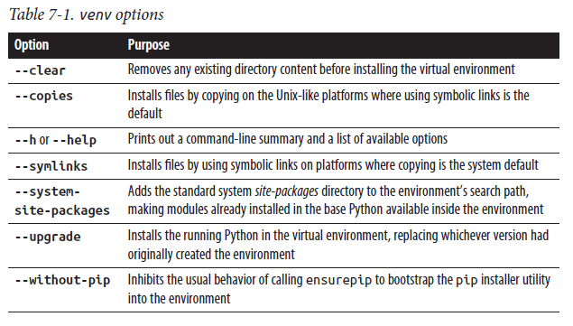

Know Which Python You’re Running

When you enter the command python at the command line, your shell has rules (which differ among Windows, Linux, and macOS) that determine which program you run. If you are clear on those rules, you always know which interpreter you are using.

Using python -m venv directory_path to create a virtual environment guarantees that it’s based on the same Python version as the interpreter used to create it. Similarly, using python -m pip package_name will install the package for the interpreter associated with the python command. Activating a virtual environment changes the association with the python command: this is the simplest way to ensure packages are installed into the virtual environment

The following Unix terminal session shows the creation of a virtualenv and the structure of the created directory tree. The listing of the bin subdirectory shows that this particular user, by default, uses an interpreter installed in /usr/local/bin. ( When running these commands on reduced-footprint Linux distributions, you may need to separately install venv or other supporting packages first. )

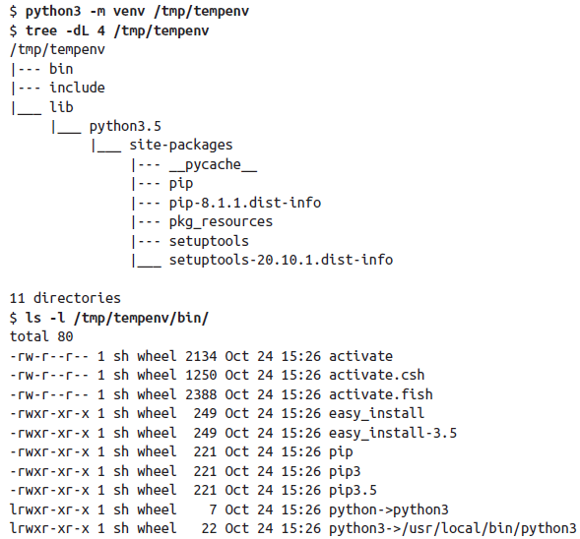

Deleting a virtualenv is as simple as removing the directory in which it resides (and all subdirectories and files in the tree: rm -rf envpath in Unix-like systems). Ease of removal is a helpful aspect of using virtualenvs.

The venv module includes features to help the programmed creation of tailored environments (e.g., by preinstalling certain modules in the environment or performing other post-creation steps). It is comprehensively documented online; we do not cover the API further in this book.

### Working with Virtual Environments

To use a virtualenv, you activate it from your normal shell environment. Only one virtualenv can be active at a time—activations don’t “stack” like function calls. Activation tells your Python environment to use the virtualenv’s Python interpreter and site-packages (along with the interpreter’s full standard library). When you want to stop using those dependencies, deactivate the virtualenv, and your standard Python environment is once again available. The virtualenv directory tree continues to exist until deleted, so you can activate and deactivate it at will.

Activating a virtualenv in Unix-based environments requires using the source shell command so that the commands in the activation script make changes to the current shell environment. Simply running the script would mean its commands were executed in a subshell, and the changes would be lost when the subshell terminated. For bash, zsh, and similar shells, you activate an environment located at path envpath with the command:

$ source envpath/bin/activate

or:

$ . envpath/bin/activate

Users of other shells are supported by the scripts activate.csh and activate.fish, located in the same directory. On Windows systems, use activate.bat (or, if using Powershell, Activate.ps1):

C:\> envpath/Scripts/activate.bat

Activation does many things. Most importantly, it:

* Adds the virtualenv’s bin directory at the beginning of the shell’s PATH environment variable, so its commands get run in preference to anything of the same name already on the PATH
* Defines a deactivate command to remove all effects of activation and return the Python environment to its former state
* Modifies the shell prompt to include the virtualenv’s name at the start
* Defines a VIRTUAL_ENV environment variable as the path to the virtualenv’s root directory (scripts can use this to introspect the virtualenv)

As a result of these actions, once a virtualenv is activated, the python command runs the interpreter associated with that virtualenv. The interpreter sees the libraries (modules and packages) installed in that environment, and pip—now the one from the virtualenv, since installing the module also installed the command in the virtualenv’s bin directory—by default installs new packages and modules in the environment’s site-packages directory.

Those new to virtualenvs should understand that a virtualenv is not tied to any project directory. It’s perfectly possible to work on several projects, each with its own source tree, using the same virtualenv. Activate it, then move around your filesystem as necessary to accomplish your programming tasks, with the same libraries available (because the virtualenv determines the Python environment). When you want to disable the virtualenv and stop using that set of resources, simply issue the command deactivate. This undoes the changes made on activation, removing the virtualenv’s bin directory from your PATH, so the python command once again runs your usual interpreter. As long as you don’t delete it, the virtualenv remains available for future use: just repeat the command to activate it. Do Not Use py –3.x in a Virtualenv on Windows The Windows py launcher provides mixed support for virtualenvs. It makes it very easy to define a virtualenv using a specific Python version, using a command like the following:

C:\> py -3.7 -m venv C:\path\to\new_virtualenv

This creates a new virtualenv, running the installed Python 3.7.

Once activated, you can run the Python interpreter in the virtualenv using either the python command or the bare py command with no version specified. However, if you specify the py command using a version option, even if it is the same version used to construct the virtualenv, you will not run the virtualenv Python. Instead, you will run the corresponding system-installed version of Python.

### Managing Dependency Requirements

Since virtualenvs were designed to complement installation with pip, it should come as no surprise that pip is the preferred way to maintain dependencies in a virtualenv. Because pip is already extensively documented, we mention only enough here to demonstrate its advantages in virtual environments. Having created a virtualenv, activated it, and installed dependencies, you can use the pip freeze command to learn the exact versions of those dependencies:

(tempenv) $ pip freeze

appnope==0.1.0

decorator==4.0.10

ipython==5.1.0

ipython-genutils==0.1.0

pexpect==4.2.1

pickleshare==0.7.4

prompt-toolkit==1.0.8

ptyprocess==0.5.1

Pygments==2.1.3

requests==2.11.1

simplegeneric==0.8.1

six==1.10.0

traitlets==4.3.1

wcwidth==0.1.7

If you redirect the output of this command to a file called filename, you can re-create the same set of dependencies in a different virtualenv with the command pip install -r filename.

When distributing code for use by others, Python developers conventionally include a requirements.txt file listing the necessary dependencies. pip installs any indicated dependencies along with the packages you request when you install software from PyPI. While you’re developing software it’s also convenient to have a requirements file, as you can use it to add the necessary dependencies to the active virtualenv (unless they are already installed) with a simple pip install -r requirements.txt.

To maintain the same set of dependencies in several virtualenvs, use the same requirements file to add dependencies to each one. This is a convenient way to develop projects to run on multiple Python versions: create virtualenvs based on each of your required versions, then install from the same requirements file in each. While the preceding example uses exactly versioned dependency specifications as produced by pip freeze, in practice you can specify dependencies and version requirements in quite complex ways; see the documentation for details.

### Other Environment Management Solutions

Python virtual environments are focused on providing an isolated Python interpreter, into which you can install dependencies for one or more Python applications. The virtualenv package was the original way to create and manage virtualenvs. It has extensive facilities, including the ability to create environments from any available Python interpreter. Now maintained by the Python Packaging Authority team, a subset of its functionality has been extracted as the standard library venv module covered earlier, but virtualenv is worth learning about if you need more control.

The pipenv package is another dependency manager for Python environments. It maintains virtual environments whose contents are recorded in a file named Pipfile. Much in the manner of similar JavaScript tools, it provides deterministic environments through the use of a Pipfile.lock file, allowing the exact same dependencies to be deployed as in the original installation.

conda, mentioned in “Anaconda and Miniconda” on page 8, has a rather broader scope and can provide package, environment, and dependency management for any language. conda is written in Python, and installs its own Python interpreter in the base environment. Whereas a standard Python virtualenv normally uses the Python interpreter with which it was created; in conda, Python itself (when it is included in the environment) is simply another dependency. This makes it practical to update the version of Python used in the environment, if necessary. You can also, if you wish, use pip to install packages in a Python-based conda environment. conda can dump an environment’s contents as a YAML file, and you can use the file to replicate the environment elsewhere.

Because of its additional flexibility, coupled with comprehensive open source support led by its originator, Anaconda, Inc. (formerly Continuum), conda is widely used in academic environments, particularly in data science and engineering, artificial intelligence, and financial analytics. It installs software from what it calls channels. The default channel maintained by Anaconda contains a wide range of packages, and third parties maintain specialized channels (such as the bioconda channel for bioinformatics software). There is also a community-based conda-forge channel, open to anyone who wants to join up and add software. Signing up for an account on Anaconda.org lets you create your own channel and distribute software through the conda-forge channel.

### Best Practices with Virtualenvs

There is remarkably little advice on how best to manage your work with virtualenvs, though there are several sound tutorials: any good search engine will give you access to the most current ones. We can, however, offer a modest amount of advice that we hope will help you to get the most out of virtual environments.

When you are working with the same dependencies in multiple Python versions, it is useful to indicate the version in the environment name and use a common prefix. So, for the project mutex you might maintain environments called mutex_39 and mutex_310 for development under two different versions of Python. When it’s obvious which Python is involved (remember, you see the environment name in your shell prompt), there’s less risk of testing with the wrong version. You can maintain dependencies using common requirements to control resource installation in both.

Keep the requirements file(s) under source control, not the whole environment. Given the requirements file it’s easy to re-create a virtualenv, which depends only on the Python release and the requirements. You distribute your project, and let your users decide which version(s) of Python to run it on and create the appropriate virtual environment(s).

Keep your virtualenvs outside your project directories. This avoids the need to explicitly force source code control systems to ignore them. It really doesn’t matter where else you store them.

Your Python environment is independent of your projects’ locations in the filesystem. You can activate a virtual environment and then switch branches and move around a change-controlled source tree to use it wherever is convenient.

To investigate a new module or package, create and activate a new virtualenv and then pip install the resources that interest you. You can play with this new environment to your heart’s content, confident in the knowledge that you won’t be installing unwanted dependencies into other projects.

You may find that experiments in a virtualenv require installation of resources that aren’t currently project requirements. Rather than “pollute” your development environment, fork it: create a new virtualenv from the same requirements plus the testing functionality. Later, to make these changes permanent, use change control to merge your source and requirements changes back in from the forked branch.

If you are so inclined, you can create virtual environments based on debug builds of Python, giving you access to a wealth of information about the performance of your Python code (and, of course, of the interpreter itself).

Developing a virtual environment also requires change control, and the ease of virtualenv creation helps here too. Suppose that you recently released version 4.3 of a module, and you want to test your code with new versions of two of its dependencies. You could, with sufficient skill, persuade pip to replace the existing copies of dependencies in your existing virtualenv. It’s much easier, though, to branch your project using source control tools, update the requirements, and create an

entirely new virtual environment based on the updated requirements. The original virtualenv remains intact, and you can switch between virtualenvs to investigate specific aspects of any migration issues that might arise. Once you have adjusted your code so that all tests pass with the updated dependencies, you can check in your code and requirement changes and merge into version 4.4 to complete the update, advising your colleagues that your code is now ready for the updated versions of the dependencies.

Virtual environments won’t solve all of a Python programmer’s problems: tools can always be made more sophisticated, or more general. But, by golly, virtualenvs work, and we should take all the advantage of them that we can.

## Core Built-ins and Standard Library Modules

The term built-in has more than one meaning in Python. In many contexts, built-in means an object directly accessible to Python code without an import statement. The section “Python built-ins” on page 224 shows Python’s mechanism to allow this direct access. Built-in types in Python include numbers, sequences, dictionaries, sets, functions (all covered in Chapter 3), classes (covered in “Python Classes” on page 115), standard exception classes (covered in “Exception Objects” on page 205), and modules (covered in “Module Objects” on page 222). “The io Module” on page 322 covers the file type, and “Internal Types” on page 434 some other built-in types intrinsic to Python’s internal operation. This chapter provides additional coverage of built-in core types in the opening section and covers built-in functions available in the module builtins in “Built-in Functions” on page 251.

Some modules are called “built-in” because they’re in the Python standard library (though it takes an import statement to use them), as opposed to add-on modules, also known as Python extensions.

This chapter covers several built-in core modules: namely, the standard library modules sys, copy, collections, functools, heapq, argparse, and itertools.

You’ll find a discussion of each module x in the respective section “The x Module.” Chapter 9 covers some string-related built-in core modules (string, codecs, and unicodedata) with the same section-name convention. Chapter 10 covers re in “Regular Expressions and the re Module” on page 305.

### Built-in Types

Table 8-1 provides a brief overview of Python’s core built-in types. More details about many of these types, and about operations on their instances, are found throughout Chapter 3. In this section, by “any number” we mean, specifically, “any noncomplex number.” Also, many built-ins accept at least some of their parameters in a positional-only way; we use the 3.8+ positional-only marker /, covered in “Positional-only marker” on page 96, to indicate this.

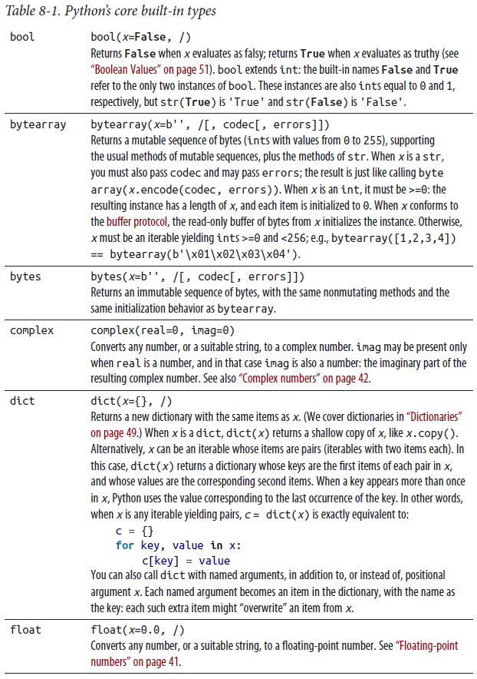

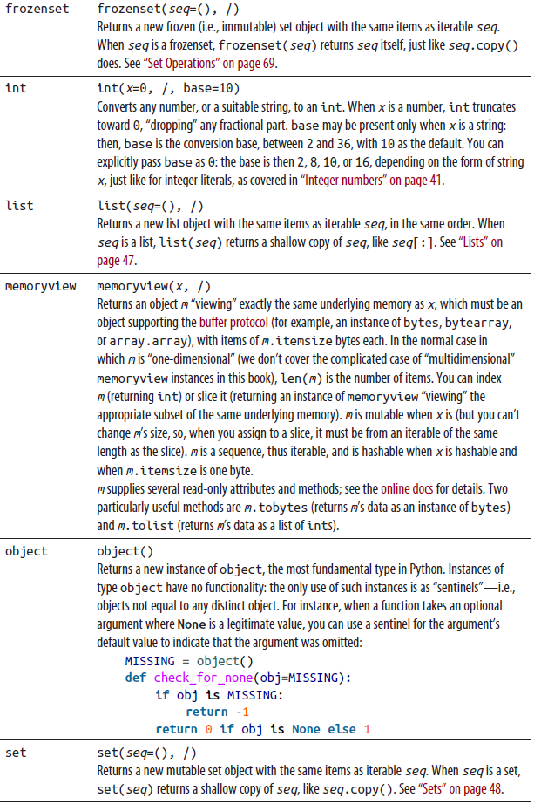

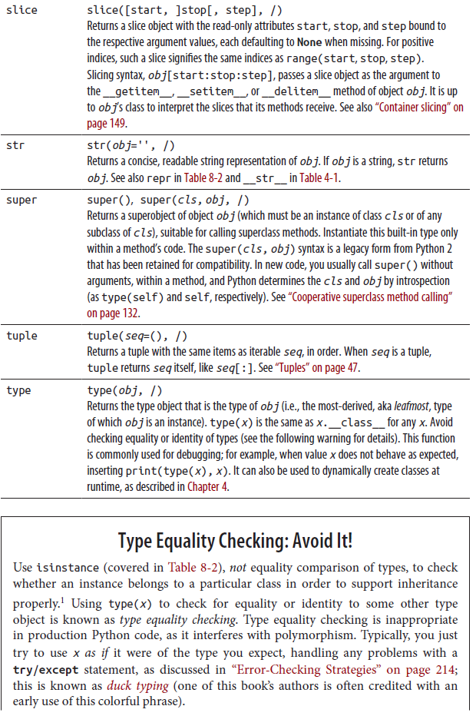

When you just have to type-check, usually for debugging purposes, use isinstance instead. In a broader sense, isinstance(x, atype) is also a form of type checking, but it is a lesser evil than type(x) is atype. isinstance accepts an x that is an instance of any subclass of atype, or an object that implements protocol atype, not just a direct instance of atype itself. In particular, isinstance is fine when you’re checking for an abstract base class (see “Abstract Base Classes” on page 150) or protocol (see “Protocols” on page 179); this newer idiom is also sometimes known as goose typing (again, this phrase is credited to one of this book’s authors).

### Built-in Functions

Table 8-2 covers Python functions (and some types that, in practice, are only used as if they were functions) in the module builtins, in alphabetical order. Built-ins’ names are not keywords. This means you can bind, in local or global scope, an identifier that’s a built-in name, although we recommend avoiding it (see the following warning!). Names bound in local or global scope override names bound in built-in scope, so local and global names hide built-in ones. You can also rebind names in built-in scope, as covered in “Python built-ins” on page 224.

**Don’t Hide Built-ins**

Avoid accidentally hiding built-ins: your code might need them later. It’s often tempting to use natural names such as input, list, or filter for your own variables, but don’t do it: these are names of built-in Python types or functions, and reusing them for your own purposes makes those built-in types and functions inaccessible. Unless you get into the habit of never hiding built-ins’ names with your own, sooner or later you’ll get mysterious bugs in your code caused by just such hiding occurring accidentally.

Many built-in functions cannot be called with named arguments, only with positional ones. In Table 8-2, we mention cases in which this limitation does not hold; when it does, we also use the 3.8+ positional-only marker /, covered in “Positional-only marker” on page 96.

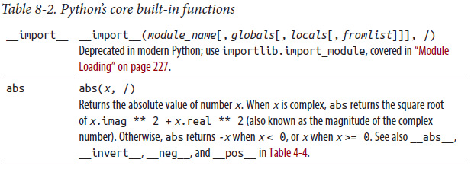

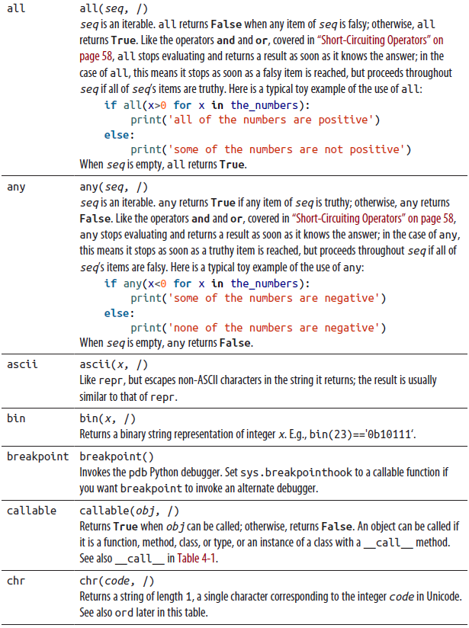

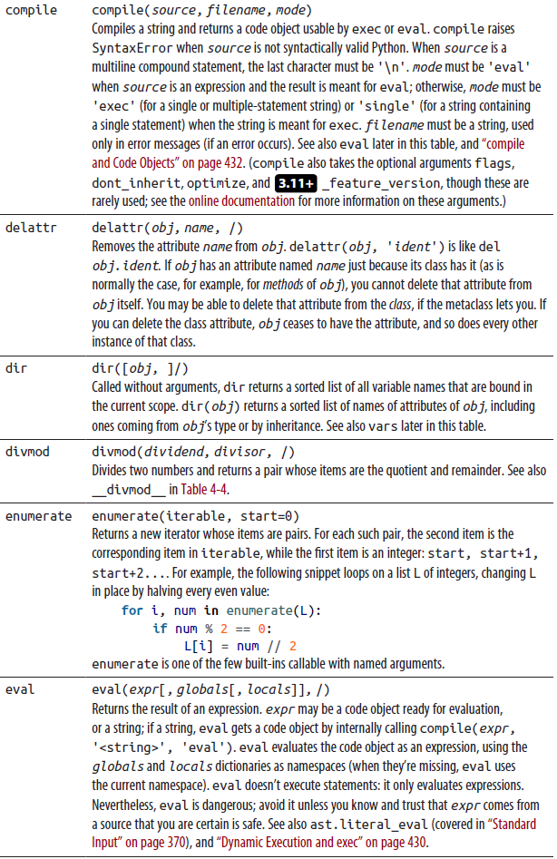

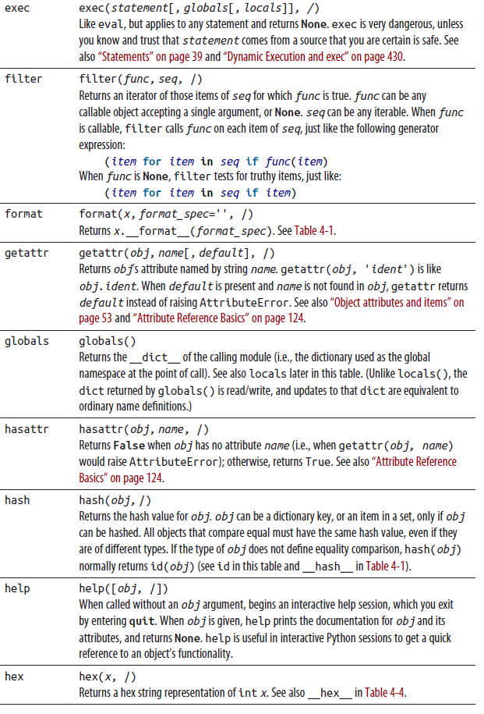

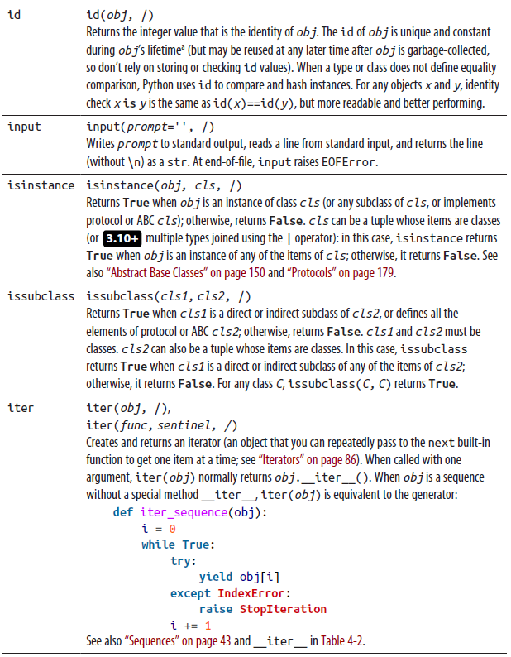

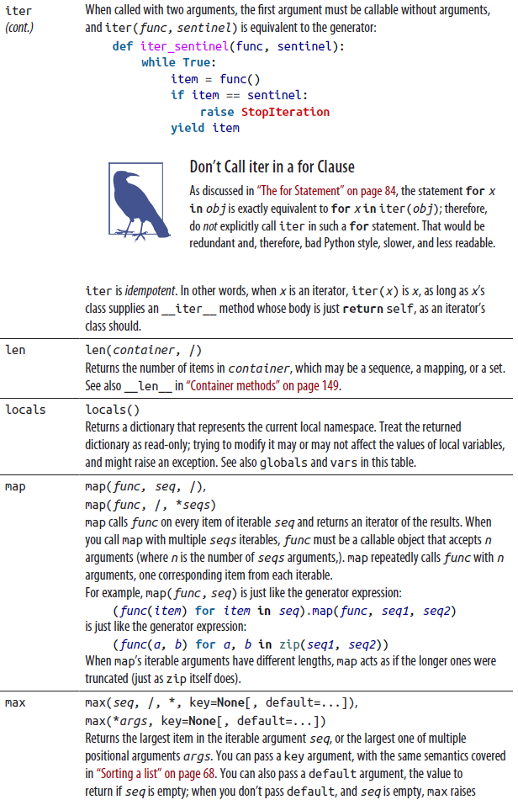



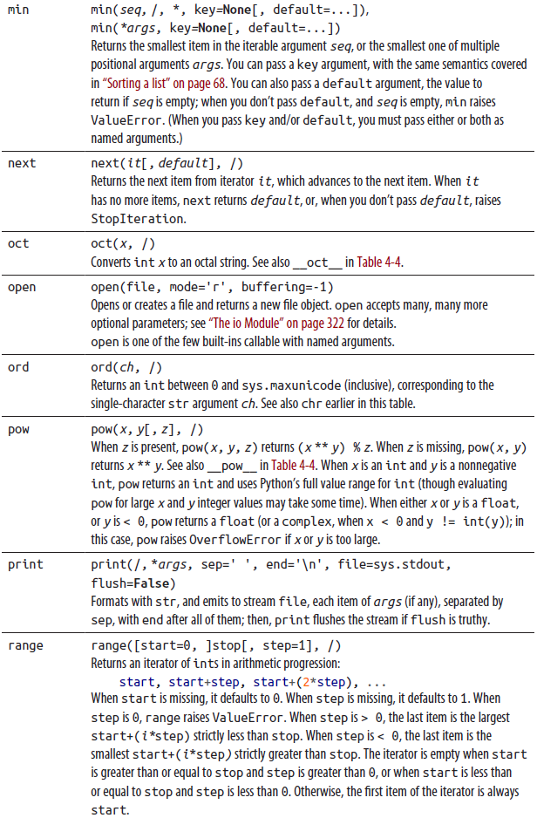



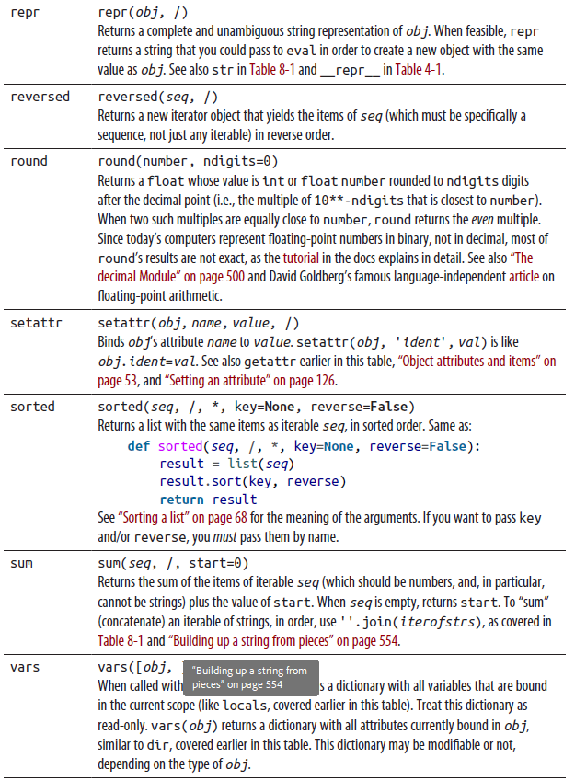

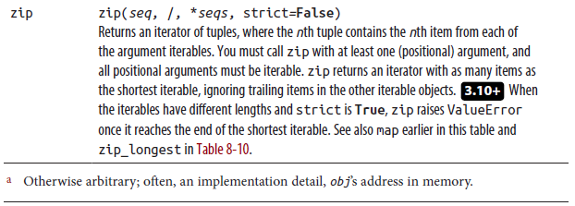

### The sys Module

The attributes of the sys module are bound to data and functions that provide information on the state of the Python interpreter or affect the interpreter directly. Table 8-3 covers the most frequently used attributes of sys. Most sys attributes we don’t cover are meant specifically for use in debuggers, profilers, and integrated development environments; see the online docs for more information. Platform-specific information is best accessed using the platform module, which we do not cover in this book; see the online docs for details on this module.

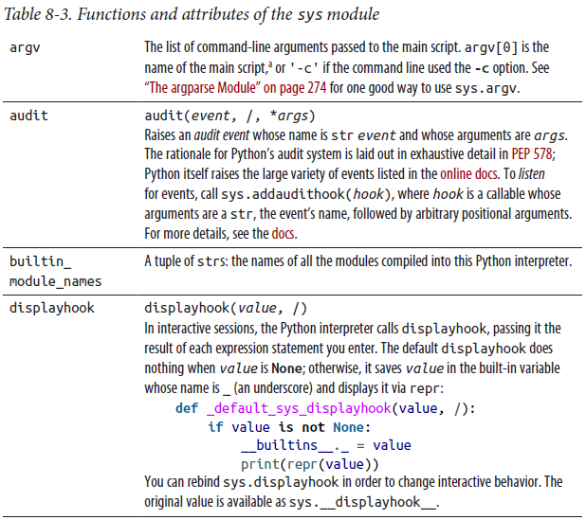

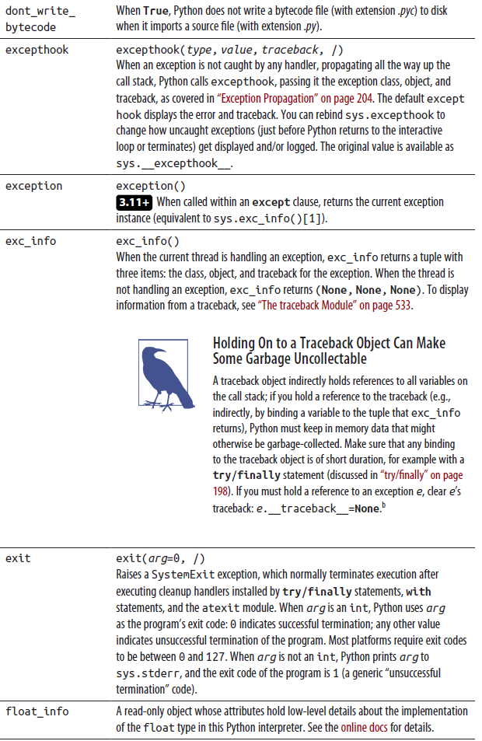

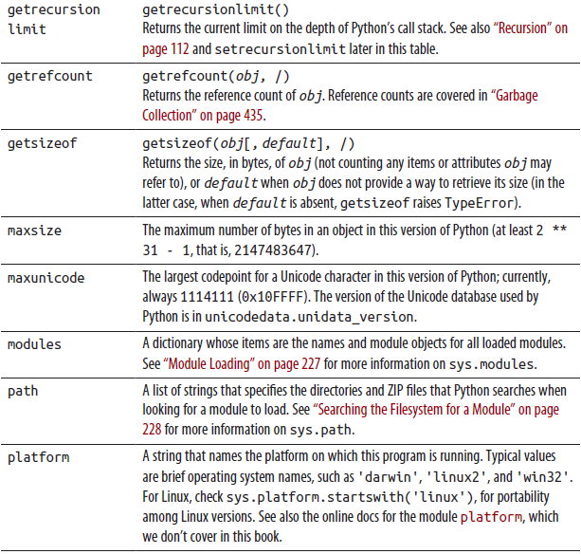

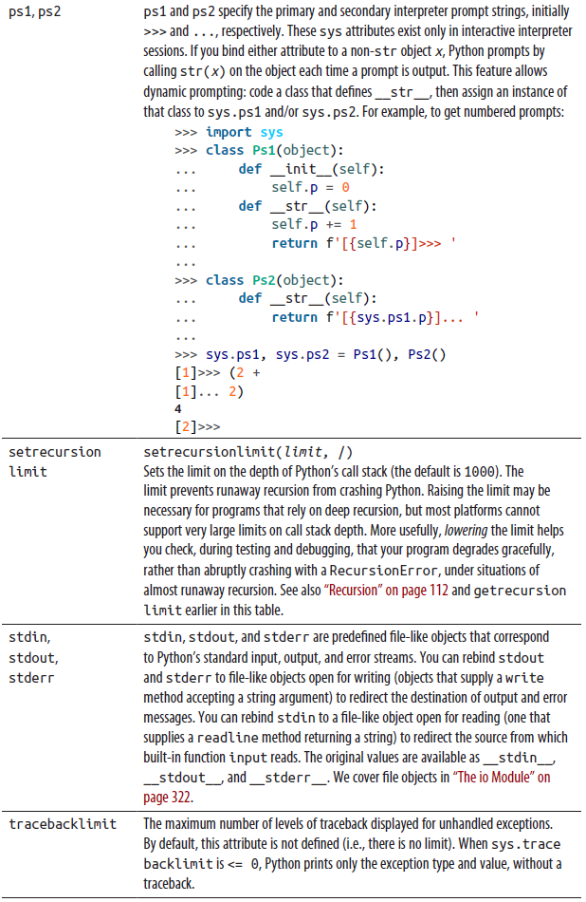

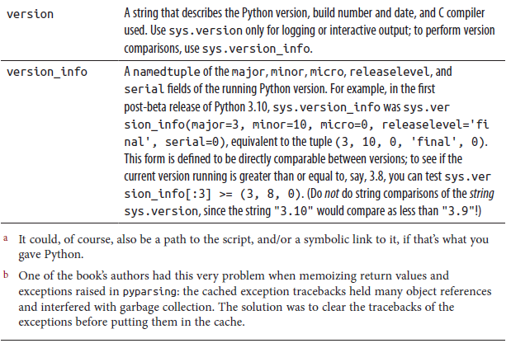

### The copy Module

As discussed in “Assignment Statements” on page 53, assignments in Python do not copy the righthand-side object being assigned. Rather, assignments add references to the RHS object. When you want a copy of object x, ask x for a copy of itself, or ask x’s type to make a new instance copied from x. If x is a list, list(x) returns a copy of x, as does x[:]. If x is a dictionary, dict(x) and x.copy() return a copy of x. If x is a set, set(x) and x.copy() return a copy of x. In each case, this book’s authors prefer the uniform and readable idiom of calling the type, but there is no consensus on this style issue in the Python community.

The copy module supplies a copy function to create and return a copy of many types of objects. Normal copies, such as those returned by list(x) for a list x and copy.copy(x) for any x, are known as shallow copies: when x has references to other objects (either as items or as attributes), a normal (shallow) copy of x has distinct references to the same objects. Sometimes, however, you need a deep copy, where referenced objects are deep-copied recursively (fortunately, this need is rare, since a deep copy can take a lot of memory and time); for these cases, the copy module also supplies a deepcopy function. These functions are discussed further in Table 8-4.

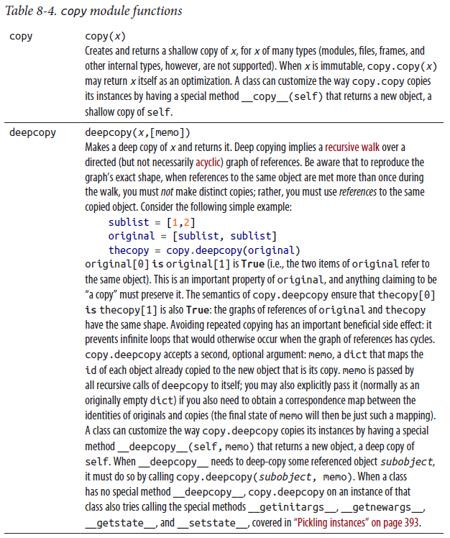

### The collections Module

The collections module supplies useful types that are collections (i.e., containers), as well as the ABCs covered in “Abstract Base Classes” on page 150. Since Python 3.4, the ABCs have been in collections.abc; for backward compatibility they could still be accessed directly in collections itself until Python 3.9, but this functionality was removed in 3.10.

#### ChainMap

ChainMap “chains” multiple mappings together; given a ChainMap instance c, accessing c[key] returns the value in the first of the mappings that has that key, while all changes to c affect only the very first mapping in c. To further explain, you could approximate this as follows:

class ChainMap(collections.abc.MutableMapping):

def __init__(self, *maps):

self.maps = list(maps)

self._keys = set()

for m in self.maps:

self._keys.update(m)

def __len__(self): return len(self._keys)

def __iter__(self): return iter(self._keys)

def __getitem__(self, key):

if key not in self._keys: raise KeyError(key)

for m in self.maps:

try: return m[key]

except KeyError: pass

def __setitem__(self, key, value):

self.maps[0][key] = value

self._keys.add(key)

def __delitem__(self, key):

del self.maps[0][key]

self._keys = set()

for m in self.maps:

self._keys.update(m)

Other methods could be defined for efficiency, but this is the minimum set that a MutableMapping requires. See the online docs for more details and a collection of recipes on how to use ChainMap.

#### Counter

Counter is a subclass of dict with int values that are meant to count how many times a key has been seen (although values are allowed to be <= 0); it’s roughly equivalent to types that other languages call “bag” or “multiset” types. A Counter instance is normally built from an iterable whose items are hashable: c = collec tions.Counter(iterable). Then, you can index c with any of iterable’s items to get the number of times that item appeared. When you index c with any missing key, the result is 0 (to remove an entry in c, use del c[entry]; setting c[entry]=0 leaves entry in c, with a value of 0).

c supports all methods of dict; in particular, c.update(otheriterable) updates all the counts, incrementing them according to occurrences in otheriterable. So, for example:

>>> c = collections.Counter('moo')

>>> c.update('foo')

leaves c['o'] giving 4, and c['f'] and c['m'] each giving 1. Note that removing an entry from c (with del) may not decrement the counter, but subtract (described in the following table) does:

>>> del c['foo']

>>> c['o']

4

>>> c.subtract('foo')

>>> c['o']

2

In addition to dict methods, c supports the extra methods detailed in Table 8-5.

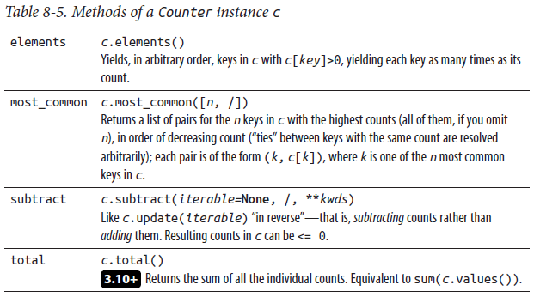

Counter objects support common arithmetic operators, such as +, -, &, and | for addition, subtraction, union, and intersection. See the online docs for more details and a collection of useful recipes on how to use Counter.

#### OrderedDict

OrderedDict is a subclass of dict with additional methods to access and manipulate items with respect to their insertion order. o.popitem() removes and returns the item at the most recently inserted key; o.move_to_end(key, last=True) moves the item with key key to the end (when last is True, the default) or to the start (when last is False). Equality tests between two instances of OrderedDict are order sensitive; equality tests between an instance of OrderedDict and a dict or other mapping are not. Since Python 3.7, dict insertion order is guaranteed to be maintained: many uses that previously required OrderedDict can now just use ordinary Python dicts. A significant difference remaining between the two is that OrderedDict’s test for equality with other OrderedDicts is order sensitive, while dict’s equality test is not. See the online docs for more details and a collection of

recipes on how to use OrderedDict.

#### defaultdict

defaultdict extends dict and adds one per instance attribute, named default_fac tory. When an instance d of defaultdict has None as the value of d.default_fac tory, d behaves exactly like a dict. Otherwise, d.default_factory must be callable without arguments, and d behaves just like a dict except when you access d with a key k that is not in d. In this specific case, the indexing d[k] calls d.default_fac tory(), assigns the result as the value of d[k], and returns the result. In other words, the type defaultdict behaves much like the following Python-coded class:

class defaultdict(dict):

def __init__(self, default_factory=None, *a, **k):

super().__init__(*a, **k)

self.default_factory = default_factory

def __getitem__(self, key):

if key not in self and self.default_factory is not None:

self[key] = self.default_factory()

return dict.__getitem__(self, key)

As this Python equivalent implies, to instantiate defaultdict you usually pass it an extra first argument (before any other arguments, positional and/or named, if any, to pass on to plain dict). The extra first argument becomes the initial value of default_factory; you can also access and rebind default_factory later, though doing so is infrequent in normal Python code.

All behavior of defaultdict is essentially as implied by this Python equivalent (except str and repr, which return strings different from those they would return for a dict). Named methods, such as get and pop, are not affected. All behavior related to keys (method keys, iteration, membership test via operator in, etc.) reflects exactly the keys that are currently in the container (whether you put them there explicitly, or implicitly via an indexing that called default_factory).

A typical use of defaultdict is, for example, to set default_factory to list, to make a mapping from keys to lists of values:

def make_multi_dict(items):

d = collections.defaultdict(list)

for key, value in items:

d[key].append(value)

return d

Called with any iterable whose items are pairs of the form (key, value), with all keys being hashable, this make_multi_dict function returns a mapping that associates each key to the lists of one or more values that accompanied it in the iterable (if you want a pure dict result, change the last statement into return dict(d)—this is rarely necessary).

If you don’t want duplicates in the result, and every value is hashable, use a collections.defaultdict(set), and add rather than append in the loop. ( When first introduced, defaultdict(int) was commonly used to maintain counts of items. Since Counter is now part of the collections module, use Counter instead of defaultdict(int) for the specific task of counting items.)

keydefaultdict

A variation on defaultdict that is not found in the collections module is a defaultdict whose default_factory takes the key as an initialization argument. This example shows how you can implement this for yourself:

class keydefaultdict(dict):

def __init__(self, default_factory=None, *a, **k):

super().__init__(*a, **k)

self.default_factory = default_factory

def __missing__(self, key):

if self.default_factory is None:

raise KeyError(key)

self[key] = self.default_factory(key)

return self[key]

The dict class supports the __missing__ method for subclasses to implement custom behavior when a key is accessed that is not yet in the dict. In this example, we implement __missing__ to call the default factory method with the new key, and add it to the dict. You can use keydefaultdict rather than defaultdict when the default_factory requires an argument (most often, this happens when the default factory is a class that takes an identifier constructor argument).

#### deque

deque is a sequence type whose instances are “double-ended queues” (additions and removals at either end are fast and thread-safe). A deque instance d is a mutable sequence, with an optional maximum length, and can be indexed and iterated on (however, d cannot be sliced; it can only be indexed one item at a time, whether for access, rebinding, or deletion). If a deque instance d has a maximum length, when items are added to either side of d so that d’s length exceeds that maximum, items are silently dropped from the other side.

deque is especially useful for implementing first-in, first-out (FIFO) queues. ( For last-in, first-out (LIFO) queues, aka “stacks,” a list, with its append and pop methods, is perfectly sufficient. ) deque is also good for maintaining “the latest N things seen,” also known in some other languages as a ring buffer.

Table 8-6 lists the methods the deque type supplies.

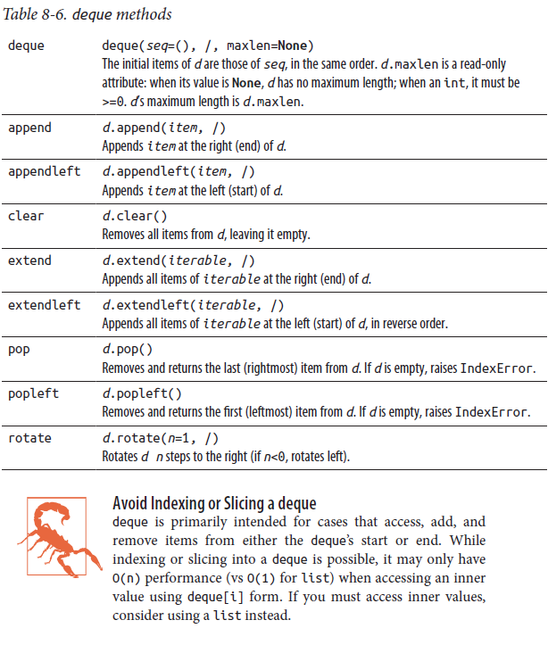

### The functools Module

The functools module supplies functions and types supporting functional programming in Python, listed in Table 8-7.

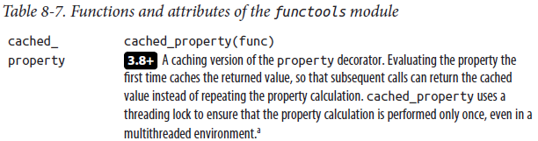

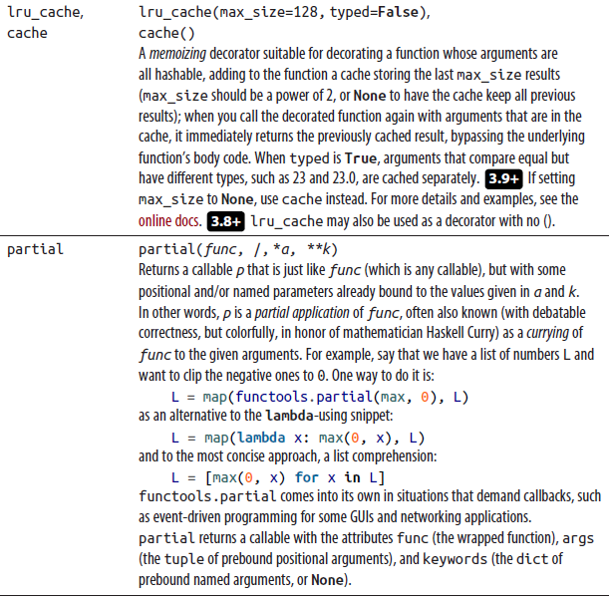

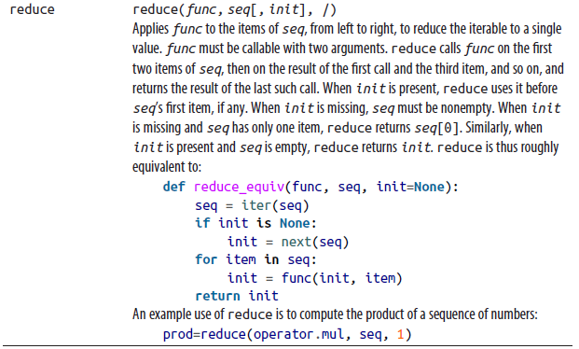

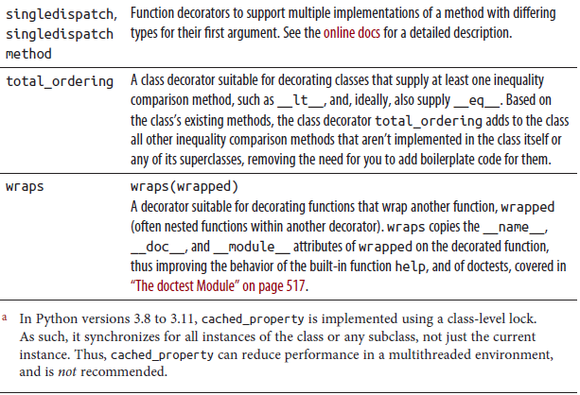

### The heapq Module

The heapq module uses min-heap algorithms to keep a list in “nearly sorted” order as items are inserted and extracted. heapq’s operation is faster than calling a list’s sort method after each insertion, and much faster than bisect (covered in the online docs). For many purposes, such as implementing “priority queues,” the nearly sorted order supported by heapq is just as good as a fully sorted order, and faster to establish and maintain. The heapq module supplies the functions listed in Table 8-8.

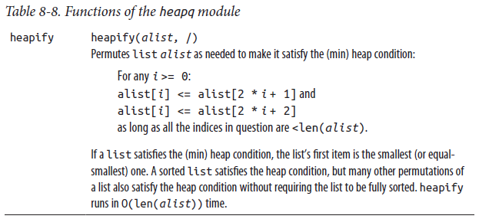

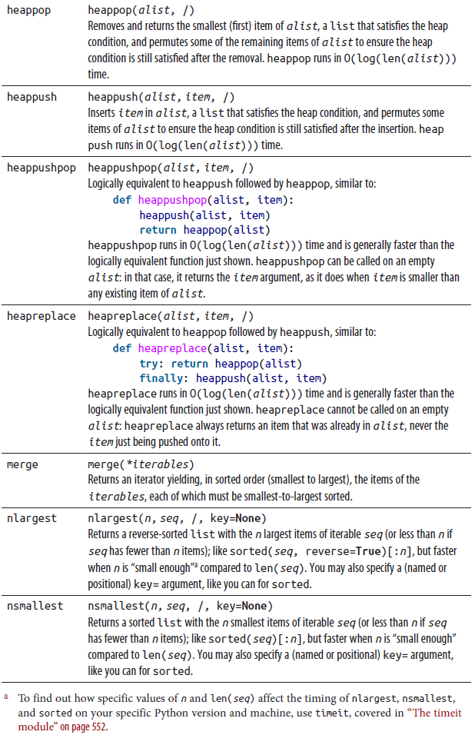

The Decorate–Sort–Undecorate Idiom

Several functions in the heapq module, although they perform comparisons, do not accept a key= argument to customize the comparisons. This is inevitable, since the functions operate in place on a plain list of the items: they have nowhere to “stash away” custom comparison keys computed once and for all.

When you need both heap functionality and custom comparisons, you can apply the good old decorate–sort–undecorate (DSU) idiom ( Also known as the Schwartzian transform. ) (which used to be crucial to optimize sorting in ancient versions of Python, before the key= functionality was introduced).

The DSU idiom, as applied to heapq, has the following components:

**Decorate**

Build an auxiliary list A where each item is a tuple starting with the sort key and ending with the item of the original list L.

**Sort**

Call heapq functions on A, typically starting with heapq.heapify(A). ( This step is not quite a full “sort,” but it looks close enough to call it one, at least if you squint. )

**Undecorate**

When you extract an item from A, typically by calling heapq.heappop(A), return just the last item of the resulting tuple (which was an item of the original list L).

When you add an item to A by calling heapq.heappush(A, /, item), decorate the actual item you’re inserting into a tuple starting with the sort key. This sequence of operations can be wrapped up in a class, as in this example:

import heapq

class KeyHeap(object):

def __init__(self, alist, /, key):

self.heap = [(key(o), i, o) for i, o in enumerate(alist)]

heapq.heapify(self.heap)

self.key = key

if alist:

self.nexti = self.heap[-1][1] + 1

else:

self.nexti = 0

def __len__(self):

return len(self.heap)

def push(self, o, /):

heapq.heappush(self.heap, (self.key(o), self.nexti, o))

self.nexti += 1

def pop(self):

return heapq.heappop(self.heap)[-1]

In this example, we use an increasing number in the middle of the decorated tuple (after the sort key, before the actual item) to ensure that actual items are never compared directly, even if their sort keys are equal (this semantic guarantee is an important aspect of the key argument’s functionality for sort and the like).

### The argparse Module

When you write a Python program meant to be run from the command line (or from a shell script in Unix-like systems, or a batch file in Windows), you often want to let the user pass to the program, on the command line or within the script, command-line arguments (including command-line options, which by convention are arguments starting with one or two dash characters). In Python, you can access the arguments as sys.argv, an attribute of the module sys holding those arguments as a list of strings (sys.argv[0] is the name or path by which the user started your program; the arguments are in the sublist sys.argv[1:]). The Python standard library offers three modules to process those arguments; we only cover the newest and most powerful one, argparse, and we only cover a small, core subset of argparse’s rich functionality. See the online reference and tutorial for much, much more. argparse provides one class, which has the following signature:

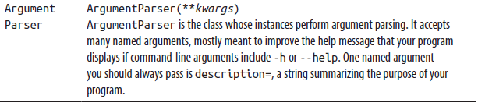

Given an instance ap of ArgumentParser, prepare it with one or more calls to ap.add_argument, then use it by calling ap.parse_args() without arguments (so it parses sys.argv). The call returns an instance of argparse.Namespace, with your program’s arguments and options as attributes.

add_argument has a mandatory first argument: an identifier string for positional command-line arguments, or a flag name for command-line options. In the latter case, pass one or more flag names; an option can have both a short name (dash, then a character) and a long name (two dashes, then an identifier).

After the positional arguments, pass to add_argument zero or more named arguments to control its behavior. Table 8-9 lists the most commonly used ones.

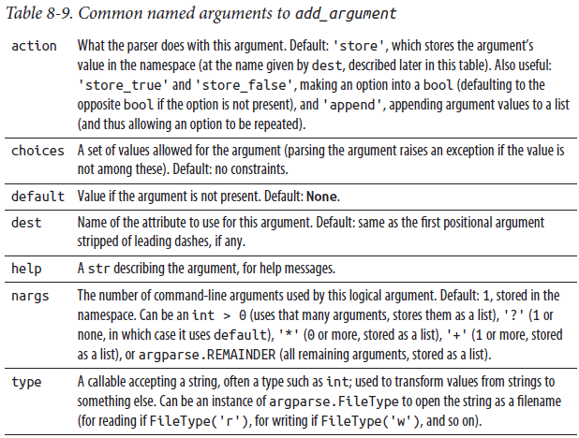

Here’s a simple example of argparse — save this code in a file called greet.py: import argparse

ap = argparse.ArgumentParser(description='Just an example')

ap.add_argument('who', nargs='?', default='World')

ap.add_argument('--formal', action='store_true')

ns = ap.parse_args()

if ns.formal:

greet = 'Most felicitous salutations, o {}.'

else:

greet = 'Hello, {}!'

print(greet.format(ns.who))

Now, python greet.py prints Hello, World!, while python greet.py --formal Cornelia prints Most felicitous salutations, o Cornelia.

The itertools Module

The itertools module offers high-performance building blocks to build and manipulate iterators. To handle long processions of items, iterators are often better than lists, thanks to the iterators’ intrinsic “lazy evaluation” approach: an iterator produces items one at a time, as needed, while all items of a list (or other sequence) must be in memory at the same time. This approach even makes it feasible to build and use unbounded iterators, while lists must always have finite numbers of items (since any machine has a finite amount of memory).

Table 8-10 covers the most frequently used attributes of itertools; each of them is an iterator type, which you call to get an instance of the type in question, or a factory function behaving similarly. See the online docs for more itertools attributes, including combinatorial generators for permutations, combinations, and Cartesian products, as well as a useful taxonomy of itertools attributes. The online docs also offer recipes describing ways to combine and use itertools attributes. The recipes assume you have from itertools import * at the top of your module; this is not recommended use, just an assumption to make the recipes’ code more compact. It’s best to import itertools as it, then use references such as it.something rather than the more verbose itertools.something. ( Some experts recommend from itertools import *, but the authors of this book disagree )

Table 8-10. Functions and attributes of the itertools module

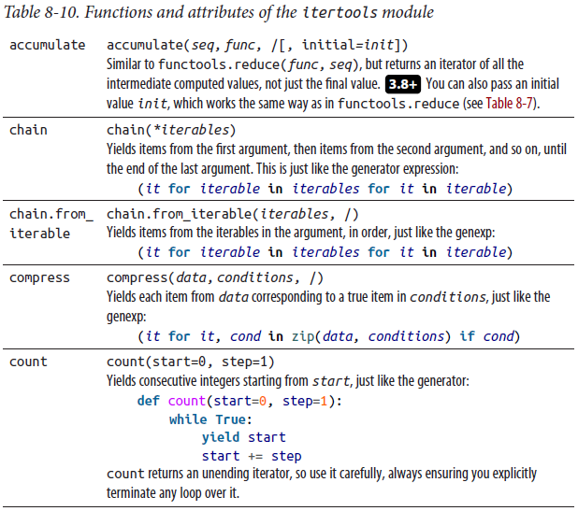

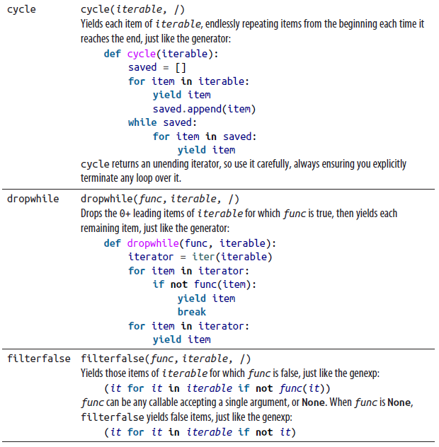

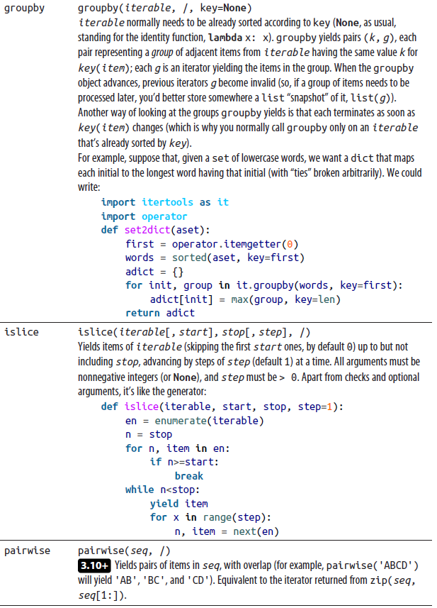

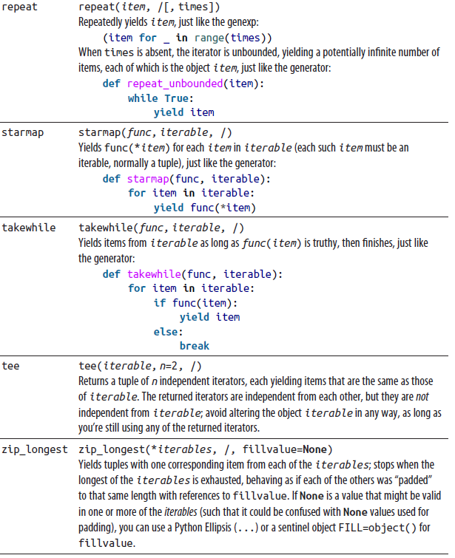

We have shown equivalent generators and genexps for many attributes of iter tools, but it’s important to take into account the sheer speed of itertools. As a trivial example, consider repeating some action 10 times:

for _ in itertools.repeat(None, 10): pass

This turns out to be about 10 to 20% faster, depending on the Python release and platform, than the straightforward alternative:

for _ in range(10): pass

## Strings and Things

Python’s str type implements Unicode text strings with operators, built-in functions, methods, and dedicated modules. The somewhat similar bytes type represents arbitrary binary data as a sequence of bytes, also known as a bytestring or byte string. Many textual operations are possible on objects of either type: since these types are immutable, methods mostly create and return a new string unless returning the subject string unchanged. A mutable sequence of bytes can be represented as a bytearray, briefly introduced in “bytearray objects” on page 47.

This chapter first covers the methods available on these three types, then discusses the string module and string formatting (including formatted string literals), followed by the textwrap, pprint, and reprlib modules. Issues related specifically to Unicode are covered at the end of the chapter.

### Methods of String Objects

str, bytes, and bytearray objects are sequences, as covered in “Strings” on page 44; of these, only bytearray objects are mutable. All immutable-sequence operations (repetition, concatenation, indexing, and slicing) apply to instances of all three types, returning a new object of the same type. Unless otherwise specified in Table 9-1, methods are present on objects of all three types. Most methods of str, bytes, and bytearray objects return values of the same type, or are specifically intended to convert among representations.

Terms such as “letters,” “whitespace,” and so on refer to the corresponding attributes of the string module, covered in the following section. Although bytearray objects are mutable, their methods returning a bytearray result do not mutate the object but instead return a newly created bytearray, even when the result is the same as the subject string.

For brevity, the term bytes in the following table refers to both bytes and byte array objects. Take care when mixing these two types, however: while they are generally interoperable, the type of the result usually depends on the order of the operands.

In Table 9-1, since integer values in Python can be arbitrarily large, for conciseness we use sys.maxsize for integer default values to mean, in practice, “integer of unlimited magnitude.”

Table 9-1. Significant str and bytes methods

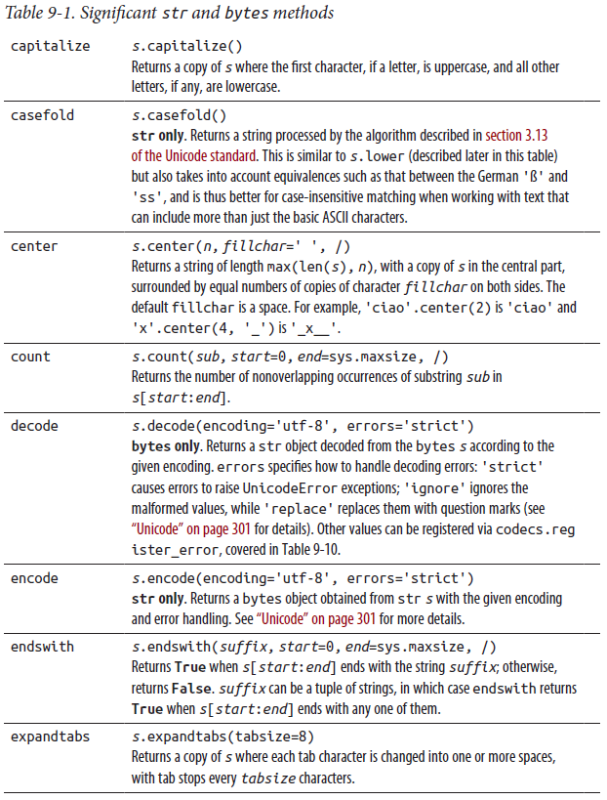

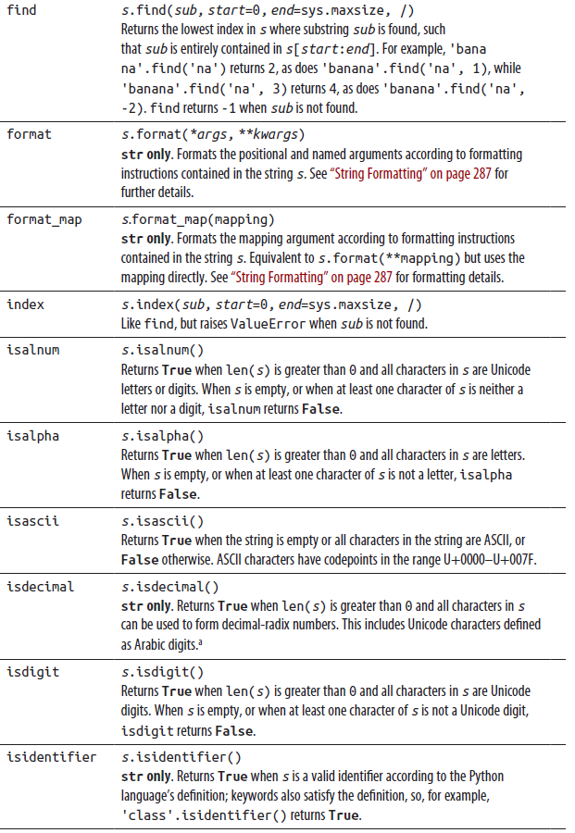

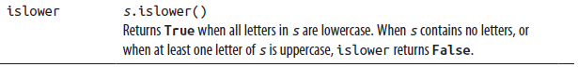

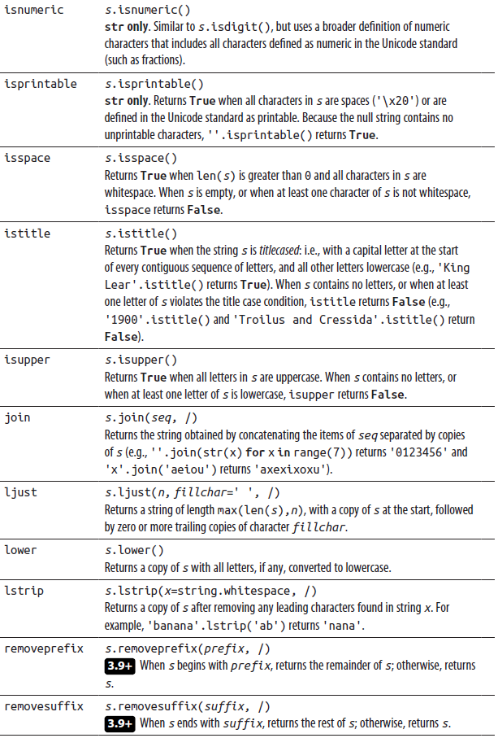

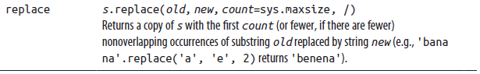

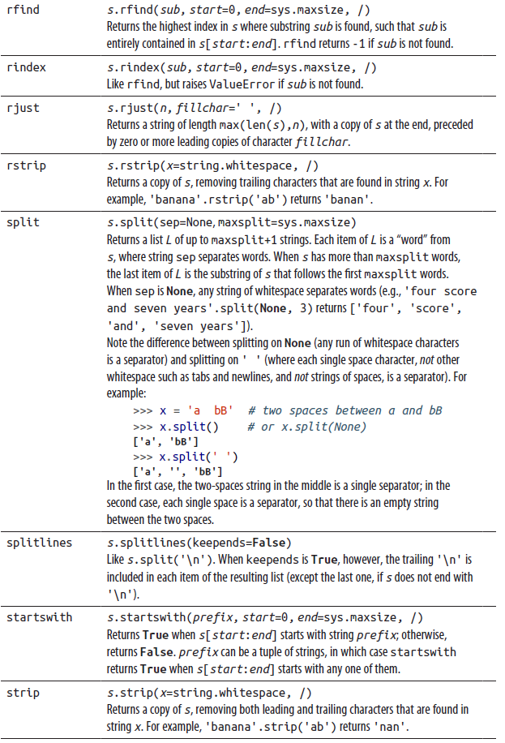 

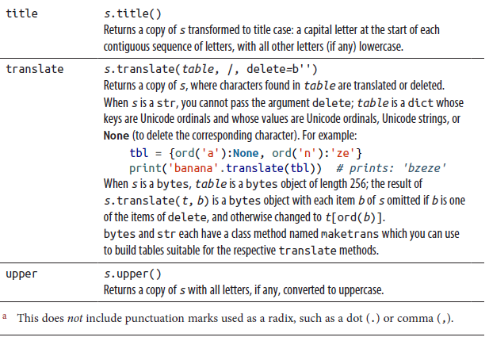

### The string Module

The string module supplies several useful string attributes, listed in Table 9-2.

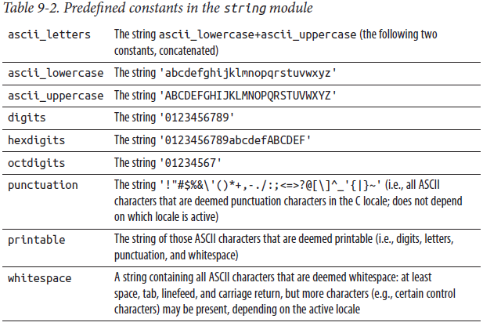

You should not rebind these attributes; the effects of doing so are undefined, since other parts of the Python library may rely on them.

The module string also supplies the class Formatter, covered in the following section.

### String Formatting

Python provides a flexible mechanism for formatting strings (but not bytestrings: for those, see “Legacy String Formatting with %” on page 297). A format string is simply a string containing replacement fields enclosed in braces ({}), made up of a value part, an optional conversion part, and an optional format specifier:

{value-part[!conversion-part][:format-specifier]}

The value part differs depending on the string type:

* For formatted string literals, or f-strings, the value part is evaluated as a Python expression (see the following section for details); expressions cannot end in an exclamation mark.
* For other strings, the value part selects an argument, or an element of an argument, to the format method.

The optional conversion part is an exclamation mark (!) followed by one of the letters s, r, or a (described in “Value Conversion” on page 290). The optional format specifier begins with a colon (:) and determines how the converted value is rendered for interpolation in the format string in place of the original replacement field.

#### Formatted String Literals (F-Strings)

This feature allows you to insert values to be interpolated inline surrounded by braces. To create a formatted string literal, put an f before the opening quote mark (this is why they’re called f-strings) of your string, e.g., f'{value}':

>>> name = 'Dawn'

>>> print(f'{name!r} is {len(name)} characters long')

'Dawn' is 4 characters long

You can use nested braces to specify components of formatting expressions:

>>> for width in 8, 11:

... for precision in 2, 3, 4, 5:

... print(f'{2.7182818284:{width}.{precision}}')

...

2.7

2.72

2.718

2.7183

2.7

2.72

2.718

2.7183

We have tried to update most of the examples in the book to use f-strings, since they are the most compact way to format strings in Python. Do remember, though, that these string literals are not constants—they evaluate each time a statement containing them is executed, which involves runtime overhead.

The values to be formatted inside formatted string literals are already inside quotes: therefore, take care to avoid syntax errors when using value-part expressions that themselves contain string quotes. With four different string quotes, plus the ability to use escape sequences, most things are possible, though admittedly readability can suffer.

**F-Strings Don’t Help Internationalization**

Given a format whose contents will have to accommodate multiple languages, it’s much better to use the format method,

since the values to be interpolated can then be computed independently before submitting them for formatting. Debug printing with f-strings

3.8+ As a convenience for debugging, the last nonblank character of the value expression in a formatted string literal can be followed by an equals sign (=), optionally surrounded by spaces. In this case the text of the expression itself and the equals sign, including any leading and trailing spaces, are output before the value. In the presence of the equals sign, when no format is specified, Python uses the repr() of the value as output; otherwise, Python uses the str() of the value unless an !r value conversion is specified:

>>> a = '*-'

>>> s = 12

>>> f'{a*s=}'

"a*s='*-*-*-*-*-*-*-*-*-*-*-*-'"

>>> f'{a*s = :30}'

'a*s = *-*-*-*-*-*-*-*-*-*-*-*- '

Note that this form is only available in formatted string literals.

Here’s a simple f-string example. Notice that all text, including any whitespace, surrounding the replacement fields is copied literally into the result:

>>> n = 10

>>> s = ('zero', 'one', 'two', 'three')

>>> i = 2

>>> f'start {"-"*n} : {s[i]} end'

'start ---------- : two end'

#### Formatting Using format Calls

The same formatting operations available in formatted string literals can also be performed by a call to the string’s format method. In these cases, rather than the value appearing inline, the replacement field begins with a value part that selects an argument of that call. You can specify both positional and named arguments. Here’s an example of a simple format method call:

>>> name = 'Dawn'

>>> print('{name} is {n} characters long'

... .format(name=name, n=len(name)))

'Dawn' is 4 characters long

>>> "This is a {1}, {0}, type of {type}".format("green", "large",

... type="vase")

'This is a large, green, type of vase'

For simplicity, none of the replacement fields in this example contain a conversion part or a format specifier.

As mentioned previously, the argument selection mechanism when using the format method can handle both positional and named arguments. The simplest replacement field is the empty pair of braces ({}), representing an automatic positional argument specifier. Each such replacement field automatically refers to the value of the next positional argument to format:

>>> 'First: {} second: {}'.format(1, 'two')

'First: 1 second: two'

To repeatedly select an argument, or use it out of order, use numbered replacement fields to specify the argument’s position in the list of arguments (counting from zero):

>>> 'Second: {1}, first: {0}'.format(42, 'two')

'Second: two, first: 42'

You cannot mix automatic and numbered replacement fields: it’s an either-or choice.

For named arguments, use argument names. If desired, you can mix them with (automatic or numbered) positional arguments:

>>> 'a: {a}, 1st: {}, 2nd: {}, a again: {a}'.format(1, 'two', a=3)

'a: 3, 1st: 1, 2nd: two, a again: 3'

>>> 'a: {a} first:{0} second: {1} first: {0}'.format(1, 'two', a=3)

'a: 3 first:1 second: two first: 1'

If an argument is a sequence, you can use numeric indices to select a specific element of the argument as the value to be formatted. This applies to both positional (automatic or numbered) and named arguments:

>>> 'p0[1]: {[1]} p1[0]: {[0]}'.format(('zero', 'one'),

... ('two', 'three'))

'p0[1]: one p1[0]: two'

>>> 'p1[0]: {1[0]} p0[1]: {0[1]}'.format(('zero', 'one'),

... ('two', 'three'))

'p1[0]: two p0[1]: one'

>>> '{} {} {a[2]}'.format(1, 2, a=(5, 4, 3))

'1 2 3'

If an argument is a composite object, you can select its individual attributes as values to be formatted by applying attribute-access dot notation to the argument selector. Here is an example using complex numbers, which have real and imag attributes that hold the real and imaginary parts, respectively:

>>> 'First r: {.real} Second i: {a.imag}'.format(1+2j, a=3+4j)

'First r: 1.0 Second i: 4.0'

Indexing and attribute-selection operations can be used multiple times, if required.

#### Value Conversion

You may apply a default conversion to the value via one of its methods. You indicate this by following any selector with !s to apply the object’s __str__ method, !r for its __repr__ method, or !a for the ascii built-in:

>>> "String: {0!s} Repr: {0!r} ASCII: {0!a}".format("banana 😀")

"String: banana 😀 Repr: 'banana 😀' ASCII: 'banana\\U0001f600'"

When a conversion is present, the conversion is applied to the value before it is formatted. Since the same value is required multiple times, in this example a format call makes much more sense than a formatted string literal, which would require the

value to be repeated three times.

#### Value Formatting: The Format Specifier

The final (optional) portion of the replacement field, known as the format specifier and introduced by a colon (:), provides any further required formatting of the (possibly converted) value. The absence of a colon in the replacement field means that the converted value (after representation as a string if not already in string form) is used with no further formatting. If present, a format specifier should be provided conforming to the syntax:

[[fill]align][sign][z][#][0][width][grouping_option][.precision][type]

Details are provided in the following subsections.

Fill and alignment

The default fill character is the space. To use an alternative fill character (which cannot be an opening or closing brace), begin the format specifier with the fill character. The fill character, if any, should be followed by an alignment indicator (see Table 9-3).

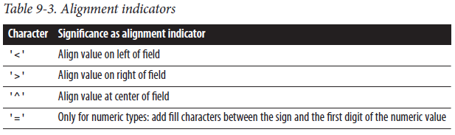

If the first and second characters are both valid alignment indicators, then the first is used as the fill character and the second is used to set the alignment.

When no alignment is specified, values other than numbers are left-aligned. Unless a field width is specified later in the format specifier (see “Field width” on page 293), no fill characters are added, whatever the fill and alignment may be:

>>> s = 'a string'

>>> f'{s:>12s}'

' a string'

>>> f'{s:>>12s}'

'>>>>a string'

>>> f'{s:><12s}'

'a string>>>>'

Sign indication

For numeric values only, you can indicate how positive and negative numbers are differentiated by including a sign indicator (see Table 9-4).

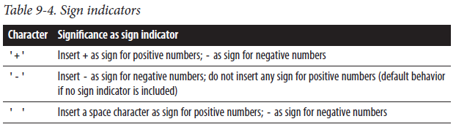

The space is the default sign indication. If a fill is specified, it will appear between the sign, if any, and the numerical value; place the sign indicator after the = to avoid it being used as a fill character:

>>> n = -1234

>>> f'{n:12}' # 12 spaces before the number

' -1234'

>>> f'{-n:+12}' # - to flip n's sign, + as sign indicator

' +1234'

>>> f'{n:+=12}' # + as fill character between sign and number

'-+++++++1234'

# + as sign indicator, spaces fill between sign and number

>>> f'{n:=+12}'

'- 1234'

# * as fill between sign and number, + as sign indicator

>>> f'{n:*=+12}'

'-*******1234'

Zero normalization (z)

3.11+ Some numeric formats are capable of representing a negative zero, which is often a surprising and unwelcome result. Such negative zeros will be normalized to positive zeros when a z character appears in this position in the format specifier:

>>> x = -0.001

>>> f'{x:.1f}'

'-0.0'

>>> f'{x:z.1f}'

'0.0'

>>> f'{x:+z.1f}'

'+0.0'

Radix indicator (#)

For numeric integer formats only, you can include a radix indicator, the # character. If present, this indicates that the digits of binary-formatted numbers should be preceded by '0b', those of octal-formatted numbers by '0o', and those of hexadecimal-formatted numbers by '0x'. For example, '{23:x}' is '17', while '{23:#x}' is '0x17', clearly identifying the value as hexadecimal.

Leading zero indicator (0)

For numeric types only, when the field width starts with a zero, the numeric value will be padded with leading zeros rather than leading spaces:

>>> f"{-3.1314:12.2f}"

' -3.13'

>>> f"{-3.1314:012.2f}"

'-00000003.13'

Field width

You can specify the width of the field to be printed. If the width specified is less than the length of the value, the length of the value is used (but for string values, see the upcoming section “Precision specification”). If alignment is not specified, the value

is left justified (except for numbers, which are right justified):

>>> s = 'a string'

>>> f'{s:^12s}'

' a string '

>>> f'{s:.>12s}'

'....a string'

Using nested braces, when calling the format method, the field width can be a format argument too:

>>> '{:.>{}s}'.format(s, 20)

'............a string'

See “Nested Format Specifications” on page 295 for a fuller discussion of this technique.

Grouping option

For numeric values in the decimal (default) format type, you can insert either a comma (,) or an underscore (_) to request that each group of three digits (digit group) in the integer portion of the result be separated by that character. For example:

>>> f'{12345678.9:,}'

'12,345,678.9'

This behavior ignores system locale; for a locale-aware use of digit grouping and decimal point character, see format type n in Table 9-5.

Precision specification

The precision (e.g., .2) has different meanings for different format types (see the following subsection for details), with .6 as the default for most numeric formats. For the f and F format types, it specifies the number of digits following the decimal point to which the value should be rounded in formatting; for the g and G format types, it specifies the number of significant digits to which the value should be rounded; for nonnumeric values, it specifies truncation of the value to its leftmost characters before formatting. For example:

>>> x = 1.12345

>>> f'as f: {x:.4f}' # rounds to 4 digits after decimal point

'as f: 1.1235'

>>> f'as g: {x:.4g}' # rounds to 4 significant digits

'as g: 1.123'

>>> f'as s: {"1234567890":.6s}' # string truncated to 6 characters

'as s: 123456'

Format type

The format specification ends with an optional format type, which determines how the value gets represented in the given width and at the given precision. In the absence of an explicit format type, the value being formatted determines the default

format type. The s format type is always used to format Unicode strings. Integer numbers have a range of acceptable format types, listed in Table 9-5.

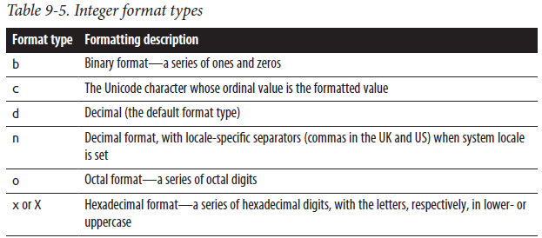

Floating-point numbers have a different set of format types, shown in Table 9-6.

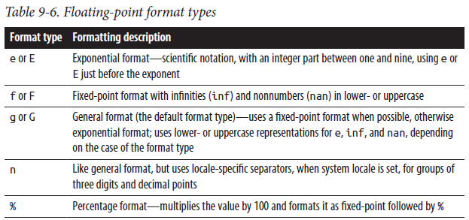

When no format type is specified, a float uses the g format, with at least one digit after the decimal point and a default precision of 12.

The following code takes a list of numbers and displays each right justified in a field width of nine characters; it specifies that each number’s sign will always display, adds a comma between each group of three digits, and rounds each number to exactly two digits after the decimal point, converting ints to floats as needed:

>>> for num in [3.1415, -42, 1024.0]:

... f'{num:>+9,.2f}'

...

' +3.14'

' -42.00'

'+1,024.00'

Nested Format Specifications

In some cases you’ll want to use expression values to help determine the precise format used: you can use nested formatting to achieve this. For example, to format a string in a field four characters wider than the string itself, you can pass a value for the width to format, as in:

>>> s = 'a string'

>>> '{0:>{1}s}'.format(s, len(s)+4)

' a string'

>>> '{0:_^{1}s}'.format(s, len(s)+4)

'__a string__'

With some care, you can use width specification and nested formatting to print a sequence of tuples into well-aligned columns. For example:

def columnar_strings(str_seq, widths):

for cols in str_seq:

row = [f'{c:{w}.{w}s}'

for c, w in zip(cols, widths)]

print(' '.join(row))

Given this function, the following code:

c = [

'four score and'.split(),

'seven years ago'.split(),

'our forefathers brought'.split(),

'forth on this'.split(),

]

columnar_strings(c, (8, 8, 8))

prints:

four score and

seven years ago

our forefath brought

forth on this

#### Formatting of User-Coded Classes

Values are ultimately formatted by a call to their __format__ method with the format specifier as an argument. Built-in types either implement their own method or inherit from object, whose rather unhelpful format method only accepts an empty string as an argument:

>>> object().__format__('')

'<object object at 0x110045070>'

>>> import math

>>> math.pi.__format__('18.6')

' 3.14159'

You can use this knowledge to implement an entirely different formatting minilanguage of your own, should you so choose. The following simple example demonstrates the passing of format specifications and the return of a (constant) formatted string result. The interpretation of the format specification is under your control, and you may choose to implement whatever formatting notation you choose:

>>> class S:

... def __init__(self, value):

... self.value = value

... def __format__(self, fstr):

... match fstr:

... case 'U':

... return self.value.upper()

... case 'L':

... return self.value.lower()

... case 'T':

... return self.value.title()

... case _:

... return ValueError(f'Unrecognized format code'

... f' {fstr!r}')

>>> my_s = S('random string')

>>> f'{my_s:L}, {my_s:U}, {my_s:T}'

'random string, RANDOM STRING, Random String'

The return value of the __format__ method is substituted for the replacement field in the formatted output, allowing any desired interpretation of the format string. This technique is used in the datetime module, to allow the use of strftime-style format strings. Consequently, the following all give the same result:

>>> import datetime

>>> d = datetime.datetime.now()

>>> d.__format__('%d/%m/%y')

'10/04/22'

>>> '{:%d/%m/%y}'.format(d)

'10/04/22'

>>> f'{d:%d/%m/%y}'

'10/04/22'

To help you format your objects more easily, the string module provides a Formatter class with many helpful methods for handling formatting tasks. See the online docs for details.

#### Legacy String Formatting with %

A legacy form of string formatting expression in Python has the syntax:

format % values

where format is a str, bytes, or bytearray object containing format specifiers, and values are the values to format, usually as a tuple. ( In this book we cover only a subset of this legacy feature, the format specifier, that you must know about to properly use the logging module (discussed in “The logging module” on page 217). ) Unlike Python’s newer formatting capabilities, you can also use % formatting with bytes and bytearray objects, not just str ones.

The equivalent use in logging would be, for example:

logging.info(format, *values)

with the values coming as positional arguments after the format.

The legacy string-formatting approach has roughly the same set of features as the C language’s printf and operates in a similar way. Each format specifier is a substring of format that starts with a percent sign (%) and ends with one of the conversion characters shown in Table 9-7.

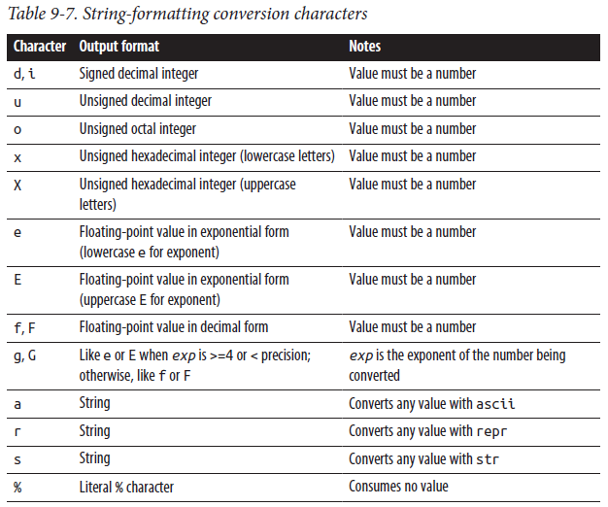

The a, r, and s conversion characters are the ones most often used with the logging module. Between the % and the conversion character, you can specify a number of optional modifiers, as we’ll discuss shortly.

What is logged with a formatting expression is format, where each format specifier is replaced by the corresponding item of values converted to a string according to the specifier. Here are some simple examples:

import logging

logging.getLogger().setLevel(logging.INFO)

x = 42

y = 3.14

z = 'george'

logging.info('result = %d', x) # logs: result = 42

logging.info('answers: %d %f', x, y) # logs: answers: 42 3.140000

logging.info('hello %s', z) # logs: hello george

#### Format Specifier Syntax

Each format specifier corresponds to an item in values by position. A format specifier can include modifiers to control how the corresponding item in values is converted to a string. The components of a format specifier, in order, are:

* The mandatory leading % character that marks the start of the specifier
* Zero or more optional conversion flags:

'#' The conversion uses an alternate form (if any exists for its type).

'0' The conversion is zero padded.

'-' The conversion is left justified.

' ' Negative numbers are signed, and a space is placed before a positive number.

'+' A numeric sign (+ or -) is placed before any numeric conversion.

* An optional minimum width of the conversion: one or more digits, or an asterisk (*), meaning that the width is taken from the next item in values
* An optional precision for the conversion: a dot (.) followed by zero or more digits or by a *, meaning that the precision is taken from the next item in values
* A mandatory conversion type from Table 9-7

There must be exactly as many values as format has specifiers (plus one extra for each width or precision given by *). When a width or precision is given by *, the * consumes one item in values, which must be an integer and is taken as the number of characters to use as the width or precision of that conversion.

**Always Use %r (or %a) to Log Possibly Erroneous Strings**

Most often, the format specifiers in your format string will all be %s; occasionally, you’ll want to ensure horizontal alignment

of the output (for example, in a right-justified, maybe truncated space of exactly six characters, in which case you’d use %6.6s). However, there is an important special case for %r or %a.

When you’re logging a string value that might be erroneous (for example, the name of a file that is not found), don’t use %s: when the error is that the string has spurious leading or trailing spaces, or contains some nonprinting characters such as \b, %s can make this hard for you to spot by studying the logs. Use %r or %a instead, so that all characters are clearly shown, possibly via escape sequences. (For f-strings, the corresponding syntax would be {variable!r} or {variable!a}).

**Text Wrapping and Filling**

The textwrap module supplies a class and a few functions to format a string by breaking it into lines of a given maximum length. To fine-tune the filling and wrapping, you can instantiate the TextWrapper class supplied by textwrap and apply detailed control. Most of the time, however, one of the functions exposed by textwrap suffices; the most commonly used functions are covered in Table 9-8.

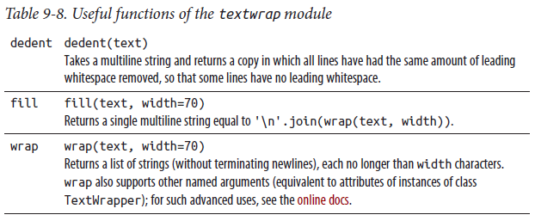

### The pprint Module

The pprint module pretty-prints data structures, with formatting that strives to be more readable than that supplied by the built-in function repr (covered in Table 8-2). To fine-tune the formatting, you can instantiate the PrettyPrinter class supplied by pprint and apply detailed control, helped by auxiliary functions also supplied by pprint. Most of the time, however, one of the functions exposed by pprint suffices (see Table 9-9).

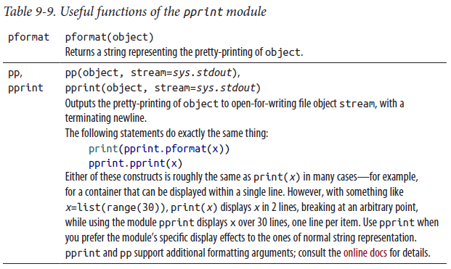

### The reprlib Module

The reprlib module supplies an alternative to the built-in function repr (covered in Table 8-2), with limits on length for the representation string. To fine-tune the length limits, you can instantiate or subclass the Repr class supplied by the reprlib module and apply detailed control. Most of the time, however, the only function exposed by the module suffices: repr(obj), which returns a string representing obj, with sensible limits on length.

## Unicode

To convert bytestrings into Unicode strings, use the decode method of bytestrings (see Table 9-1). The conversion must always be explicit, and is performed using an auxiliary object known as a codec (short for coder–decoder). A codec can also convert Unicode strings to bytestrings using the encode method of strings. To identify a codec, pass the codec name to decode or encode. When you pass no codec name, Python uses a default encoding, normally 'utf-8'.

Every conversion has a parameter errors, a string specifying how conversion errors are to be handled. Sensibly, the default is 'strict', meaning any error raises an exception. When errors is 'replace', the conversion replaces each character causing errors with '?' in a bytestring result, or with u'\ufffd' in a Unicode result. When errors is 'ignore', the conversion silently skips characters causing errors.

When errors is 'xmlcharrefreplace', the conversion replaces each character causing errors with the XML character reference representation of that character in the result. You may code your own function to implement a conversion error handling strategy and register it under an appropriate name by calling codecs.register_error, covered in the table in the following section.

### The codecs Module

The mapping of codec names to codec objects is handled by the codecs module. This module also lets you develop your own codec objects and register them so that they can be looked up by name, just like built-in codecs. It provides a function that lets you look up any codec explicitly as well, obtaining the functions the codec uses for encoding and decoding, as well as factory functions to wrap file-like objects. Such advanced facilities are rarely used, and we do not cover them in this book. The codecs module, together with the encodings package of the standard Python library, supplies built-in codecs useful to Python developers dealing with internationalization issues. Python comes with over 100 codecs; you can find a complete list, with a brief explanation of each, in the online docs. It’s not good practice to install a codec as the site-wide default in the module sitecustomize; rather, the preferred usage is to always specify the codec by name whenever converting between byte and Unicode strings. Python’s default Unicode encoding is 'utf-8'.

The codecs module supplies codecs implemented in Python for most ISO 8859 encodings, with codec names from 'iso8859-1' to 'iso8859-15'. A popular codec in Western Europe is 'latin-1', a fast, built-in implementation of the ISO 8859-1 encoding that offers a one-byte-per-character encoding of special characters found in Western European languages (beware that it lacks the Euro currency character '€'; however, if you need that, use 'iso8859-15'). On Windows systems only, the codec named 'mbcs' wraps the platform’s multibyte character set conversion procedures. The codecs module also supplies various code pages with names from 'cp037' to 'cp1258', and Unicode standard encodings 'utf-8' (likely to be most often the best choice, thus recommended, and the default) and 'utf-16' (which has specific big-endian and little-endian variants: 'utf-16-be' and 'utf-16-le').

For use with UTF-16, codecs also supplies attributes BOM_BE and BOM_LE, byte-order marks for big-endian and little-endian machines, respectively, and BOM, the byteorder mark for the current platform.

In addition to various functions for more advanced uses, as mentioned earlier, the codecs module supplies a function to let you register your own conversion error handling functions:

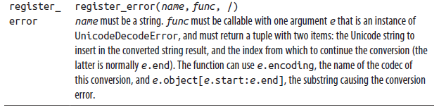

### The unicodedata Module

The unicodedata module provides easy access to the Unicode Character Database. Given any Unicode character, you can use functions supplied by unicodedata to obtain the character’s Unicode category, official name (if any), and other relevant information. You can also look up the Unicode character (if any) that corresponds to a given official name:

>>> import unicodedata

>>> unicodedata.name('⚀')

'DIE FACE-1'

>>> unicodedata.name('Ⅵ')

'ROMAN NUMERAL SIX'

>>> int('Ⅵ')

ValueError: invalid literal for int() with base 10: 'Ⅵ'

>>> unicodedata.numeric('Ⅵ') # use unicodedata to get numeric value

6.0

>>> unicodedata.lookup('RECYCLING SYMBOL FOR TYPE-1 PLASTICS')

'♳'

## Regular Expressions

Regular expressions (REs, aka regexps) let programmers specify pattern strings and perform searches and substitutions. Regular expressions are not easy to master, but they can be a powerful tool for processing text. Python offers rich regular expression functionality through the built-in re module. In this chapter, we thoroughly present all about Python’s REs.

### Regular Expressions and the re Module

A regular expression is built from a string that represents a pattern. With RE functionality, you can examine any string and check which parts of the string, if any, match the pattern.

The re module supplies Python’s RE functionality. The compile function builds an RE object from a pattern string and optional flags. The methods of an RE object look for matches of the RE in a string or perform substitutions. The re module also exposes functions equivalent to an RE object’s methods, but with the RE’s pattern string as the first argument.

This chapter covers the use of REs in Python; it does not teach every minute detail about how to create RE patterns. For general coverage of REs, we recommend the book Mastering Regular Expressions, by Jeffrey Friedl (O’Reilly), offering thorough coverage of REs at both tutorial and advanced levels. Many tutorials and references on REs can also be found online, including an excellent, detailed tutorial in Python’s online docs. Sites like Pythex and regex101 let you test your REs interactively. Alternatively, you can start IDLE, the Python REPL, or any other interactive interpreter, import re, and experiment directly.

#### REs and bytes Versus str

REs in Python work in two ways, depending on the type of the object being matched: when applied to str instances, an RE matches accordingly (e.g., a Unicode character c is deemed to be “a letter” if 'LETTER' in unicodedata.name(c)); when applied to bytes instances, an RE matches in terms of ASCII (e.g., a byte c is deemed to be “a letter” if c in string.ascii_letters). For example:

import re

print(re.findall(r'\w+', 'cittá')) # prints: ['cittá']

print(re.findall(rb'\w+', 'cittá'.encode())) # prints: [b'citt']

Pattern String Syntax

The pattern string representing a regular expression follows a specific syntax:

* Alphabetic and numeric characters stand for themselves. An RE whose pattern is a string of letters and digits matches the same string.
* Many alphanumeric characters acquire special meaning in a pattern when they are preceded by a backslash (\), or escaped.
* Punctuation characters work the other way around: they stand for themselves when escaped but have special meaning when unescaped.
* The backslash character is matched by a repeated backslash (\\).

An RE pattern is a string concatenating one or more pattern elements; each element in turn is itself an RE pattern. For example, r'a' is a one-element RE pattern that matches the letter a, and r'ax' is a two-element RE pattern that matches an a immediately followed by an x.

Since RE patterns often contain backslashes, it’s best to always specify RE patterns in raw string literal form (covered in “Strings” on page 44). Pattern elements (such as r'\t', equivalent to the string literal '\\t') do match the corresponding special characters (in this case, the tab character \t), so you can use a raw string literal even when you need a literal match for such special characters.

Table 10-1 lists the special elements in RE pattern syntax. The exact meanings of some pattern elements change when you use optional flags, together with the pattern string, to build the RE object. The optional flags are covered in “Optional Flags” on page 311.

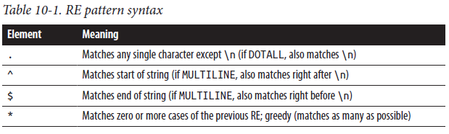

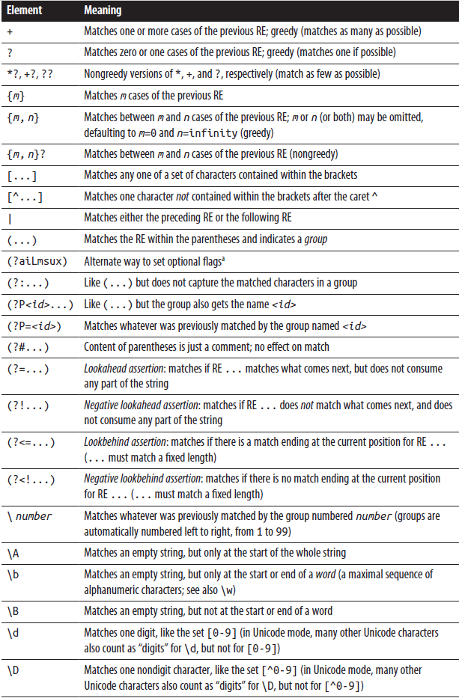

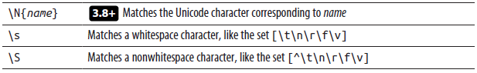

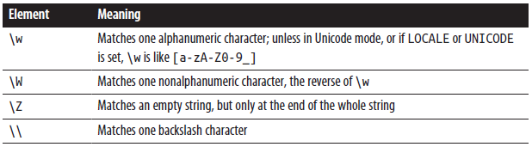

Always place the (?...) construct for setting flags, if any, at the start of the pattern, for readability; placing it elsewhere raises DeprecationWarning.

Using a \ character followed by an alphabetic character not listed here or in Table 3-4 raises an re.error exception.

#### Common Regular Expression Idioms

Always Use r’...’ Syntax for RE Pattern Literals Use raw string literals for all RE pattern literals, and only for them. This ensures you’ll never forget to escape a backslash (\), and improves code readability since it makes your RE pattern literals stand out.

.* as a substring of a regular expression’s pattern string means “any number of repetitions (zero or more) of any character.” In other words, .* matches any substring of a target string, including the empty substring. .+ is similar but matches only a nonempty substring. For example, this:

r'pre.*post'

matches a string containing a substring 'pre' followed by a later substring 'post', even if the latter is adjacent to the former (e.g., it matches both 'prepost' and 'pre23post'). On the other hand, this:

r'pre.+post'

matches only if 'pre' and 'post' are not adjacent (e.g., it matches 'pre23post' but does not match 'prepost'). Both patterns also match strings that continue after the 'post'. To constrain a pattern to match only strings that end with 'post', end the pattern with \Z. For example, this:

r'pre.*post\Z'

matches 'prepost' but not 'preposterous'.

All of these examples are greedy, meaning that they match the substring beginning with the first occurrence of 'pre' all the way to the last occurrence of 'post'. When you care about what part of the string you match, you may often want to specify nongreedy matching, which in our example would match the substring beginning with the first occurrence of 'pre' but only up to the first following occurrence of 'post'.

For example, when the string is 'preposterous and post facto', the greedy RE pattern r'pre.*post' matches the substring 'preposterous and post'; the nongreedy variant r'pre.*?post' matches just the substring 'prepost'. Another frequently used element in RE patterns is \b, which matches a word boundary. To match the word 'his' only as a whole word and not its occurrences as a substring in such words as 'this' and 'history', the RE pattern is:

r'\bhis\b'

with word boundaries both before and after. To match the beginning of any word starting with 'her', such as 'her' itself and 'hermetic', but not words that just contain 'her' elsewhere, such as 'ether' or 'there', use:

r'\bher'

with a word boundary before, but not after, the relevant string. To match the end of any word ending with 'its', such as 'its' itself and 'fits', but not words that contain 'its' elsewhere, such as 'itsy' or 'jujitsu', use:

r'its\b'

with a word boundary after, but not before, the relevant string. To match whole words thus constrained, rather than just their beginning or end, add a pattern element \w* to match zero or more word characters. To match any full word starting with 'her', use:

r'\bher\w*'

To match just the first three letters of any word starting with 'her', but not the word 'her' itself, use a negative word boundary \B:

r'\bher\B'

To match any full word ending with 'its', including 'its' itself, use:

r'\w*its\b'

#### Sets of Characters

You denote sets of characters in a pattern by listing the characters within brackets ([]). In addition to listing characters, you can denote a range by giving the first and last characters of the range separated by a hyphen (-). The last character of the range is included in the set, differently from other Python ranges. Within a set, special characters stand for themselves, except \, ], and -, which you must escape (by preceding them with a backslash) when their position is such that, if not escaped, they would form part of the set’s syntax. You can denote a class of characters within a set by escaped-letter notation, such as \d or \S. \b in a set means a backspace character (chr(8)), not a word boundary. If the first character in the set’s pattern, right after the [, is a caret (^), the set is complemented: such a set matches any character except those that follow ^ in the set pattern notation.

A frequent use of character sets is to match a “word,” using a definition of which characters can make up a word that differs from \w’s default (letters and digits). To match a word of one or more characters, each of which can be an ASCII letter, an

apostrophe, or a hyphen, but not a digit (e.g., "Finnegan-O'Hara"), use:

r"[a-zA-Z'\-]+"

Always Escape Hyphens in Character Sets

It’s not strictly necessary to escape the hyphen with a backslash in this case, since its position at the end of the set makes the situation syntactically unambiguous. However, using the backslash is advisable because it makes the pattern more readable,

by visually distinguishing the hyphen that you want to have as a character in the set from those used to denote ranges. (When you want to include a backslash in the character set, of course, you denote that by escaping the backslash itself: write it as \\.)

#### Alternatives

A vertical bar (|) in a regular expression pattern, used to specify alternatives, has low syntactic precedence. Unless parentheses change the grouping, | applies to the whole pattern on either side, up to the start or end of the pattern, or to another |. A

pattern can be made up of any number of subpatterns joined by |. It is important to note that an RE of subpatterns joined by | will match the first matching subpattern, not the longest. A pattern like r'ab|abc' will never match 'abc' because the 'ab'

match gets evaluated first. Given a list L of words, an RE pattern that matches any one of the words is:

'|'.join(rf'\b{word}\b' for word in L)

Escaping Strings

If the items of L can be more general strings, not just words, you need to escape each of them with the function re.escape

(covered in Table 10-6), and you may not want the \b word boundary markers on either side. In this case, you could use the following RE pattern (sorting the list in reverse order by length to avoid accidentally “masking” a longer word by a shorter one):

'|'.join(re.escape(s) for s in sorted( L, key=len, reverse=True ))

#### Groups

A regular expression can contain any number of groups, from none to 99 (or even more, but only the first 99 groups are fully supported). Parentheses in a pattern string indicate a group. The element (?P<id>...) also indicates a group and gives the group a name, id, that can be any Python identifier. All groups, named and unnamed, are numbered, left to right, 1 to 99; “group 0” means the string that the whole RE matches.

For any match of the RE with a string, each group matches a substring (possibly an empty one). When the RE uses |, some groups may not match any substring, although the RE as a whole does match the string. When a group doesn’t match any substring, we say that the group does not participate in the match. An empty string ('') is used as the matching substring for any group that does not participate in a match, except where otherwise indicated later in this chapter. For example, this:

r'(.+)\1+\Z'

matches a string made up of two or more repetitions of any nonempty substring. The (.+) part of the pattern matches any nonempty substring (any character, one or more times) and defines a group, thanks to the parentheses. The \1+ part of the pattern matches one or more repetitions of the group, and \Z anchors the match to the end of the string.

### Optional Flags

The optional flags argument to the function compile is a coded integer built by bitwise ORing (with Python’s bitwise OR operator, |) one or more of the following attributes of the module re. Each attribute has both a short name (one uppercase

letter), for convenience, and a long name (an uppercase multiletter identifier), which is more readable and thus normally preferable:

A or ASCII

Uses ASCII-only characters for \w, \W, \b, \B, \d, and \D; overrides the default UNICODE flag

I or IGNORECASE

Makes matching case-insensitive

L or LOCALE

Uses the Python LOCALE setting to determine characters for \w, \W, \b, \B, \d, and \D markers; you can only use this option with bytes patterns

M or MULTILINE

Makes the special characters ^ and $ match at the start and end of each line (i.e., right after/before a newline), as well as at the start and end of the whole string (\A and \Z always match only the start and end of the whole string)

S or DOTALL

Causes the special character . to match any character, including a newline

U or UNICODE

Uses full Unicode to determine characters for \w, \W, \b, \B, \d, and \D markers; although retained for backward compatibility, this flag is now the default X or VERBOSE

Causes whitespace in the pattern to be ignored, except when escaped or in a character set, and makes a nonescaped # character in the pattern begin a comment that lasts until the end of the line

Flags can also be specified by inserting a pattern element with one or more of the letters aiLmsux between (? and ), rather than by the flags argument to the compile function of the re module (the letters correspond to the uppercase flags given in the preceding list). Options should always be placed at the start of the pattern; not doing this produces a deprecation warning. In particular, placement at the start is mandatory if x (the inline flag character for verbose RE parsing) is among the options, since x changes the way Python parses the pattern. Options apply to the whole RE, except that the aLu options can be applied locally within a group.

Using the explicit flags argument is more readable than placing an options element within the pattern. For example, here are three ways to define equivalent REs with the compile function. Each of these REs matches the word “hello” in any mix of upper- and lowercase letters:

import re

r1 = re.compile(r'(?i)hello')

r2 = re.compile(r'hello', re.I)

r3 = re.compile(r'hello', re.IGNORECASE)

The third approach is clearly the most readable, and thus the most maintainable, though slightly more verbose. The raw string form is not strictly necessary here, since the patterns do not include backslashes. However, using raw string literals does no harm, and we recommend you always use them for RE patterns to improve clarity and readability.

The option re.VERBOSE (or re.X) lets you make patterns more readable and understandable through appropriate use of whitespace and comments. Complicated and verbose RE patterns are generally best represented by strings that take up more than one line, and therefore you normally want to use a triple-quoted raw string literal for such pattern strings. For example, to match a string representing an integer that may be in octal, hex, or decimal format, you could use use either of the following:

repat_num1 = r'(0o[0-7]*|0x[\da-fA-F]+|[1-9]\d*)\Z'

repat_num2 = r'''(?x) # (re.VERBOSE) pattern matching int literals

( 0o [0-7]* # octal: leading 0o, 0+ octal digits

| 0x [\da-fA-F]+ # hex: 0x, then 1+ hex digits

| [1-9] \d* # decimal: leading non-0, 0+ digits

)\Z # end of string

'''

The two patterns defined in this example are equivalent, but the second one is made more readable and understandable by the comments and the free use of whitespace to visually group portions of the pattern in logical ways.

### Match Versus Search

So far, we’ve been using regular expressions to match strings. For example, the RE with pattern r'box' matches strings such as 'box' and 'boxes', but not 'inbox'. In other words, an RE match is implicitly anchored at the start of the target string, as if the RE’s pattern started with \A.

Often you’ll be interested in locating possible matches for an RE anywhere in the string, without anchoring (e.g., find the r'box' match within such strings as 'inbox', as well as in 'box' and 'boxes'). In this case, the Python term for the operation is a search, as opposed to a match. For such searches, use the search method of an RE object instead of the match method, which matches only from the beginning of the string. For example:

import re

r1 = re.compile(r'box')

if r1.match('inbox'):

print('match succeeds')

else:

print('match fails') # prints: match fails

if r1.search('inbox'):

print('search succeeds') # prints: search succeeds

else:

print('search fails')

If you want to check that the whole string matches, not just its beginning, you can instead use the method fullmatch. All of these methods are covered in Table 10-3.

### Anchoring at String Start and End

\A and \Z are the pattern elements ensuring that a regular expression match is anchored at the string’s start or end. The elements ^ for start and $ for end are also used in similar roles. For RE objects that are not flagged as MULTILINE, ^ is the same

as \A, and $ is the same as \Z. For a multiline RE, however, ^ can anchor at the start of the string or the start of any line (where “lines” are determined based on \n separator characters). Similarly, with a multiline RE, $ can anchor at the end of the string or the end of any line. \A and \Z always anchor exclusively at the start and end of the string, whether the RE object is multiline or not.

For example, here’s a way to check whether a file has any lines that end with digits:

import re

digatend = re.compile(r'\d$', re.MULTILINE)

with open('afile.txt') as f:

if digatend.search(f.read()):

print('some lines end with digits')

else:

print('no line ends with digits')

A pattern of r'\d\n' is almost equivalent, but in that case, the search fails if the very last character of the file is a digit not followed by an end-of-line character. With the preceding example, the search succeeds if a digit is at the very end of the file’s contents, as well as in the more usual case where a digit is followed by an end-of-line character.

### Regular Expression Objects

Table 10-2 covers the read-only attributes of a regular expression object r that detail how r was built (by the function compile of the module re, covered in Table 10-6).

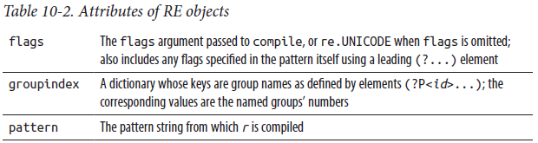

These attributes make it easy to retrieve from a compiled RE object its original pattern string and flags, so you never have to store those separately.

An RE object r also supplies methods to find matches for r in a string, as well as to perform substitutions on such matches (see Table 10-3). Matches are represented by special objects, covered in the following section.

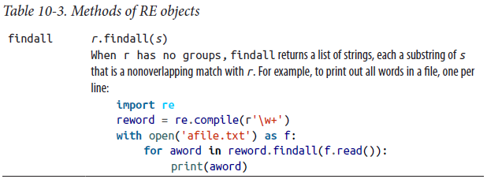

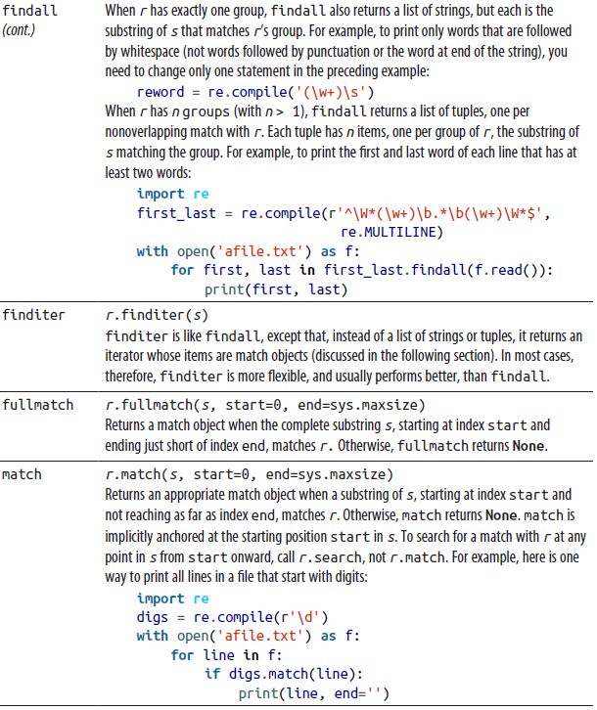

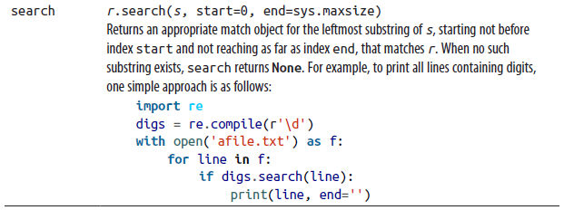

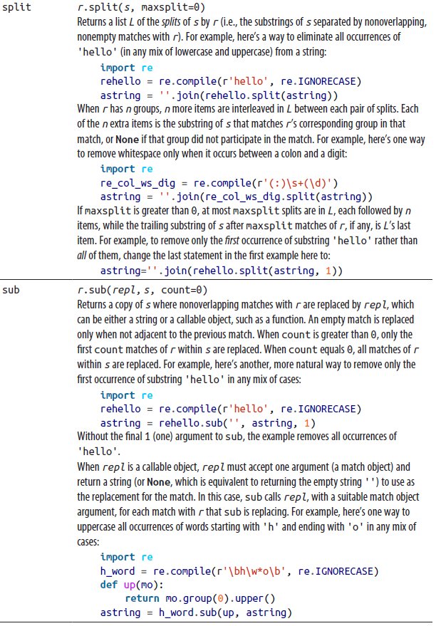

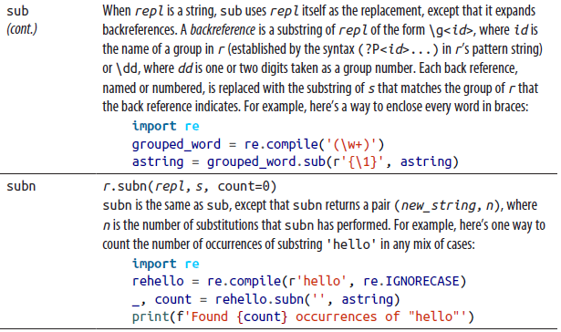

### Match Objects

Match objects are created and returned by the methods fullmatch, match, and search of a regular expression object, and are the items of the iterator returned by the method finditer. They are also implicitly created by the methods sub and subn when the argument repl is callable, since in that case the appropriate match object is passed as the only argument on each call to repl. A match object m supplies the following read-only attributes that detail how search or match created m, listed in Table 10-4.

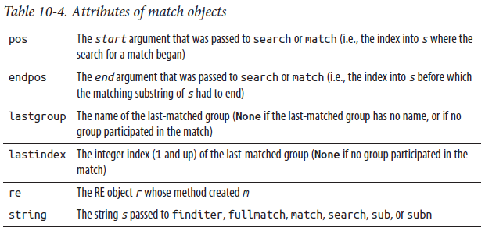

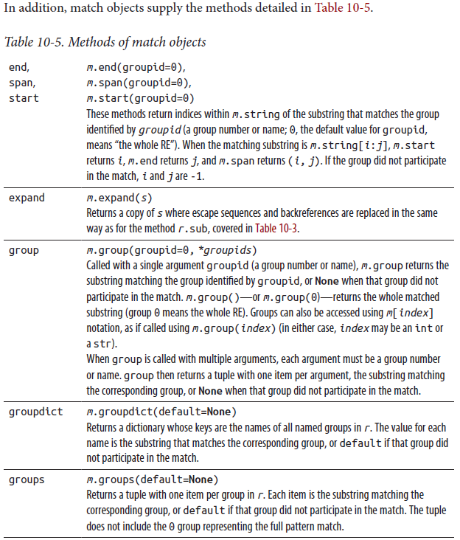

### Functions of the re Module

In addition to the attributes listed in “Optional Flags” on page 311, the re module provides one function for each method of a regular expression object (findall, fin diter, fullmatch, match, search, split, sub, and subn, described in Table 10-3), each with an additional first argument, a pattern string that the function implicitly compiles into an RE object. It is usually better to compile pattern strings into RE objects explicitly and call the RE object’s methods, but sometimes, for a one-off use of an RE pattern, calling functions of the module re can be handier. For example, to count the number of occurrences of 'hello' in any mix of cases, one concise, function-based way is:

import re

_, count = re.subn(r'hello', '', astring, flags=re.I)

print(f'Found {count} occurrences of "hello"')

The re module internally caches RE objects it creates from the patterns passed to functions; to purge the cache and reclaim some memory, call re.purge. The re module also supplies error, the class of exceptions raised upon errors (generally, errors in the syntax of a pattern string), and two more functions, listed in Table 10-6.

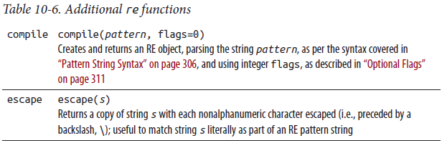

### REs and the := Operator

The introduction of the := operator in Python 3.8 established support for a successive-match idiom in Python similar to the one that’s common in Perl. In this idiom, a series of if/elsif branches tests a string against different regular expressions. In Perl, the if ($var =~ /regExpr/) statement both evaluates the regular expression and saves the successful match in the variable var:1

if ($statement =~ /I love (\w+)/) {

print "He loves $1\n";

}

elsif ($statement =~ /Ich liebe (\w+)/) {

print "Er liebt $1\n";

}

elsif ($statement =~ /Je t\'aime (\w+)/) {

print "Il aime $1\n";

}

Prior to Python 3.8, this evaluate-and-store behavior was not possible in a single if/elif statement; developers had to use a cumbersome cascade of nested if/else statements:

m = re.match('I love (\w+)', statement)

if m:

print(f'He loves {m.group(1)}')

else:

m = re.match('Ich liebe (\w+)', statement)

if m:

print(f'Er liebt {m.group(1)}')

else:

m = re.match('J'aime (\w+)', statement)

if m:

print(f'Il aime {m.group(1)}')

Using the := operator, this code simplifies to:

if m := re.match(r'I love (\w+)', statement):

print(f'He loves {m.group(1)}')

elif m := re.match(r'Ich liebe (\w+)', statement):

print(f'Er liebt {m.group(1)}')

elif m := re.match(r'J'aime (\w+)', statement):

print(f'Il aime {m.group(1)}')

### The Third-Party regex Module

As an alternative to the Python standard library’s re module, a popular package for regular expressions is the third-party regex module, by Matthew Barnett. regex has an API that’s compatible with the re module and adds a number of extended features, including:

• Recursive expressions

• Defining character sets by Unicode property/value

• Overlapping matches

• Fuzzy matching

• Multithreading support (releases GIL during matching)

• Matching timeout

• Unicode case folding in case-insensitive matches

• Nested sets

## File and Text Operations

This chapter covers issues related to files and filesystems in Python. A file is a stream of text or bytes that a program can read and/or write; a filesystem is a hierarchical repository of files on a computer system.

**Other Chapters That Also Deal with Files**

Files are a crucial concept in programming: so, although this chapter is one of the largest in the book, other chapters also have material relevant to handling specific kinds of files. In particular, Chapter 12 deals with many kinds of files related to persistence and database functionality (CSV files in Chapter 12, JSON files in “The json Module” on page 386, pickle files in “The pickle Module” on page 389, shelve files in “The shelve Module” on page 395, DBM and DBM-like files in “The dbm Package” on page 397, and SQLite database files in “SQLite” on page 405), Chapter 22 deals with files in HTML format, and Chapter 23 deals with files in XML format.

Files and streams come in many flavors. Their contents can be arbitrary bytes, or text. They may be suitable for reading, writing, or both, and they may be buffered, so that data is temporarily held in memory on the way to or from the file. Files may also allow random access, moving forward and back within the file, or jumping to read or write at a particular location in the file. This chapter covers each of these topics.

In addition, this chapter also covers the polymorphic concept of file-like objects (objects that are not actually files but behave to some extent like files), modules that deal with temporary files and file-like objects, and modules that help you access the contents of text and binary files and support compressed files and other data archives. Python’s standard library supports several kinds of lossless compression, including (ordered by the typical ratio of compression on a text file, from highest to lowest):

• LZMA (used, for example, by the xz program), see module lzma

• bzip2 (used, for example, by the bzip2 program), see module bz2

• deflate (used, for example, by the gzip and zip programs), see modules zlib, gzip, and zipfile

The tarfile module lets you read and write TAR files compressed with any one of these algorithms. The zipfile module lets you read and write ZIP files and also handles bzip2 and LZMA compressions. We cover both of these modules in this chapter. We don’t cover the details of compression in this book; for details, see the online docs.

In the rest of this chapter, we will refer to all files and file-like objects as files. In modern Python, input/output (I/O) is handled by the standard library’s io module. The os module supplies many of the functions that operate on the filesystem, so this chapter also introduces that module. It then covers operations on the filesystem (comparing, copying, and deleting directories and files; working with filepaths; and accessing low-level file descriptors) provided by the os module, the os.path module, and the new and preferable pathlib module, which provides an object-oriented approach to filesystem paths. For a cross-platform interprocess communication (IPC) mechanism known as memory-mapped files, see the module mmap, covered in Chapter 15.

While most modern programs rely on a graphical user interface (GUI), often via a browser or a smartphone app, text-based, nongraphical “command-line” user interfaces are still very popular for their ease, speed of use, and scriptability. This chapter concludes with a discussion of non-GUI text input and output in Python in “Text Input and Output” on page 368, terminal text I/O in “Richer-Text I/O” on page 371, and, finally, how to build software showing text understandable to different users, across languages and cultures, in “Internationalization” on page 374.

### The io Module

As mentioned in this chapter’s introduction, io is the standard library module in Python that provides the most common ways for your Python programs to read or write files. In modern Python, the built-in function open is an alias for the function io.open. Use io.open (or its built-in alias open) to make a Python file object to read from, and/or write to, a file as seen by the underlying operating system. The parameters you pass to open determine what type of object is returned. This object can be an instance of io.TextIOWrapper if textual, or, if binary, one of io.BufferedReader, io.BufferedWriter, or io.BufferedRandom, depending on

whether it’s read-only, write-only, or read/write. This section covers the various types of file objects, as well as the important issue of making and using temporary files (on disk, or even in memory).

I/O Errors Raise OSError

Python reacts to any I/O error related to a file object by raising an instance of built-in exception class OSError (many useful subclasses exist, as covered in “OSError subclasses” on page 208). Errors causing this exception include a failing open call, calls to a method on a file to which the method doesn’t apply (e.g., write on a read-only file, or seek on a nonseekable file), and actual I/O errors diagnosed by a file object’s methods.

The io module also provides the underlying classes, both abstract and concrete, that, by inheritance and by composition (also known as wrapping), make up the file objects that your program generally uses. We do not cover these advanced topics in this book. If you have access to unusual channels for data, or nonfilesystem data storage, and want to provide a file interface to those channels or storage, you can ease your task (through appropriate subclassing and wrapping) using other classes in the io module. For assistance with such advanced tasks, consult the online docs.

#### Creating a File Object with open

To create a Python file object, call open with the following syntax:

open(file, mode='r', buffering=-1, encoding=None, errors='strict',

newline=None, closefd=True, opener=os.open)

file can be a string or an instance of pathlib.Path (any path to a file as seen by the underlying OS), or an int (an OS-level file descriptor as returned by os.open, or by whatever function you pass as the opener argument). When file is a path (a string or pathlib.Path instance), open opens the file thus named (possibly creating it, depending on the mode argument—despite its name, open is not just for opening existing files: it can also create new ones). When file is an integer, the underlying OS file must already be open (via os.open).

Opening a File Pythonically

open is a context manager: use with open(...) as f:, not f =open(...), to ensure the file f gets closed as soon as the with statement’s body is done. open creates and returns an instance f of the appropriate io module class, depending on the mode and buffering settings. We refer to all such instances as file objects; they are polymorphic with respect to each other.

mode

mode is an optional string indicating how the file is to be opened (or created). The possible values for mode are listed in Table 11-1.

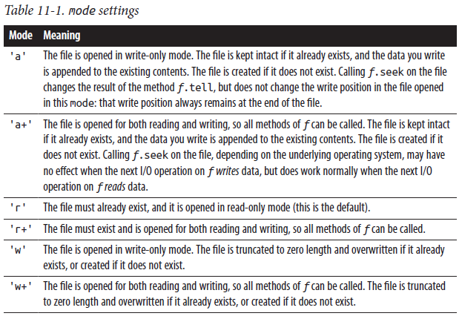

Binary and text modes

The mode string may include any of the values in Table 11-1, followed by a b or t. b indicates that the file should be opened (or created) in binary mode, while t indicates text mode. When neither b nor t is included, the default is text (i.e., 'r' is like 'rt', 'w+' is like 'w+t', and so on), but per The Zen of Python, “explicit is better than implicit.”

Binary files let you read and/or write strings of type bytes, and text files let you read and/or write Unicode text strings of type str. For text files, when the underlying channel or storage system deals in bytes (as most do), encoding (the name of an encoding known to Python) and errors (an error-handler name such as 'strict', 'replace', and so on, as covered under decode in Table 9-1) matter, as they specify how to translate between text and bytes, and what to do on encoding and decoding errors.

Buffering

buffering is an integer value that denotes the buffering policy you’re requesting for the file. When buffering is 0, the file (which must be binary mode) is unbuffered; the effect is as if the file’s buffer is flushed every time you write anything to the file. When buffering is 1, the file (which must be open in text mode) is line buffered, which means the file’s buffer is flushed every time you write \n to the file. When buffering is greater than 1, the file uses a buffer of about buffering bytes, often rounded up to some value convenient for the driver software. When buffering is <0, a default is used, depending on the type of file stream. Normally, this default is line buffering for files that correspond to interactive streams, and a buffer of io.DEFAULT_BUFFER_SIZE bytes for other files.

Sequential and nonsequential (“random”) access

A file object f is inherently sequential (a stream of bytes or text). When you read, you get bytes or text in the sequential order in which they are present. When you write, the bytes or text you write are added in the order in which you write them. For a file object f to support nonsequential access (also known as random access), it must keep track of its current position (the position in the storage where the next read or write operation starts transferring data), and the underlying storage for the file must support setting the current position. f.seekable returns True when f supports nonsequential access.

When you open a file, the default initial read/write position is at the start of the file. Opening f with a mode of 'a' or 'a+' sets f’s read/write position to the end of the file before writing data to f. When you write or read n bytes to/from file object f, f’s position advances by n. You can query the current position by calling f.tell, and change the position by calling f.seek, both covered in the next section.

When calling f.seek on a text-mode f, the offset you pass must be 0 (to position f at the start or end, depending on f.seek’s second parameter), or the opaque result returned by an earlier call to f.tell, ( tell’s value is opaque for text files, since they contain variable-length characters. For binary files, it’s simply a straight byte count. ) to position f back to a spot you had thus “bookmarked” before.

Attributes and Methods of File Objects

A file object f supplies the attributes and methods documented in Table 11-2.

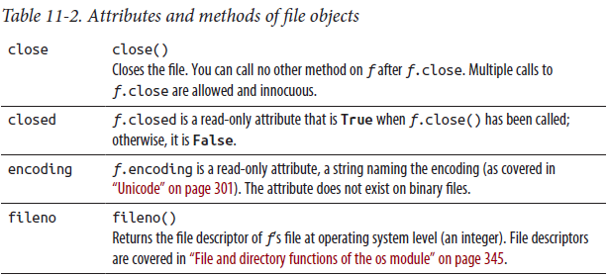

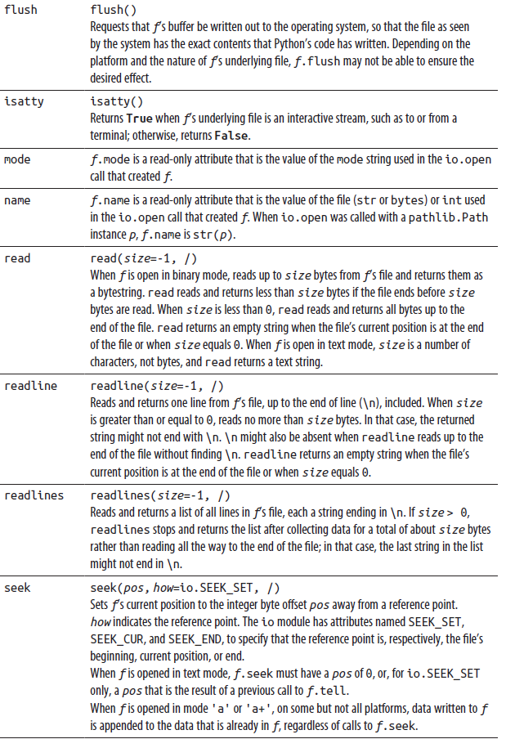

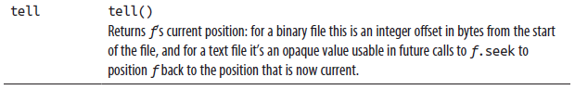

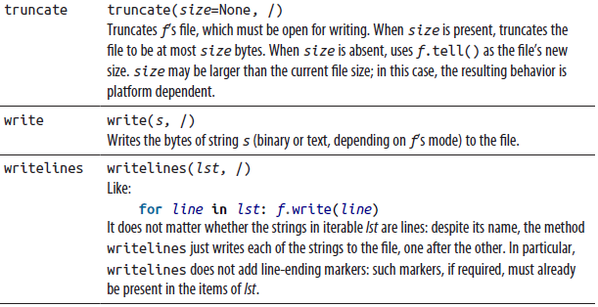

Iteration on File Objects

A file object f, open for reading, is also an iterator whose items are the file’s lines. Thus, the loop:

for line in f:

iterates on each line of the file. Due to buffering issues, interrupting such a loop prematurely (e.g., with break), or calling next(f) instead of f.readline(), leaves the file’s position set to an arbitrary value. If you want to switch from using f as an iterator to calling other reading methods on f, be sure to set the file’s position to a known value by appropriately calling f.seek. On the plus side, a loop directly on f has very good performance, since these specifications allow the loop to use internal buffering to minimize I/O without taking up excessive amounts of memory even for huge files.

#### File-Like Objects and Polymorphism

An object x is file-like when it behaves polymorphically to a file object as returned by io.open, meaning that we can use x “as if ” x were a file. Code using such an object (known as client code of the object) usually gets the object as an argument, or by calling a factory function that returns the object as the result. For example, if the only method that client code calls on x is x.read, without arguments, then all x needs to supply in order to be file-like enough for that code is a method read that is callable without arguments and returns a string. Other client code may need x to implement a larger subset of file methods. File-like objects and polymorphism are not absolute concepts: they are relative to demands placed on an object by some specific client code.

Polymorphism is a powerful aspect of object-oriented programming, and file-like objects are a good example of polymorphism. A client-code module that writes to or reads from files can automatically be reused for data residing elsewhere, as long as the module does not break polymorphism by type checking. When we discussed the built-ins type and isinstance in Table 8-1, we mentioned that type checking is often best avoided, as it blocks Python’s normal polymorphism. Often, to support polymorphism in your client code, you just need to avoid type checking. You can implement a file-like object by coding your own class (as covered in Chapter 4) and defining the specific methods needed by client code, such as read. A file-like object fl need not implement all the attributes and methods of a true file object f. If you can determine which methods the client code calls on fl, you can choose to implement only that subset. For example, when fl is only going to be written, fl doesn’t need “reading” methods, such as read, readline, and readlines.

If the main reason you want a file-like object instead of a real file object is to keep the data in memory, rather than on disk, use the io module’s classes StringIO or BytesIO, covered in “In-Memory Files: io.StringIO and io.BytesIO” on page 334. These classes supply file objects that hold data in memory and largely behave polymorphically to other file objects. If you’re running multiple processes that you want to communicate via file-like objects, consider mmap, covered in Chapter 15.

### The tempfile Module

The tempfile module lets you create temporary files and directories in the most secure manner afforded by your platform. Temporary files are often a good idea when you’re dealing with an amount of data that might not comfortably fit in memory, or when your program must write data that another process later uses. The order of the parameters for the functions in this module is a bit confusing: to make your code more readable, always call these functions with namedargument syntax. The tempfile module exposes the functions and classes outlined in Table 11-3.

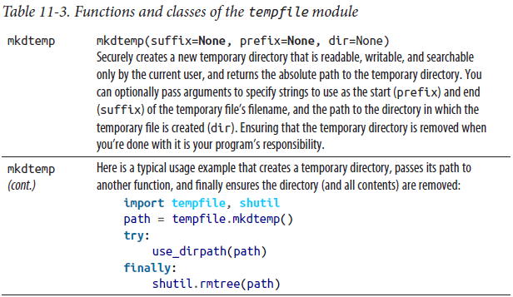

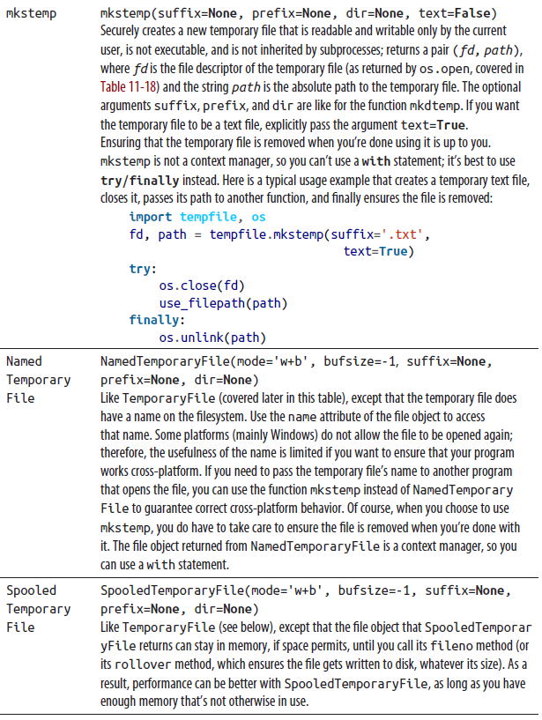

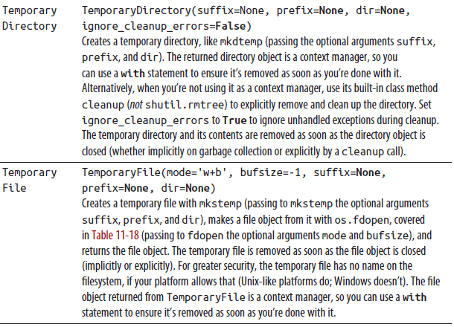

### Auxiliary Modules for File I/O

File objects supply the functionality needed for file I/O. Other Python library modules, however, offer convenient supplementary functionality, making I/O even easier and handier in several important cases. We’ll look at two of those modules

here.

#### The fileinput Module

The fileinput module lets you loop over all the lines in a list of text files. Performance is good—comparable to the performance of direct iteration on each file— since buffering is used to minimize I/O. You can therefore use this module for line-oriented file input whenever you find its rich functionality convenient, with no worry about performance. The key function of the module is input; fileinput also supplies a FileInput class whose methods support the same functionality. Both are described in Table 11-4

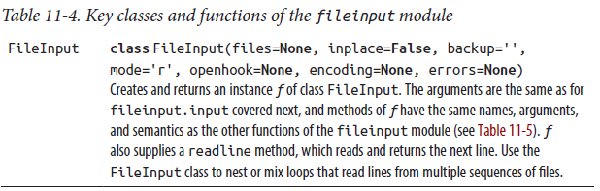

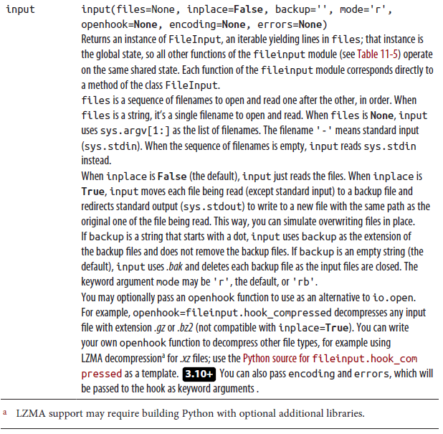

The functions of the fileinput module listed in Table 11-5 work on the global state created by fileinput.input, if any; otherwise, they raise RuntimeError.

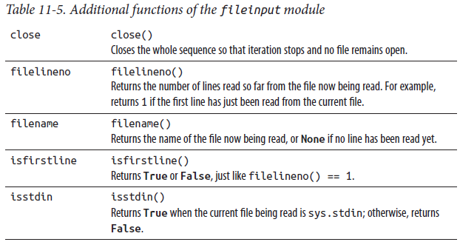

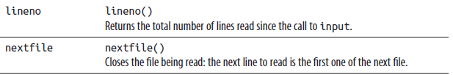

Here’s a typical example of using fileinput for a “multifile search and replace,” changing one string into another throughout the text files whose names were passed as command-line arguments to the script:

import fileinput

for line in fileinput.input(inplace=True):

print(line.replace('foo', 'bar'), end='')

In such cases it’s important to include the end='' argument to print, since each line has its line-end character \n at the end, and you need to ensure that print doesn’t add another (or else each file would end up “double-spaced”).

You may also use the FileInput instance returned by fileinput.input as a context manager. Just as with io.open, this will close all files opened by the FileInput upon exiting the with statement, even if an exception occurs:

with fileinput.input('file1.txt', 'file2.txt') as infile:

dostuff(infile)

#### The struct Module

The struct module lets you pack binary data into a bytestring, and unpack the bytes of such a bytestring back into the Python data they represent. This is useful for many kinds of low-level programming. Often, you use struct to interpret data records from binary files that have some specified format, or to prepare records to write to such binary files. The module’s name comes from C’s keyword struct, which is usable for related purposes. On any error, functions of the module struct raise exceptions that are instances of the exception class struct.error.

The struct module relies on struct format strings following a specific syntax. The first character of a format string gives the byte order, size, and alignment of the packed data; the options are listed in Table 11-6.

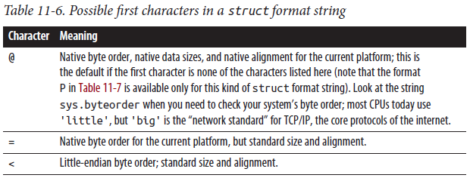



Standard sizes are indicated in Table 11-7. Standard alignment means no forced alignment, with explicit padding bytes used as needed. Native sizes and alignment are whatever the platform’s C compiler uses. Native byte order can put the most significant byte at either the lowest (big-endian) or highest (little-endian) address, depending on the platform.

After the optional first character, a format string is made up of one or more format characters, each optionally preceded by a count (an integer represented by decimal digits). Common format characters are listed in Table 11-7; see the online docs for a complete list. For most format characters, the count means repetition (e.g., '3h' is exactly the same as 'hhh'). When the format character is s or p—that is, a bytestring—the count is not a repetition: it’s the total number of bytes in the string.

You can freely use whitespace between formats, but not between a count and its format character. The format s means a fixed-length bytestring as long as its count (the Python string is truncated, or padded with copies of the null byte b'\0', if needed). The format p means a “Pascal-like” bytestring: the first byte is the number of significant bytes that follow, and the actual contents start from the second byte.

The count is the total number of bytes, including the length byte.

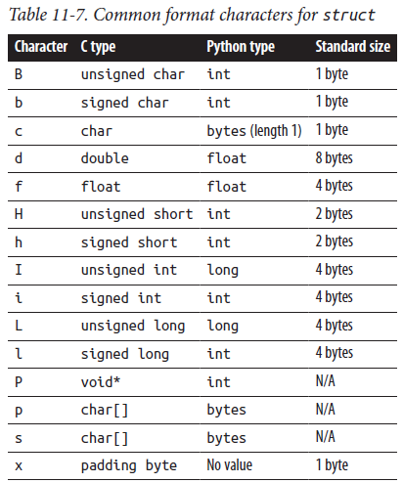

The struct module supplies the functions covered in Table 11-8.

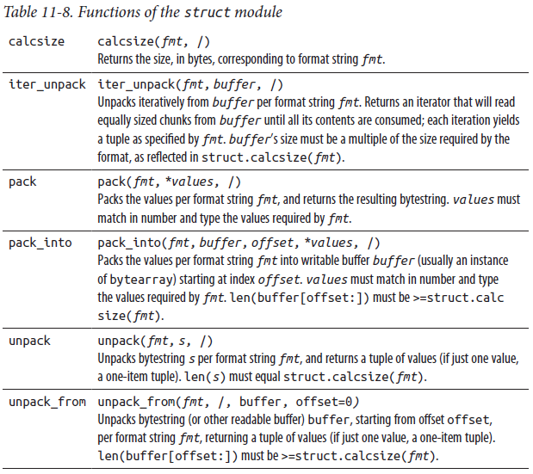

The struct module also offers a Struct class, which is instantiated with a format string as an argument. Instances of this class implement pack, pack_into, unpack, unpack_from, and iter_unpack methods corresponding to the functions described in the preceding table; they take the same arguments as the corresponding module functions, but omitting the fmt argument, which was provided on instantiation. This allows the class to compile the format string once and reuse it. Struct objects also have a format attribute that holds the format string for the object, and a size attribute that holds the calculated size of the structure.

In-Memory Files: io.StringIO and io.BytesIO

You can implement file-like objects by writing Python classes that supply the methods you need. If all you want is for data to reside in memory, rather than in a file as seen by the operating system, use the classes StringIO or BytesIO of the io module. The difference between them is that instances of StringIO are text-mode files, so reads and writes consume or produce text strings, while instances of BytesIO are binary files, so reads and writes consume or produce bytestrings. These classes are especially useful in tests and other applications where program output should be redirected for buffering or journaling; “The print Function” on page 369 includes a useful context manager example, redirect, that demonstrates this.

When you instantiate either class you can optionally pass a string argument, respectively str or bytes, to use as the initial content of the file. Additionally, you can pass the argument newline='\n' to StringIO (but not BytesIO) to control how line endings are handled (like in TextIoWrapper); if newline is None, newlines are written as \n on all platforms. In addition to the methods described in Table 11-2, an instance f of either class supplies one extra method:

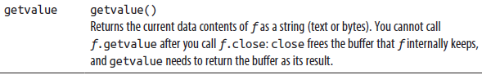

### Archived and Compressed Files

Storage space and transmission bandwidth are increasingly cheap and abundant, but in many cases you can save such resources, at the expense of some extra computational effort, by using compression. Computational power grows cheaper and more abundant even faster than some other resources, such as bandwidth, so compression’s popularity keeps growing. Python makes it easy for your programs to support compression. We don’t cover the details of compression in this book, but you can find details on the relevant standard library modules in the online docs. The rest of this section covers “archive” files (which collect in a single file a collection of files and optionally directories), which may or may not be compressed.

Python’s stdlib offers two modules to handle two very popular archive formats: tarfile (which, by default, does not compress the files it bundles), and zipfile (which, by default, does compress the files it bundles).

#### The tarfile Module

The tarfile module lets you read and writeTAR files (archive files compatible with those handled by popular archiving programs such as tar), optionally with gzip, bzip2, or LZMA compression. TAR files are typically named with a .tar or .tar.(compression type) extension. 3.8+ The default format of new archives is POSIX.1-2001 (pax). python -m tarfile offers a useful command-line interface to the module’s functionality: run it without arguments to get a brief help message.

The tarfile module supplies the functions listed in Table 11-9. When handling invalid TAR files, functions of tarfile raise instances of tarfile.TarError.

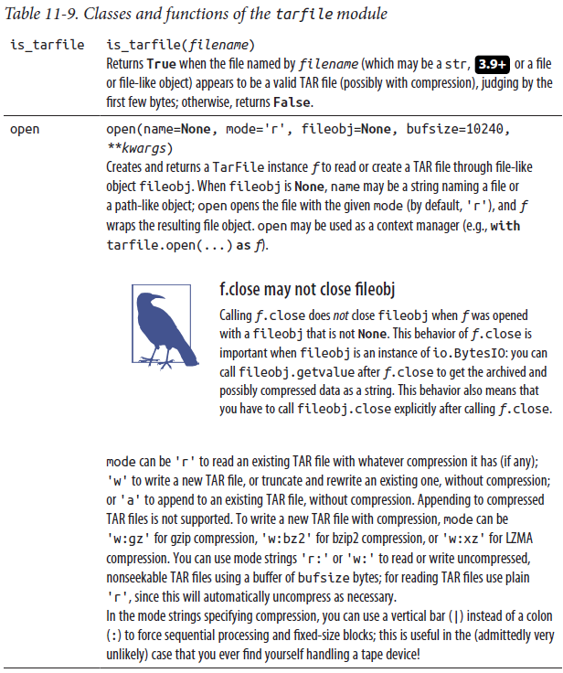

The TarFile class

TarFile is the underlying class for most tarfile methods, but is not used directly. A TarFile instance f, created using tarfile.open, supplies the methods detailed in Table 11-10.

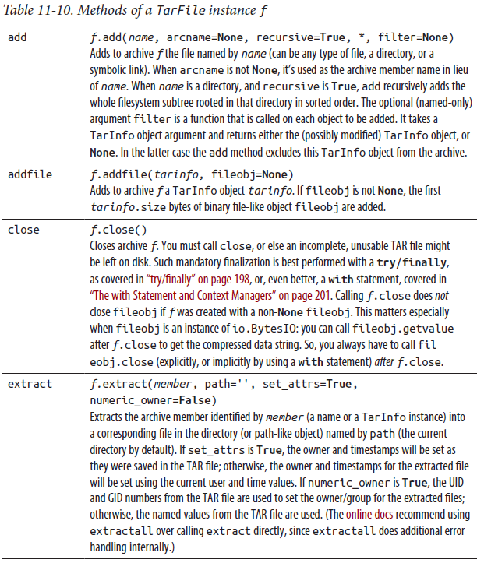

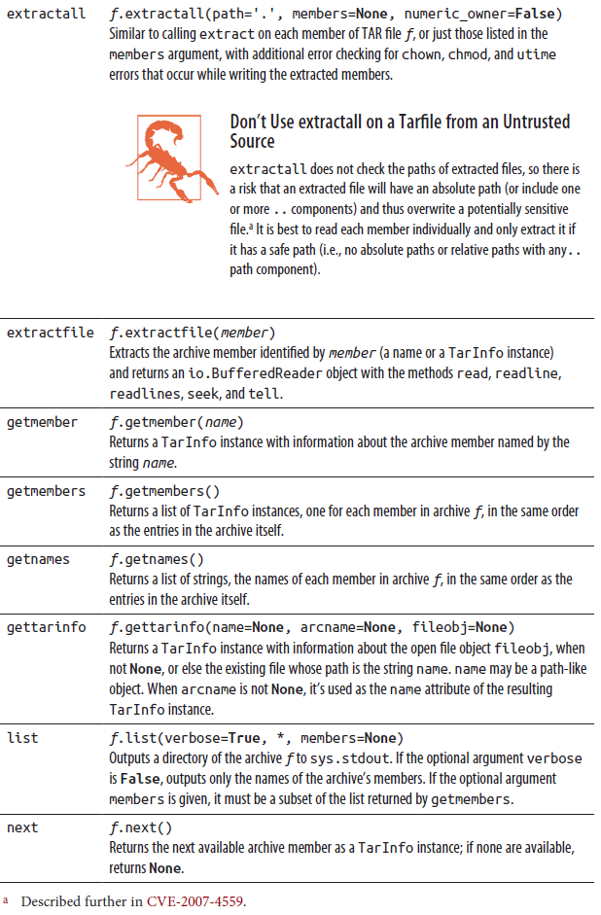

The TarInfo class

The methods getmember and getmembers of TarFile instances return instances of TarInfo, supplying information about members of the archive. You can also build a TarInfo instance with a TarFile instance’s method gettarinfo. The name argument

may be a path-like object. The most useful attributes and methods supplied by a TarInfo instance t are listed in Table 11-11.

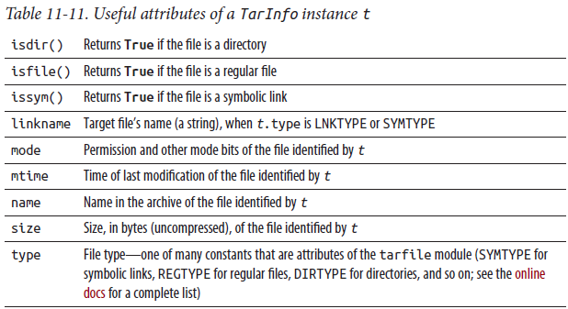

#### The zipfile Module

The zipfile module can read and write ZIP files (i.e., archive files compatible with those handled by popular compression programs such as zip and unzip, pkzip and pkunzip, WinZip, and so on, typically named with a .zip extension). python -m zipfile offers a useful command-line interface to the module’s functionality: run it without further arguments to get a brief help message.

Detailed information about ZIP files is available on the PKWARE and Info-ZIP websites. You need to study that detailed information to perform advanced ZIP file handling with zipfile. If you do not specifically need to interoperate with other programs using the ZIP file standard, the modules lzma, gzip, and bz2 are usually better ways to deal with compression, as is tarfile to create (optionally compressed) archives.

The zipfile module can’t handle multidisk ZIP files, and cannot create encrypted archives (it can decrypt them, albeit rather slowly). The module also cannot handle archive members using compression types besides the usual ones, known as stored (a file copied to the archive without compression) and deflated (a file compressed using the ZIP format’s default algorithm). zipfile also handles the bzip2 and LZMA compression types, but beware: not all tools can handle those, so if you use them you’re sacrificing some portability to get better compression.

The zipfile module supplies function is_zipfile and class Path, as listed in Table 11-12. In addition, it supplies classes ZipFile and ZipInfo, described later. For errors related to invalid ZIP files, functions of zipfile raise exceptions that are instances of the exception class zipfile.error.

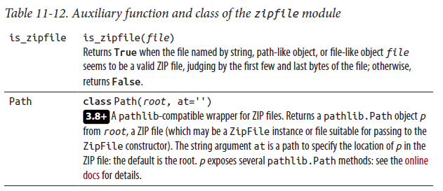

The ZipFile class

The main class supplied by zipfile is ZipFile. Its constructor has the following signature:

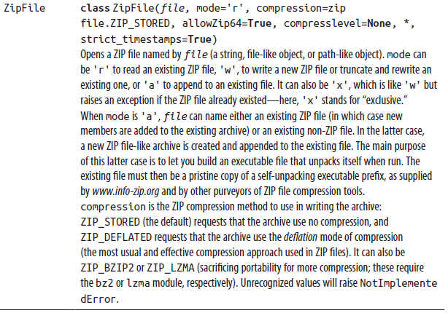

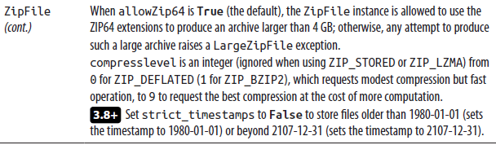

ZipFile is a context manager; thus, you can use it in a with statement to ensure the underlying file gets closed when you’re done with it. For example:

with zipfile.ZipFile('archive.zip') as z:

data = z.read('data.txt')

In addition to the arguments with which it was instantiated, a ZipFile instance z has the attributes fp and filename, which are the file-like object z works on and its filename (if known); comment, the possibly empty string that is the archive’s comment; and filelist, the list of ZipInfo instances in the archive. In addition, z has a writable attribute called debug, an int from 0 to 3 that you can assign to control how much debugging output to emit to sys.stdout:2 from nothing when z.debug is 0, to the maximum amount of information available when z.debug is 3. A ZipFile instance z supplies the methods listed in Table 11-13.

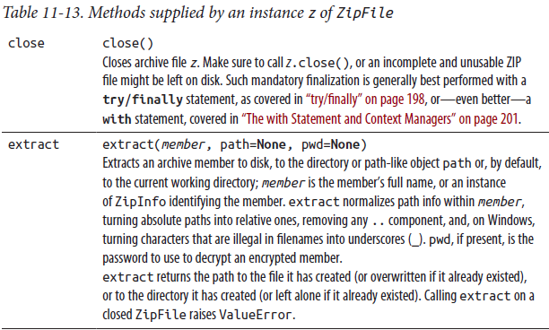

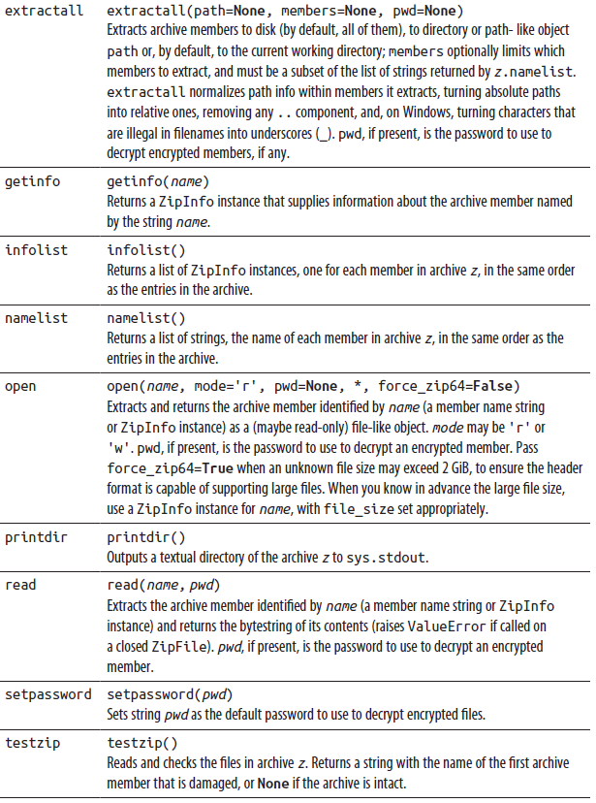

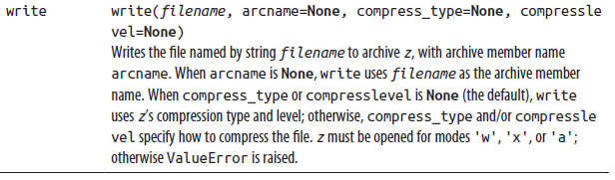

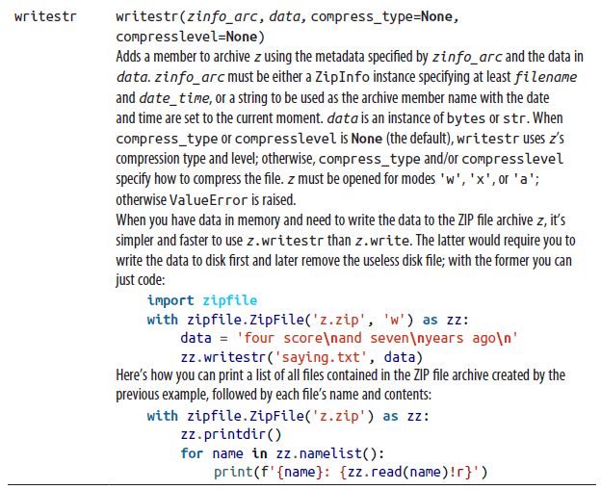

The ZipInfo class

The methods getinfo and infolist of ZipFile instances return instances of class ZipInfo to supply information about members of the archive. Table 11-14 lists the most useful attributes supplied by a ZipInfo instance z.

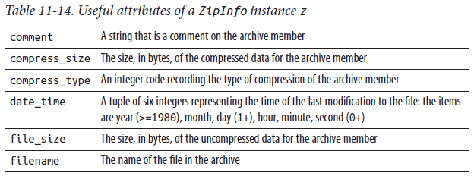

### The os Module

os is an umbrella module presenting a nearly uniform cross-platform view of the capabilities of various operating systems. It supplies low-level ways to create and handle files and directories, and to create, manage, and destroy processes. This section covers filesystem-related functions of os; “Running Other Programs with the os Module” on page 478 covers process-related functions. Most of the time you can use other modules at higher levels of abstraction and gain productivity, but understanding what is “underneath” in the low-level os module can still be quite useful (hence our coverage).

The os module supplies a name attribute, a string that identifies the kind of platform on which Python is being run. Common values for name are 'posix' (all kinds of Unix-like platforms, including Linux and macOS) and 'nt' (all kinds of Windows platforms); 'java' is for the old but still-missed Jython. You can exploit some unique capabilities of a platform through functions supplied by os.

However, this book focuses on cross-platform programming, not platform-specific functionality, so we cover neither parts of os that exist only on one platform, nor platform-specific modules: functionality covered in this book is available at least on 'posix' and 'nt' platforms. We do, though, cover some of the differences among the ways in which a given functionality is provided on various platforms.

#### Filesystem Operations

Using the os module, you can manipulate the filesystem in a variety of ways: creating, copying, and deleting files and directories; comparing files; and examining filesystem information about files and directories. This section documents the attributes and methods of the os module that you use for these purposes, and covers some related modules that operate on the filesystem.

Path-string attributes of the os module

A file or directory is identified by a string, known as its path, whose syntax depends on the platform. On both Unix-like and Windows platforms, Python accepts Unix syntax for paths, with a slash (/) as the directory separator. On non-Unix-like platforms, Python also accepts platform-specific path syntax. On Windows, in particular, you may use a backslash (\) as the separator. However, you then need to double up each backslash as \\ in string literals, or use raw string literal syntax (as covered in “Strings” on page 44); you also needlessly lose portability. Unix path syntax is handier and usable everywhere, so we strongly recommend that you always use it. In the rest of this chapter, we use Unix path syntax in both explanations and examples.

The os module supplies attributes that provide details about path strings on the current platform, detailed in Table 11-15. You should typically use the higher-level path manipulation operations covered in “The os.path Module” on page 3543 rather than

lower-level string operations based on these attributes. However, these attributes may be useful at times.

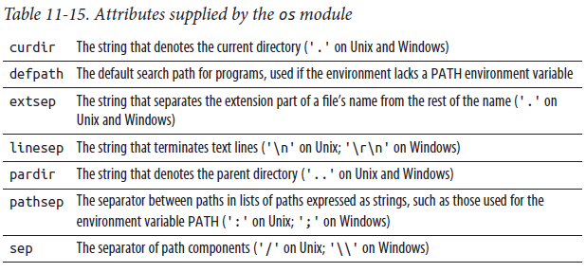

Permissions

Unix-like platforms associate nine bits with each file or directory: three each for the file’s owner, its group, and everybody else (aka “others” or “the world”), indicating whether the file or directory can be read, written, and executed by the given subject. These nine bits are known as the file’s permission bits, and are part of the file’s mode (a bit string that includes other bits that describe the file). You often display these bits in octal notation, which groups three bits per digit. For example, mode 0o664 indicates a file that can be read and written by its owner and group, and that anybody else can read, but not write. When any process on a Unix-like system creates a file or directory, the operating system applies to the specified mode a bit mask known as the process’s umask, which can remove some of the permission bits.

Non-Unix-like platforms handle file and directory permissions in very different ways. However, the os functions that deal with file permissions accept a mode argument according to the Unix-like approach described in the previous paragraph. Each platform maps the nine permission bits in a way appropriate for it. For example, on Windows, which distinguishes only between read-only and read/write files and does not record file ownership, a file’s permission bits show up as either 0o666 (read/write) or 0o444 (read-only). On such a platform, when creating a file, the implementation looks only at bit 0o200, making the file read/write when that bit is 1 and read-only when it is 0.

File and directory functions of the os module

The os module supplies several functions (listed in Table 11-16) to query and set file and directory status. In all versions and platforms, the argument path to any of these functions can be a string giving the path of the file or directory involved, or it can be a path-like object (in particular, an instance of pathlib.Path, covered later in this chapter). There are also some particularities on some Unix platforms:

• Some of the functions also support a file descriptor (fd)—an int denoting a file as returned, for example, by os.open—as the path argument. The module attribute os.supports_fd is the set of functions in the os module that support this behavior (the module attribute is missing on platforms lacking such support).

• Some functions support the optional keyword-only argument follow_sym links, defaulting to True. When this argument is True, if path indicates a symbolic link, the function follows it to reach an actual file or directory; when it’s False, the function operates on the symbolic link itself. The module attribute os.supports_follow_symlinks, if present, is the set of functions in the os module that support this argument.

• Some functions support the optional named-only argument dir_fd, defaulting to None. When dir_fd is present, path (if relative) is taken as being relative to the directory open at that file descriptor; when missing, path (if relative) is taken as relative to the current working directory. If path is absolute, dir_fd is ignored. The module attribute os.supports_dir_fd, if present, is the set of functions of the os module that support this argument.

Additionally, on some platforms the named-only argument effective_ids, defaulting to False, lets you choose to use effective rather than real user and group identifiers. Check whether it is available on your platform with os.supports_effective_ids.

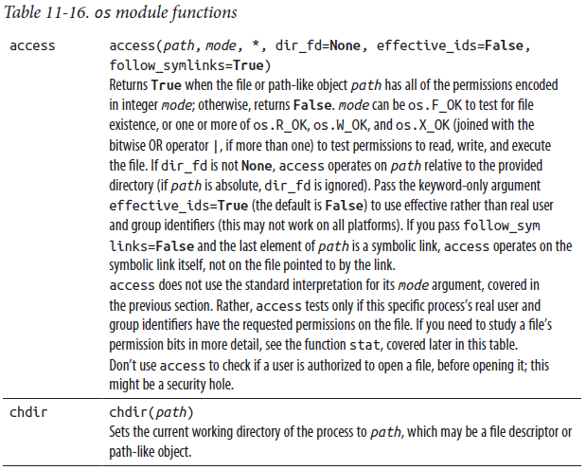

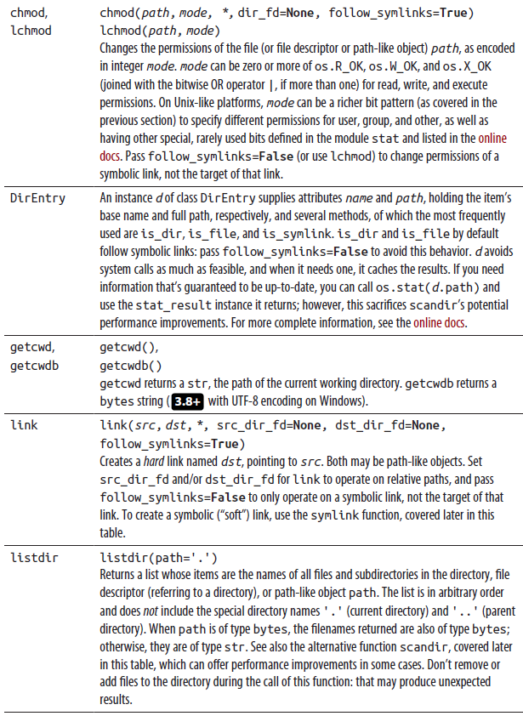

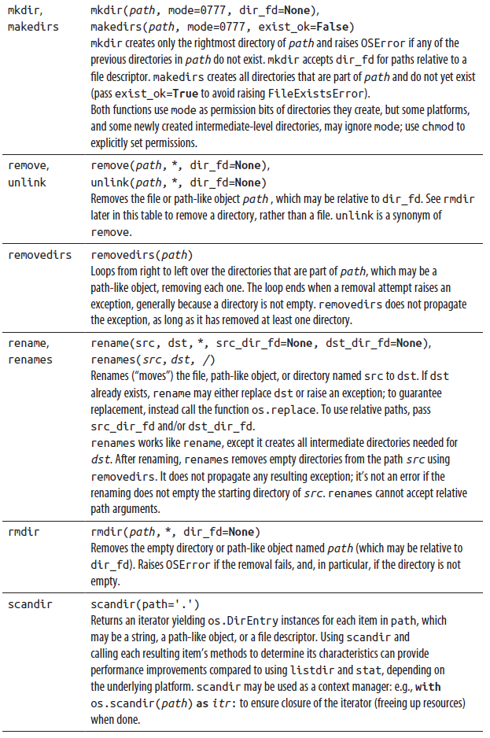

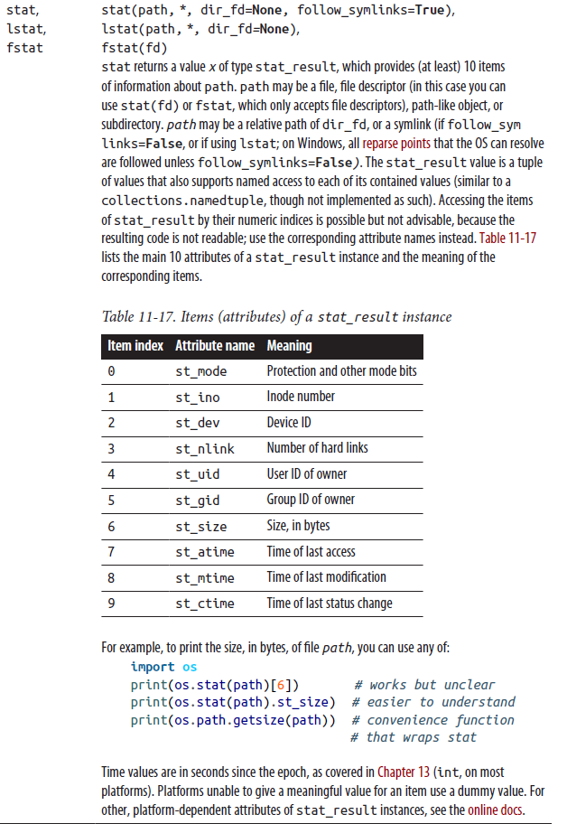

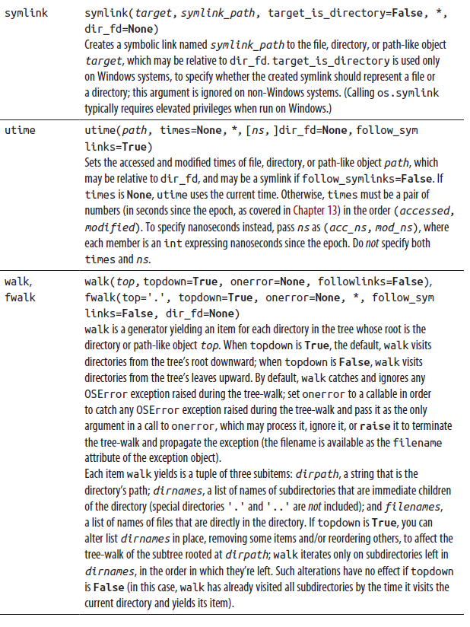

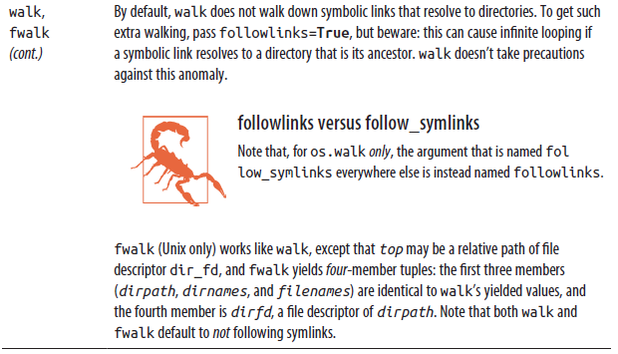

File descriptor operations

In addition to the many functions covered earlier, the os module supplies several that work specifically with file descriptors. A file descriptor is an integer that the operating system uses as an opaque handle to refer to an open file. While it is usually best to use Python file objects (covered in “The io Module” on page 322) for I/O tasks, sometimes working with file descriptors lets you perform some operations faster, or (at the possible expense of portability) in ways not directly available with io.open. File objects and file descriptors are not interchangeable.

To get the file descriptor n of a Python file object f, call n = f.fileno(). To create a new Python file object f using an existing open file descriptor fd, use f = os.fdopen(fd), or pass fd as the first argument of io.open. On Unix-like and Windows platforms, some file descriptors are preallocated when a process starts: 0 is the file descriptor for the process’s standard input, 1 for the process’s standard output, and 2 for the process’s standard error. Calling os module methods such as dup or close on these preallocated file descriptors can be useful for redirecting or manipulating standard input and output streams.

The os module provides many functions for dealing with file descriptors; some of the most useful are listed in Table 11-18.

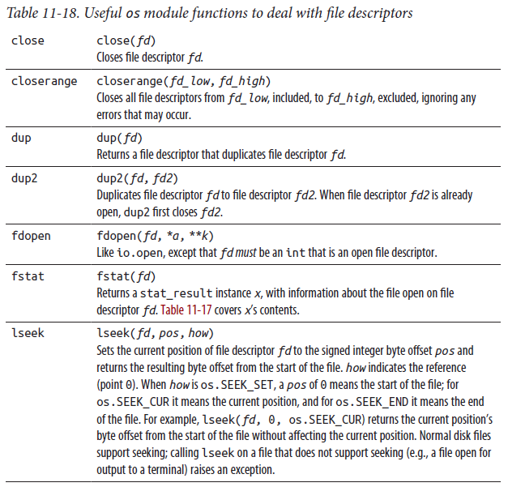

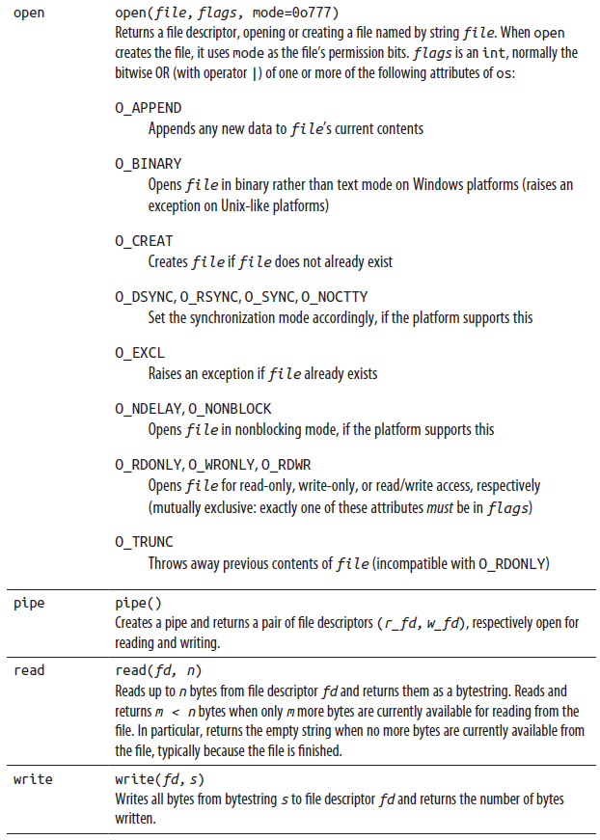

#### The os.path Module

The os.path module supplies functions to analyze and transform path strings and path-like objects. The most commonly useful functions from the module are listed in Table 11-19.

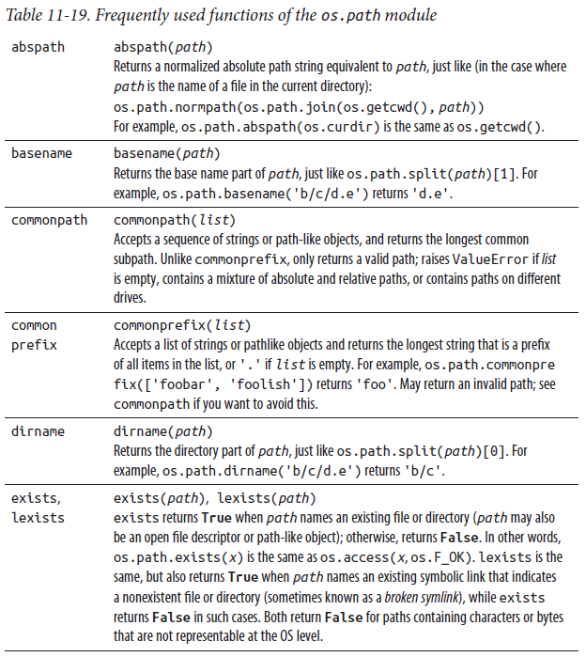

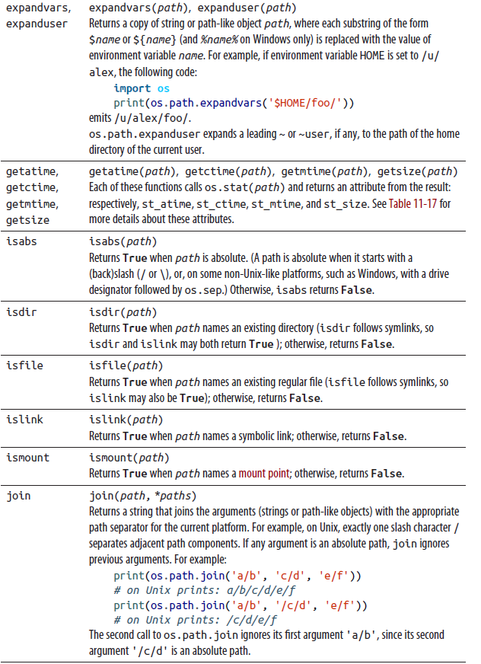

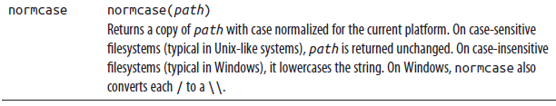

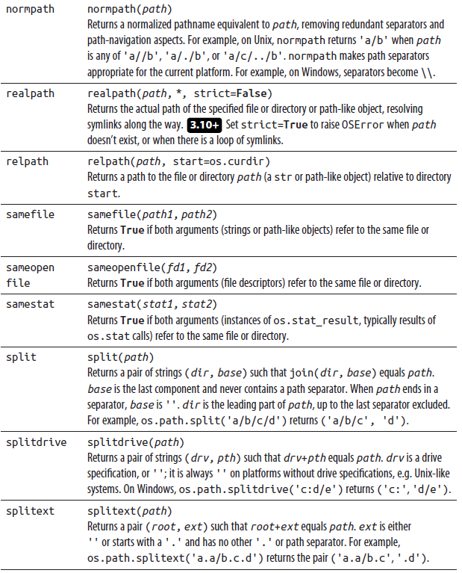

#### OSError Exceptions

When a request to the operating system fails, os raises an exception, an instance of OSError. os also exposes the built-in exception class OSError with the synonym os.error. Instances of OSError expose three useful attributes, detailed in Table 11-20.

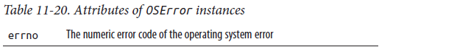

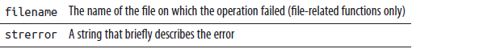

OSError has subclasses to specify what the problem was, as discussed in “OSError subclasses” on page 208.

os functions can also raise other standard exceptions, such as TypeError or ValueError, when called with invalid argument types or values, so that they didn’t even attempt the underlying operating system functionality.

### The errno Module

The errno module supplies dozens of symbolic names for error code numbers. Use errno to handle possible system errors selectively, based on error codes; this will enhance your program’s portability and readability. However, a selective except with the appropriate OSError subclass often works better than errno. For example, to handle “file not found” errors, while propagating all other kinds of errors, you could use:

import errno

try:

os.some_os_function_or_other()

except FileNotFoundError as err:

print(f'Warning: file {err.filename!r} not found; continuing')

except OSError as oserr:

print(f'Error {errno.errorcode[oserr.errno]}; continuing')

errno supplies a dictionary named errorcode: the keys are error code numbers, and the corresponding values are the error names, strings such as 'ENOENT'. Displaying errno.errorcode[err.errno] as part of the explanation behind some OSError instance’s err can often make the diagnosis clearer and more understandable to readers who specialize in the specific platform.

### The pathlib Module

The pathlib module provides an object-oriented approach to filesystem paths, pulling together a variety of methods for handling paths and files as objects, not as strings (unlike os.path). For most use cases, pathlib.Path will provide everything you’ll need. On rare occasions, you’ll want to instantiate a platform-specific path, or a “pure” path that doesn’t interact with the operating system; see the online docs if you need such advanced functionality. The most commonly useful functions of pathlib.Path are listed in Table 11-21, with examples for a pathlib.Path object p. On Windows, pathlib.Path objects are returned as WindowsPath; on Unix, as PosixPath, as shown in the examples in Table 11-21. (For clarity, we are simply importing pathlib rather than using the more common and idiomatic from path lib import Path.)

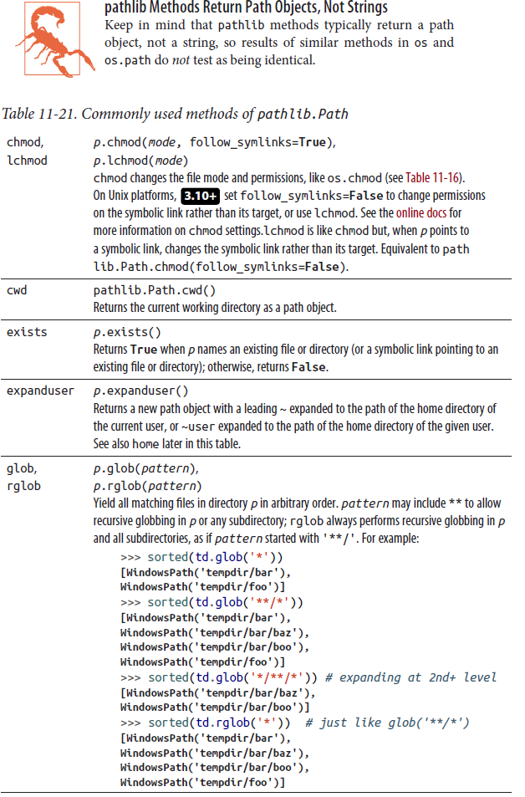

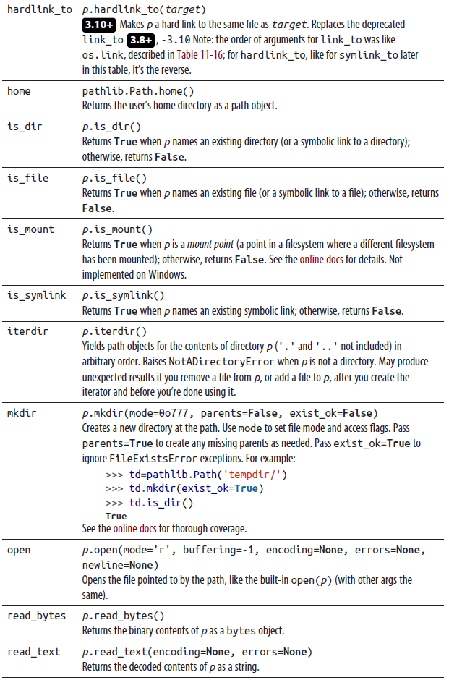



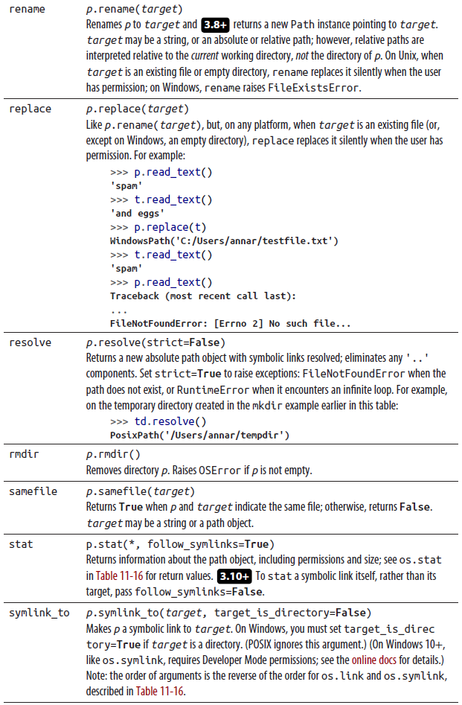

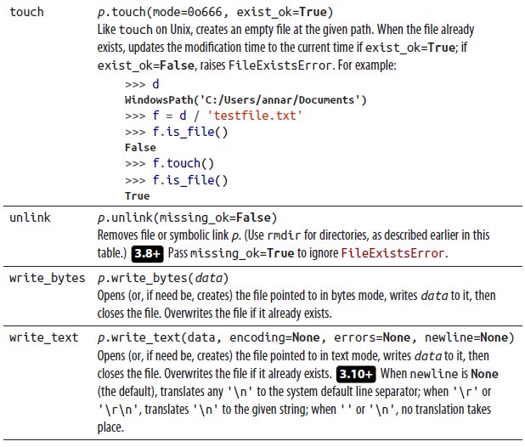

pathlib.Path objects also support the attributes listed in Table 11-22 to access the various component parts of the path string. Note that some attributes are strings, while others are Path objects. (For brevity, OS-specific types such as PosixPath or WindowsPath are shown simply using the abstract Path class.)

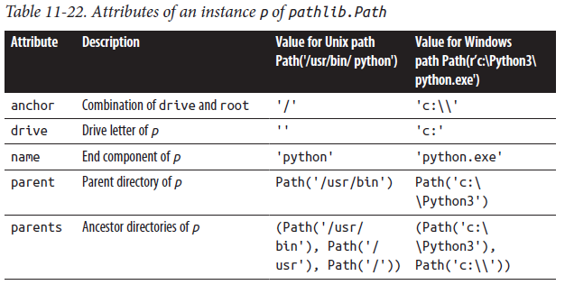

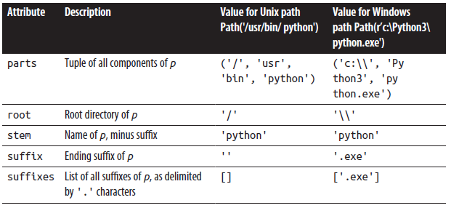

The online documentation includes more examples for paths with additional components, such as filesystem and UNC shares.

pathlib.Path objects also support the '/' operator, an excellent alternative to os.path.join or Path.joinpath from the Path module. See the example code in the description of Path.touch in Table 11-21.

### The stat Module

The function os.stat (covered in Table 11-16) returns instances of stat_result, whose item indices, attribute names, and meaning are also covered there. The stat module supplies attributes with names like those of stat_result’s attributes in uppercase, and corresponding values that are the corresponding item indices. The more interesting contents of the stat module are functions to examine the st_mode attribute of a stat_result instance and determine the kind of file. os.path also supplies functions for such tasks, which operate directly on the file’s path. The functions supplied by stat, shown in Table 11-23, are faster than os’s when you perform several tests on the same file: they require only one os.stat system call at the start of a series of tests to obtain the file’s st_mode, while the functions in os.path implicitly ask the operating system for the same information at each test.

Each function returns True when mode denotes a file of the given kind; otherwise, it returns False.

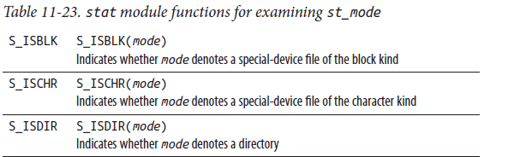

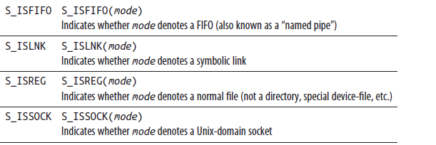

Several of these functions are meaningful only on Unix-like systems, since other platforms do not keep special files such as devices and sockets in the same namespace as regular files; Unix-like systems do.

The stat module also supplies two functions that extract relevant parts of a file’s mode (x.st_mode, for some result x of function os.stat), listed in Table 11-24.

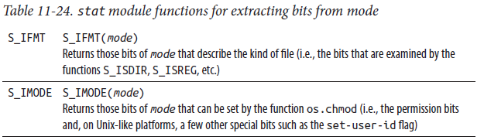

The stat module supplies a utility function, stat.filemode(mode), that converts a file’s mode to a human readable string of the form '-rwxrwxrwx'.

### The filecmp Module

The filecmp module supplies a few functions that are useful for comparing files and directories, listed in Table 11-25.

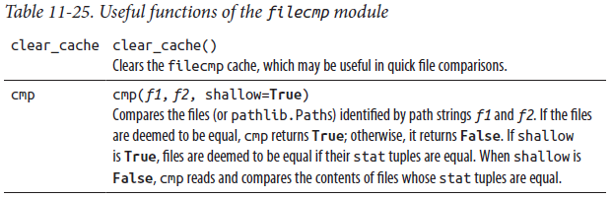

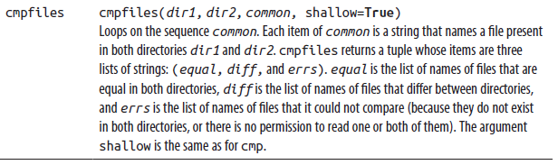

The filecmp module also supplies the class dircmp. The constructor for this class has the signature:

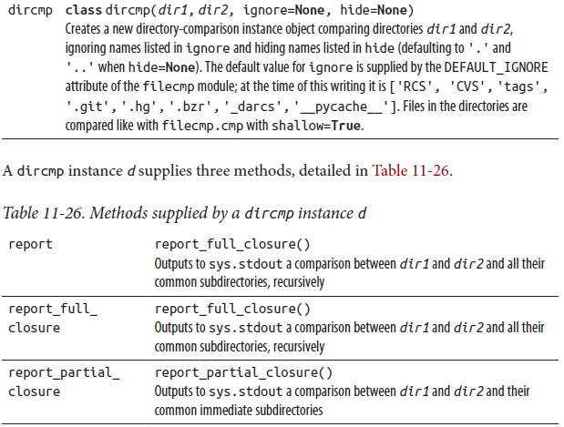

In addition, d supplies several attributes, covered in Table 11-27. These attributes are computed “just in time” (i.e., only if and when needed, thanks to a __getattr__ special method) so that using a dircmp instance incurs no unnecessary overhead.

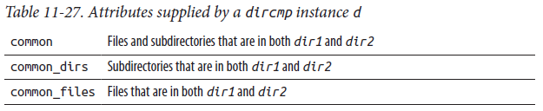

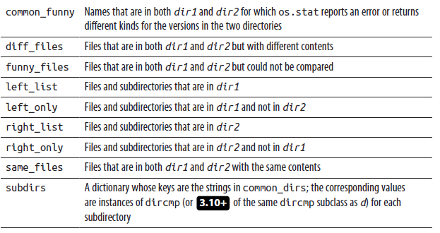

### The fnmatch Module

The fnmatch module (an abbreviation for filename match) matches filename strings or paths with patterns that resemble the ones used by Unix shells, as listed in Table 11-28.

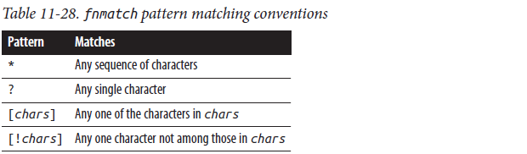

fnmatch does not follow other conventions of Unix shell pattern matching, such as treating a slash (/) or a leading dot (.) specially. It also does not allow escaping special characters: rather, to match a special character, enclose it in brackets. For example, to match a filename that’s a single close bracket, use '[]]'.

The fnmatch module supplies the functions listed in Table 11-29.

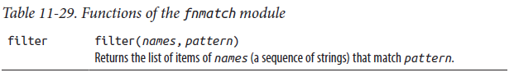

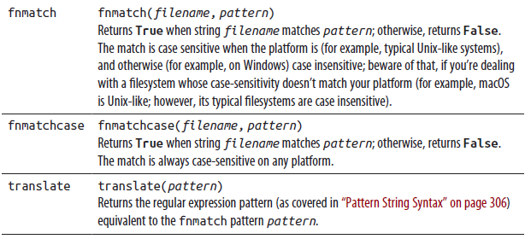

### The glob Module

The glob module lists (in arbitrary order) the pathnames of files that match a path pattern, using the same rules as fnmatch; in addition, it treats a leading dot (.), separator (/), and ** specially, like Unix shells do. Table 11-30 lists some useful functions provided by the glob module.

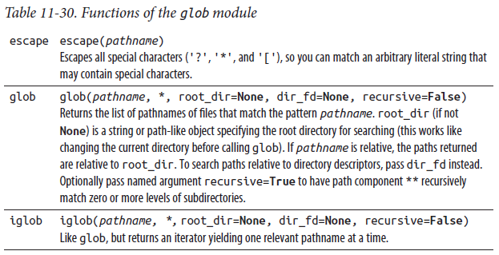

### The shutil Module

The shutil module (an abbreviation for shell utilities) supplies functions to copy and move files, and to remove an entire directory tree. On some Unix platforms, most of the functions support the optional keyword-only argument follow_sym links, defaulting to True. When follow_symlinks=True, if a path indicates a symbolic link, the function follows it to reach an actual file or directory; when False, the function operates on the symbolic link itself. Table 11-31 lists the functions provided by the shutil module.

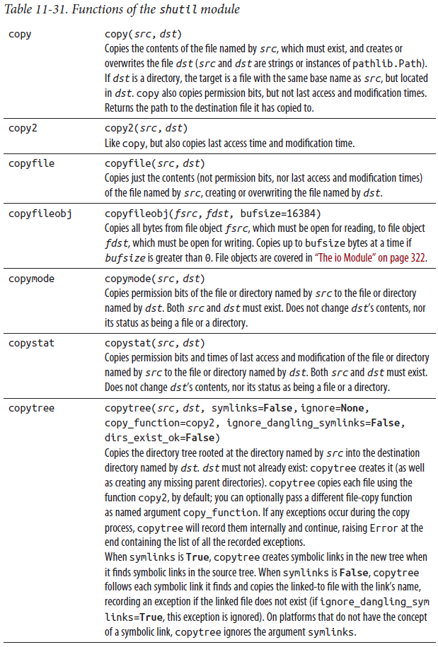

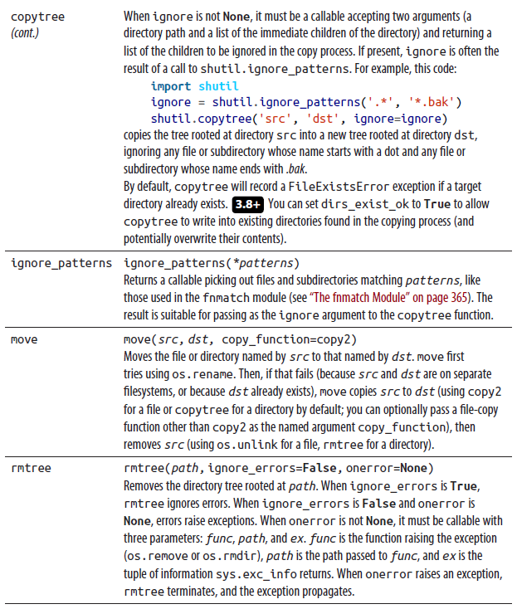

Beyond offering functions that are directly useful, the source file shutil.py in the Python stdlib is an excellent example of how to use many of the os functions.

## Text Input and Output

Python presents non-GUI text input and output streams to Python programs as file objects, so you can use the methods of file objects (covered in “Attributes and Methods of File Objects” on page 325) to operate on these streams.

### Standard Output and Standard Error

The sys module (covered in “The sys Module” on page 259) has the attributes stdout and stderr, which are writable file objects. Unless you are using shell redirection or pipes, these streams connect to the “terminal” running your script. Nowadays, actual terminals are very rare: a so-called terminal is generally a screen window that supports text I/O.

The distinction between sys.stdout and sys.stderr is a matter of convention. sys.stdout, known as standard output, is where your program emits results. sys.stderr, known as standard error, is where output such as error, status, or progress messages should go. Separating program output from status and error messages helps you use shell redirection effectively. Python respects this convention, using sys.stderr for its own errors and warnings.

### The print Function

Programs that output results to standard output often need to write to sys.stdout. Python’s print function (covered in Table 8-2) can be a rich, convenient alternative to sys.stdout.write. print is fine for the informal output used during development to help you debug your code, but for production output, you may need more control of formatting than print affords. For example, you may need to control spacing, field widths, the number of decimal places for floating-point values, and so on. If so, you can prepare the output as an f-string (covered in “String Formatting” on page 287), then output the string, usually with the write method of the appropriate file object. (You can pass formatted strings to print, but print may add spaces and newlines; the write method adds nothing at all, so it’s easier for you to control what exactly gets output.)

If you need to direct output to a file f that is open for writing, just calling f.write is often best, while print(..., file=f) is sometimes a handy alternative. To repeatedly direct the output from print calls to a certain file, you can temporarily change the value of sys.stdout. The following example is a general-purpose redirection function usable for such a temporary change; in the presence of multitasking, make sure to also add a lock in order to avoid any contention (see also the context lib.redirect_stdout decorator described in Table 6-1):

def redirect(func: Callable, *a, **k) -> (str, Any):

"""redirect(func, *a, **k) -> (func's results, return value)

func is a callable emitting results to standard output.

redirect captures the results as a str and returns a pair

(output string, return value).

"""

import sys, io

save_out = sys.stdout

sys.stdout = io.StringIO()

try:

retval = func(*args, **kwds)

return sys.stdout.getvalue(), retval

finally:

sys.stdout.close()

sys.stdout = save_out

### Standard Input

In addition to stdout and stderr, the sys module provides the stdin attribute, which is a readable file object. When you need a line of text from the user, you can call the built-in function input (covered in Table 8-2), optionally with a string argument to use as a prompt.

When the input you need is not a string (for example, when you need a number), use input to obtain a string from the user, then other built-ins, such as int, float, or ast.literal_eval, to turn the string into the number you need. To evaluate an expression or string from an untrusted source, we recommend using the function literal_eval from the standard library module ast (as covered in the online docs). ast.literal_eval(astring) returns a valid Python value (such as an int, a float, or a list) for the given literal astring when it can ( 3.10+ stripping any leading spaces and tabs from string inputs), or else raises a SyntaxError or ValueError exception; it never has any side effects. To ensure complete safety, astring cannot contain any operator or any nonkeyword identifier; however, + and - may be accepted as positive or negative signs on numbers, rather than as operators.

For example:

import ast

print(ast.literal_eval('23')) # prints 23

print(ast.literal_eval(' 23')) # prints 23 (3.10++)

print(ast.literal_eval('[2,-3]')) # prints [2, -3]

print(ast.literal_eval('2+3')) # raises ValueError

print(ast.literal_eval('2+')) # raises SyntaxError

**eval Can Be Dangerous**

Don’t use eval on arbitrary, unsanitized user inputs: a nasty (or well-meaning but careless) user can breach security or otherwise cause damage this way. There is no effective defense —just avoid using eval (and exec) on input from sources you

do not fully trust.

**The getpass Module**

Very occasionally, you may want the user to input a line of text in such a way that somebody looking at the screen cannot see what the user is typing. This may occur when you’re asking the user for a password, for example. The getpass module provides a function for this, as well as one to get the current user’s username (see Table 11-32).

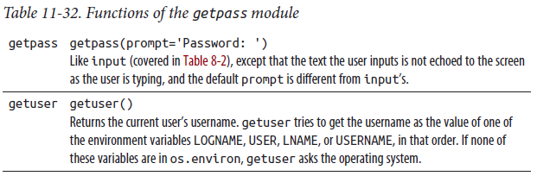

### Richer-Text I/O

The text I/O modules covered so far supply basic text I/O functionality on all platform terminals. Most platforms also offer enhanced text I/O features, such as responding to single keypresses (not just entire lines), printing text in any terminal row and column position, and enhancing the text with background and foreground colors and font effects like bold, italic, and underline. For this kind of functionality you’ll need to consider a third-party library. We focus here on the readline module, then take a quick look at a few console I/O options, including mscvrt, with a brief mention of curses, rich, and colorama, which we do not cover further.

#### The readline Module

The readline module wraps the GNU Readline Library, which lets the user edit text lines during interactive input and recall previous lines for editing and re-entry. Readline comes preinstalled on many Unix-like platforms, and it’s available online. On Windows, you can install and use the third-party module pyreadline. When readline is available, Python uses it for all line-oriented input, such as input. The interactive Python interpreter always tries to load readline to enable line editing and recall for interactive sessions. Some readline functions control advanced functionality: particularly history, for recalling lines entered in previous sessions; and completion, for context-sensitive completion of the word being entered. (See the Python readline docs for complete details on configuration commands.) You can access the module’s functionality using the functions in Table 11-33.

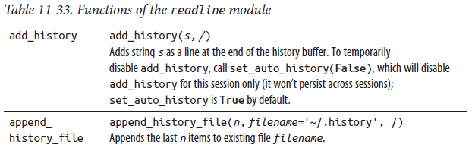

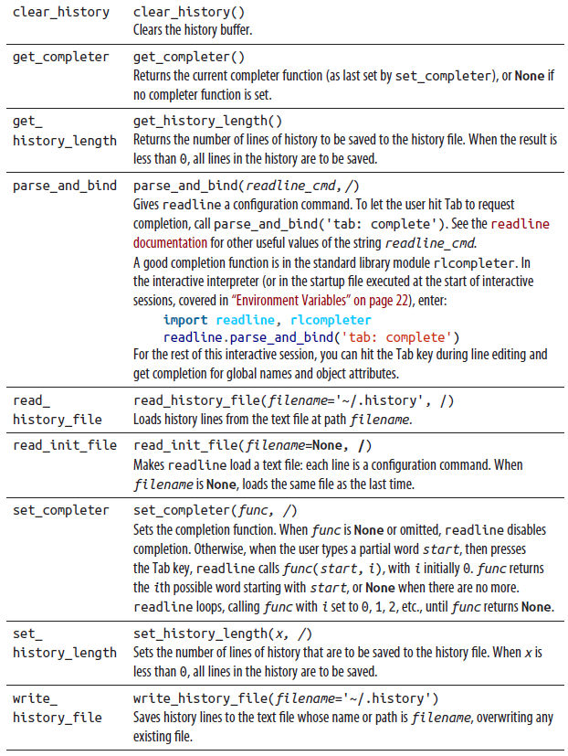

#### Console I/O

As mentioned previously, “terminals” today are usually text windows on a graphical screen. You may also, in theory, use a true terminal, or (perhaps a tad less theoretically, but these days not by much) the console (main screen) of a personal computer in text mode. All such “terminals” in use today offer advanced text I/O functionality, accessed in platform-dependent ways. The low-level curses package works on Unix-like platforms. For a cross-platform (Windows, Unix, macOS) solution, you may use the third-party package rich; in addition to its excellent online docs, there are online tutorials to help you get started. To output colored text on the terminal, see colorama, available on PyPI. msvcrt, introduced next, provides some low-level (Windows only) functions.

curses

The classic Unix approach to enhanced terminal I/O is named curses, for obscure historical reasons.4 The Python package curses lets you exert detailed control if required. We don’t cover curses in this book; for more information, see A.M. Kuchling’s and Eric Raymond’s online tutorial “Curses Programming with Python”.

The msvcrt module

The Windows-only msvcrt module (which you may need to install with pip) supplies a few low-level functions that let Python programs access proprietary extras supplied by the Microsoft Visual C++ runtime library msvcrt.dll. For example, the functions listed in Table 11-34 let you read user input character by character rather than reading a full line at a time.

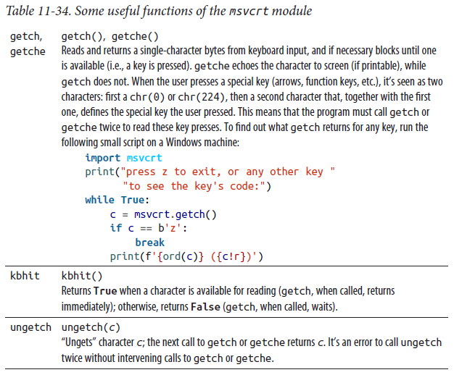

## Internationalization

Page 374